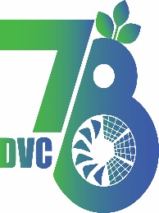
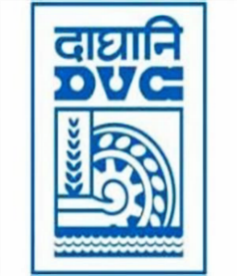
Damodar Valley Corporation
संविदा और सामग्री विभाग
Contracts and Materials Department
डीवीसी टावर्स; तृतीय तल; वीआइपी रोड; कोलकाता-७०००५४ टेली फ़ैक्स न०-०३३-२३५५-२९३६
DVC Towers; 3rd Floor; VIP Road, Kolkata – 700054 Tele fax No.-033 – 2355 –2936.

E-Tender Notice
Damodar Valley Corporation invites online bids (Open) from the eligible bidders for:
REFERENCE NO. | Description of item | Tender Downloading Period and Time
DVC NIT NO: DVC/Tender/Head Quarter/SPE/CMM//Works and Service/99199 dated 06.03.2026  ****************************************  CPP Tender ID: - 2026_DVC_269755_1 | Design, Engineering, Supply, Construction, Erection, Testing, Commissioning of 132kV Controlling Bays for S/C LILO of  MHS-PHS (Line- 17) at Kumardubi S/s including all associated work | From:  06.03.2026 at 13:00 Hrs. (IST)  To  06.04.2026 at 13:00 Hrs. (IST)

For further details and to participate in tender, please log on:
https://etenders.gov.in/eprocure/app

Note: For any Technical Queries call: - 0120-4200 462, 0120-4001 002, 0120-4001 005,
0120-6277 787

E-Mail Support: Technical support- eproc@nic.in

