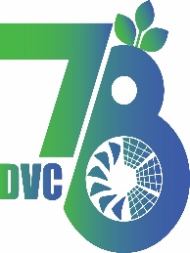
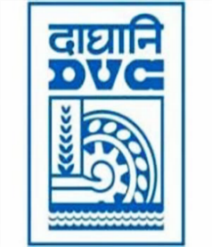
Damodar Valley Corporation
संविदा और सामग्री विभाग
Contracts and Materials Department
डीवीसी टावर्स; तृतीय तल; वीआइपी रोड; कोलकाता-७०००५४ टेली फ़ैक्स न०-०३३-२३५५-२९३६
DVC Towers; 3rd Floor; VIP Road, Kolkata – 700054 Tele fax No.-033 – 2355 –2936.

E-Tender Notice
Damodar Valley Corporation invites online bids (Open) from the eligible bidders for:
REFERENCE NO. | Description of item | Tender Downloading Period and Time
DVC NIT NO: DVC/Tender/Head Quarter/SPE/CMM//Works and Service/96929/REV 1 dated 27.03.2026  ****************************************  CPP Tender ID: - 2026_DVC_273239_1 | Supply, erection, testing and commissioning for shifting of 132 KV D/C NK-Patratu transmission line(L#81 and 82)  due to ash dyke area of PVUNL | From:  27.03.2026 at 14:00 Hrs. (IST)  To  06.04.2026 at 14:00 Hrs. (IST)  Pre-Bid: 30.03.2026 at 12:00 Hrs.

For further details and to participate in tender, please log on:
https://etenders.gov.in/eprocure/app

Note: For any Technical Queries call: - 0120-4200 462, 0120-4001 002, 0120-4001 005,
0120-6277 787

E-Mail Support: Technical support- eproc@nic.in

