Government of Karnataka
Public Works Department, Special Division, Hunsur
Short Term Item Rate Tender Notification No. 24/2025-26 Dated 20-03-2026 (Through KPP Portal)

On behalf of the Governor of Karnataka the Executive Engineer, Public Works Department, Special Division, Hunsur invites tenders one-procurement plat form from the eligible KPWD registered class-1 contractors, for the road construction works detailed in the table below in standard tender document KW4. The Tender Documents can be downloaded from 20-03-2026 from the websitehttps://kppp.karnataka.gov.in. Further details can be had from the office of the under signed during office hours.

Sl. No. | Name of work | Amount put to tender | E M D | Time allowed for completion of work | Last date for submission of  Filled tender documents in  KPP- portal (upto  16.00 hours)
1 | Construction of new Road From Ravandur Bettadapura Road Ch. 34.30 km (Foot of the Hill) to Sri Shidlumallikarjuna Swamy Temple in Bettadapura, Periyapatna Taluk, Mysore District  Indent No. PWD/2025-26/RD/WORK_INDENT33845 | Rs. 3833.61 Lakhs | Rs. 38.34 Lakhs | 18-Months (including rainy season) | 04-04-2026

No.EE:PWD:AE-1:Hun:IFT-24:2025-26 Dated: 20-03-2026
Sd/-
Executive Engineer
Public Works Department
Special Division, Hunsur

1. Copy submitted to The Chief Engineer,Communications & Buildings(South),Bengaluru for kind information.
2. Copy submitted to the Superintending Engineer, Mysore Circle,Mysore for kind information.
3. Copy to Assistant Executive Engineer, PWD Sub-division, Hunsur/K.R.Nagar/Periyapatna/H.D.Kote for information and to display the notification on the office notice board.
4. Copy to Executive Engineer’s table/Audit Officer/office notice board.
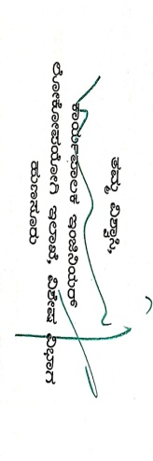

Executive Engineer
Public Works Department
Special Division, Hunsur
---------------------------------------------------------------------------------------------------------------------------------------------------------------------------------
Office of the Executive Engineer, Public Works Department, Special Division,Mysore-Bantwal Road,Hunsur PIN : 571105
Phone: 08222 251955 Fax :0821 252955 email: eehsr@kpwd.gov.inWeb:www.kpwd.gov.in

