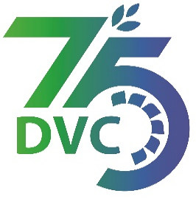
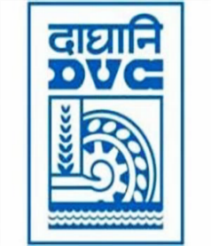
damaooadr GaaTI inagama
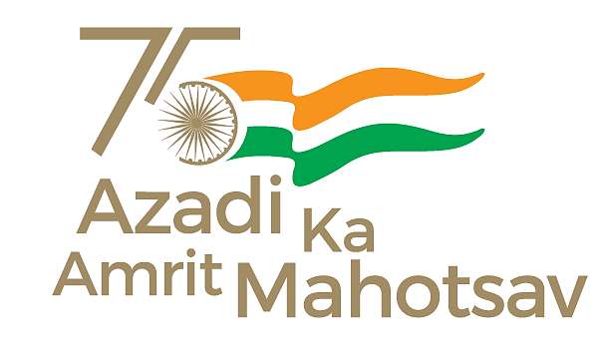
Damodar Valley Corporation
संविदा और सामग्री विभाग
Contracts and Materials Department
डीवीसी टावर्स; तृतीय तल; वीआइपी रोड; कोलकाता-७०००५४ टेली फ़ैक्स न०-०३३-२३५५-२९३६
DVC Towers; 3rd Floor; VIP Road, Kolkata – 700054 Tele fax No.-033 – 2355 –2936.

DAMODAR VALLEY CORPORATION
Contracts and Materials Department
DVC Towers; 3rd Floor; VIP Road, Kolkata – 700054
Tele fax No.-033 – 2355 –2936.

NO. DVC/Tender/Head Quarter/FUEL/CMM/Supply/00016/Capital Dated 23/03/2023
E-TENDER NOTICE

“THROUGH GeM PORTAL ONLY”

Sl. No. | NIT No. & Description of Work | Tender Downloading Time & Period
1. | NIT No. : GEM/2023/B/3280827 dated 23/03/2023  Description : Procurement of two (02) nos. of BOBRNHSM1 rakes along with two (02) nos. of BVCM for coal supply to MTPS, DVC | From 16:00 hrs of 23/03/2023 to 11:00 hrs of 20/04/2023
For further details and participate in the tender, please log https://gem.gov.in/
or www.dvc.gov.in [For view only]
for any help regarding the above tender contact to
GeM Customer care at https://gem.gov.in/contactUs

