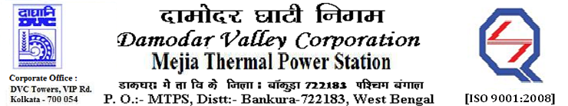
Phone No.: 03241- 263038FAX: 03241-262287

E-Tender Notices

Damodar Valley Corporation invites online bids with On-line reverse auction (RA) from eligible bidders for:

 | NIT No. | Description of Job (s) | Tender Downloading Period & Time
1. | MT/O&M/QSF-05-06-09/22-23/AA(003)/140 dated 10/11/2022 | ARC for day to day maintenance of to Generator, motorized actuators, DG Set, Electrical Cranes & Hoists, HT Bus duct, Battery Charger, Battery Bank & illumination system pertaining to Generator group for unit#1 to 6.
  From 10.05 Hrs. of 12.11.2022 to 11.30 Hrs. of 08.12.2022

For further details and to participate in the tender, please log on to DVC Website www.dvc.gov.in, and https://etenders.gov.in/eprocure/app
Note: e-procurement Helpdesk No. 9831683690 / Mob:8240124812 may please be contacted.

Your faith fully,

Sd/-

SmtArchana Lakra,
SE (Tech), MTPS, DVC,
[archana.lakra@dvc.gov.in],
Mob: 9432861534
Date: 12.11.2022

