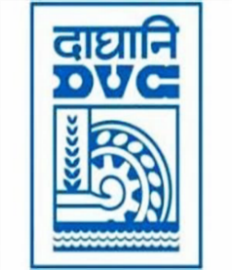
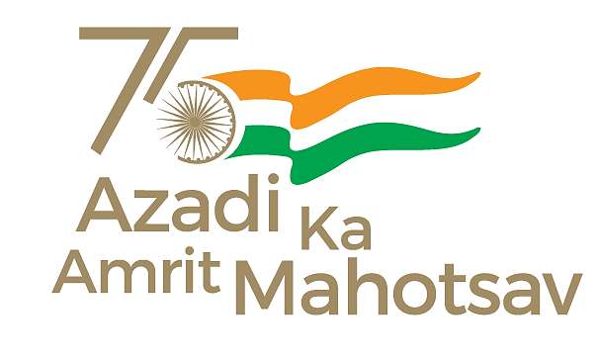
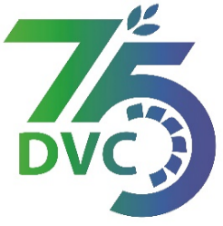
Damodar Valley Corporation
संविदा और सामग्री विभाग
Contracts and Materials Department
डीवीसी टावर्स; तृतीय तल; वीआइपी रोड; कोलकाता-७०००५४ टेली फ़ैक्स न०-०३३-२३५५-२९३६
DVC Towers; 3rd Floor; VIP Road, Kolkata – 700054 Tele fax No.-033 – 2355 –2936.

DAMODAR VALLEY CORPORATION
Contracts and Materials Department
DVC Towers; 3rd Floor; VIP Road, Kolkata – 700054
Tele fax No.-033 – 2355 –2936.

NO. DVC/Tender/Head Quarter/FUEL 1/CMM/Works and Service/00017 dated 06/06/2023
E-TENDER NOTICE

“THROUGH e-TENDERING PROCESS ONLY”

Sl. No. | NIT No. & Description of Work | Tender Downloading Time & Period
1. | NIT/Bid No. : GEM/2023/B/3535743 Dated 06/06 /2023  Description : Contract for Loading & Transportation of Coal by Road through dumper/ tipper from different collieries of ECL to MTPS, DVC Coal Yard in the distance slab of (31-70 Km) and (71-110 Km) for a period of One year  .  . | From 20:00 hrs of 06/06/2023 to 16:00 hrs of 23/06/2023
For further details and participate in the tender, please log https://gem.gov.in/
or www.dvc.gov.in [For view only]
for any help regarding the above tender contact to
GeM Customer care at https://gem.gov.in/contactUs
Mr. Nawajesh Rahman (Mob. No. 03366072327, 9831683690)

