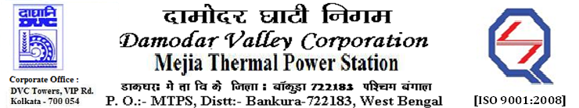
Phone No.: 03241- 263038FAX: 03241-262287

E-Tender Notice

Damodar Valley Corporation invites online bids with On-line reverse auction (RA) from eligible bidders for:

 | NIT No. | Description of Job (s) | Tender Downloading Period & Time
1. | MT/O&M/QSF-05-06-12/22-23/DBN (334)/113 dtd.27/07/2022 | AMC for operation & maintenance of Centralised AC System of New administrative building and MTPS  Unit # 4, 5 &6. | From 18:40Hrsof 27.07.2022 to  11.00 Hrs. of 23.08.2022

For further details and to participate in the tender, please log on to DVC Website www.dvc.gov.in, and https://etenders.gov.in/eprocure/app

Note: e-procurement Helpdesk No. 9831683690 / Mob:8240124812 may please be contacted.

Your faith fully,

Sd/-
ShriPradip Kumar Ghosh,
SE (C&M), Works, MTPS, DVC,
[pradip.ghosh@dvc.gov.in],
Mob: 9434745726

