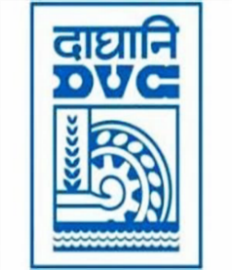
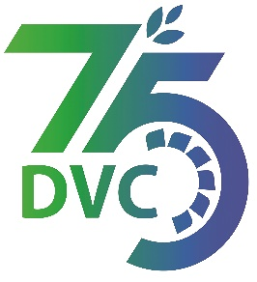
damaooadr GaaTI inagama
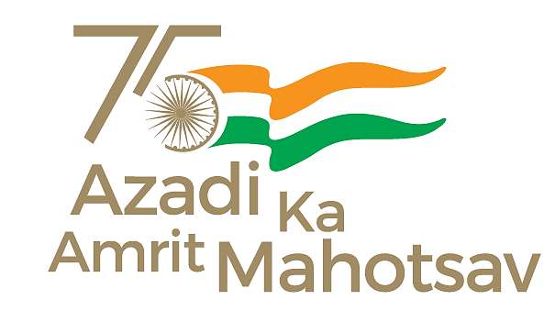
Damodar Valley Corporation
संविदाऔरसामग्रीविभाग
Contracts and Materials Department
डीवीसीटावर्स;तृतीयतल;वीआइपीरोड;कोलकाता-७०००५४टेलीफ़ैक्सन०-०३३-२३५५-२९३६
DVC Towers; 3rd Floor; VIP Road, Kolkata – 700054 Tele fax No.-033 – 2355 –2936.

E-Tender Notice
Damodar Valley Corporation invites online bids (Open Tender with E-Reverse Auction) from the eligible bidders for:
REFERENCE NO. | Description of item | Tender Downloading Period and Time
DVC NIT NO:- DVC/Tender/Head Quarter/SPE/CMM/Works and Service/00069/Capital dated 17/12/2024. ***************************  CPPTender ID:- 2024_DVC_219928_1 | Supply, Erection, Testing and Commissioning for Diversion/Shifting of 132 KV lines due to construction of new unit 1x800MW at DTPS  . | From:  17.12.2024 at 18.00 Hrs.(IST)  TO  14.01.2025 at 12.00 Hrs.(IST)

For further details and to participate in tender, please log on:
https://etenders.gov.in/eprocure/app

Note: For any Technical Queries call:-0120-4200 462, 0120-4001 002, 0120-4001 005,
0120-6277 787.
E-Mail Support:Technical - support-eproc(at)nic(dot)in

