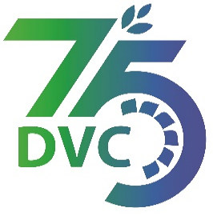

damaooadr GaaTI inagama
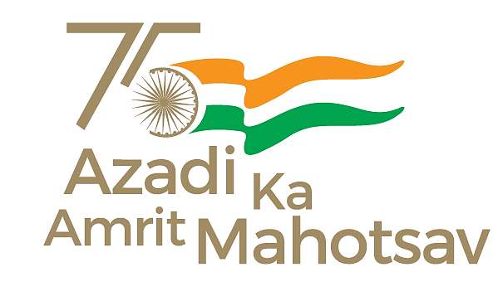
Damodar Valley Corporation
संविदा और सामग्री विभाग
Contracts and Materials Department
डीवीसी टावर्स; तृतीय तल; वीआइपी रोड; कोलकाता-७०००५४ टेली फ़ैक्स न०-०३३-२३५५-२९३६
DVC Towers; 3rd Floor; VIP Road, Kolkata – 700054 Tele fax No.-033 – 2355 –2936.

DAMODAR VALLEY CORPORATION
Contracts and Materials Department
DVC Towers; 3rd Floor; VIP Road, Kolkata – 700054
Tele fax No.-033 – 2355 –2936.

NO. DVC/Tender/Head Quarter/PROJ-TUBED-COAL MINING/CMM/Works and Service/00006/Capital
Date: 06/03/2023
E-TENDER NOTICE

Sl. No. | NIT No. & Description of Work | Tender Downloading Time & Period
1. | NIT No. : DVC/Tender/Head Quarter/PROJ-TUBED-COAL MINING/CMM/Works and Service/00006/Capital Date: 06/03/2023  Description : EOI for Hiring/engagement of Independent Engineer for a period of three (03) years for Tubed Coal Mines, Latehar, Jharkhand | From 15:00 hrs of 06/03/2023 to 12:00 hrs of 03/04/2023
For further details and participate in the tender, please log https://etenders.gov.in/eprocure/app
or www.dvc.gov.in [For view only]
for any help regarding the above tender contact to
Mr. Nawajesh Rahman (Mob. No. 03366072327, 9831683690)

(Naresh Prasad Mandal)
DCE(C&M)
—rs ,oa nk?kkfu ds fy,@For & on behalf of DVC

