
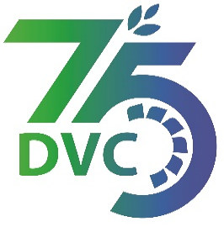
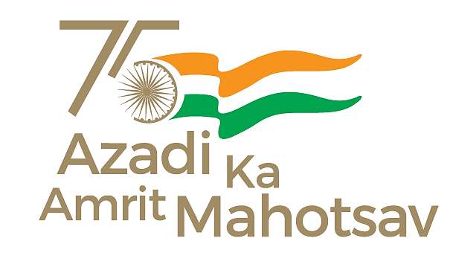
Damodar Valley Corporation
संविदा और सामग्री विभाग
Contracts and Materials Department
डीवीसी टावर्स; तृतीय तल; वीआइपी रोड; कोलकाता-७०००५४ टेली फ़ैक्स न०-०३३-२३५५-२९३६
DVC Towers; 3rd Floor; VIP Road, Kolkata – 700054 Tele fax No.-033 – 2355 –2936.

DAMODAR VALLEY CORPORATION
Contracts and Materials Department
DVC Towers; 3rd Floor; VIP Road, Kolkata – 700054
Tele fax No.-033 – 2355 –2936.

NO. GEM/2024/B/4442658 dated 05/01/2024
E-TENDER NOTICE

“THROUGH e-TENDERING PROCESS ONLY”

Sl. No. | NIT No. & Description of Work | Tender Downloading Time & Period
1. | NIT/Bid No. : GEM/2024/B/4442658 Dated: 05-01-2024  Description : Implementation of Access control in BTG and Switchyard Control Room of DVC stations.  . | upto 16:00 hrs of 02/02/2024
For further details and participate in the tender, please log GeM Portal or www.dvc.gov.in [For view only]

