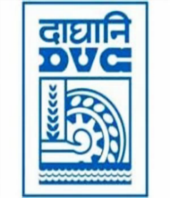

Damodar Valley Corporation
संविदा और सामग्री विभाग
Contracts and Materials Department
डीवीसी टावर्स; तृतीय तल; वीआइपी रोड; कोलकाता-७०००५४ टेली फ़ैक्स न०-०३३-२३५५-२९३६
DVC Towers; 3rd Floor; VIP Road, Kolkata – 700054 Tele fax No.-033 – 2355 –2936.

DAMODAR VALLEY CORPORATION
Contracts and Materials Department
DVC Towers; 3rd Floor; VIP Road, Kolkata – 700054
Tele fax No.-033 – 2355 –2936.

NO. GEM/2024/B/4607940 Dated: 16-02-2024
E-TENDER NOTICE

“THROUGH e-TENDERING PROCESS ONLY”

Sl. No. | NIT No. & Description of Work | Tender Downloading Time & Period
1. | NIT/Bid No. : GEM/2024/B/4607940 Dated: 16-02-2024  Description : Procurement of Ferric Alum Grade-I & Grade-IV conforming to IS 299 (Latest) for different field formations of DVC  . | upto 16:00 hrs of 15/03/2024
For further details and participate in the tender, please log GeM Portal or www.dvc.gov.in [For view only]

