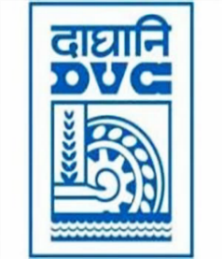
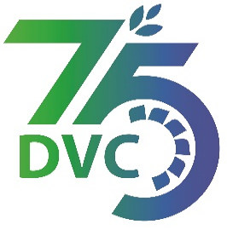
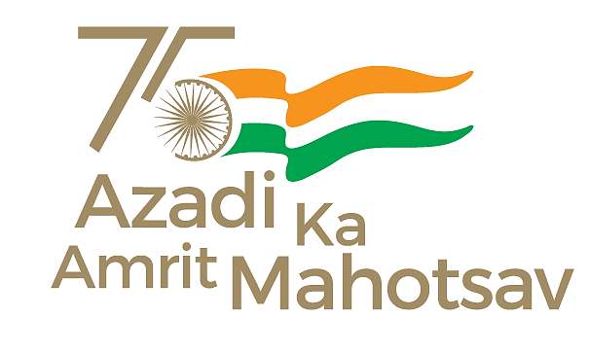
Damodar Valley Corporation
संविदा और सामग्री विभाग
Contracts and Materials Department
डीवीसी टावर्स; तृतीय तल; वीआइपी रोड; कोलकाता-७०००५४ टेली फ़ैक्स न०-०३३-२३५५-२९३६
DVC Towers; 3rd Floor; VIP Road, Kolkata – 700054 Tele fax No.-033 – 2355 –2936.

DAMODAR VALLEY CORPORATION
Contracts and Materials Department
DVC Towers; 3rd Floor; VIP Road, Kolkata – 700054
Tele fax No.-033 – 2355 –2936.

NO. DVC/Tender/Head Quarter/FUEL 1/CMM/Works and Service/00015 dated 03/05/2023
E-TENDER NOTICE

“THROUGH GeM portal ONLY”

Sl. No. | NIT No. & Description of Work | Tender Downloading Time & Period
1. | NIT/Bid No. : GEM/2023/B/3391427 Dated 03/05/2023  Description : Annual Contract for loading & transportation of coal by road with dumper/ tipper from different collieries of CCL/ Bermo Mines to BTPS Coal Yard in the distance slab of (08-20 km and 21-30 km)”.  . | From 16:00 hrs of 03/05/2023 to 12:00 hrs of 31/05/2023
For further details and participate in the tender, please log https://gem.gov.in/
or www.dvc.gov.in [For view only]
for any help regarding the above tender contact to
GeM Customer care at https://gem.gov.in/contactUs
Mr. Nawajesh Rahman (Mob. No. 03366072327, 9831683690)

