INVITATION FOR TENDERS (IFT)
KARNATAKA NEERAVARI NIGAM LIMITED
(A Government of Karnataka Enterprises)
Office of the Executive Engineer, KNNL, Canal Division No.5,Yeramarus Camp.
.
IFT No.: -/---------, Dated:
Through e –procurement
- The Executive Engineer, KNNL, Canal Division No.5, Yeramarus Camp invites Turnkey tenders on behalf of Managing Director, KNNL, Bengaluru, from eligible tenderers, for the construction of works detailed in the Table below.The tenderers may submit tenders for any or all of the works given in the Table. “Two Electronic Tender procedure as per Rule 28 of the KTPP Act shall be followed. The Tenderers are required to submit two separate sealed covers, one containing the Earnest money deposit and the details of their capability to undertake the tender (as detailed in ITT Clause 3 and 6), which will be opened first and the second cover containing the price tender which will be opened only if the Tenderer is found to be qualified to execute the tendered works. The Tenderers are advised to note the minimum qualification criteria specified in Clause 3 of the Instructions to Tenderers to qualify for award of the contract”.
- Tender documents may be downloaded from Government of Karnataka e-Procurement website https://eproc.karnataka.gov.in/eportal/index.seamunder login for Contractors:
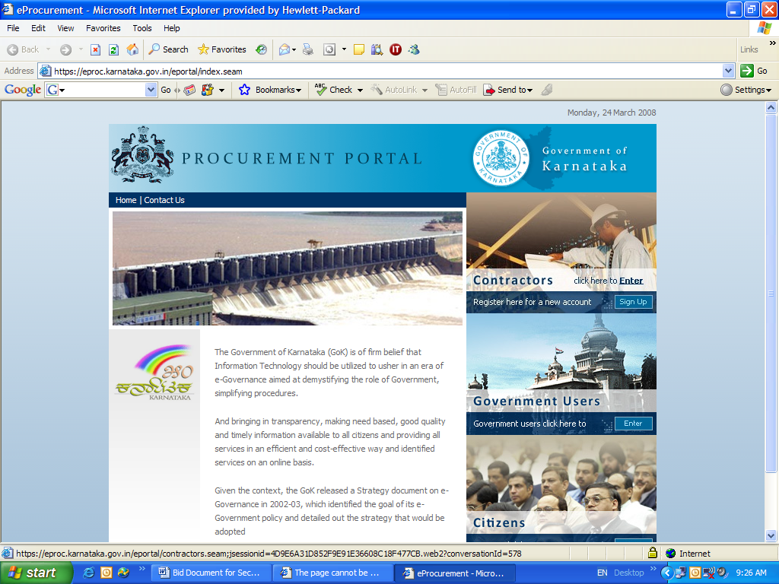
After login the Contractor has to, scroll down to the right-side bottom to see List of Tenders, click there to find the details of NIT and download copy of the tender. The tender can be downloaded in the portal as per prescribed date and time published in the portal. Only Interested Contractors who wish to participate should remit online transaction fee for tender after registering in the portal. The transaction fee is non-refundable.
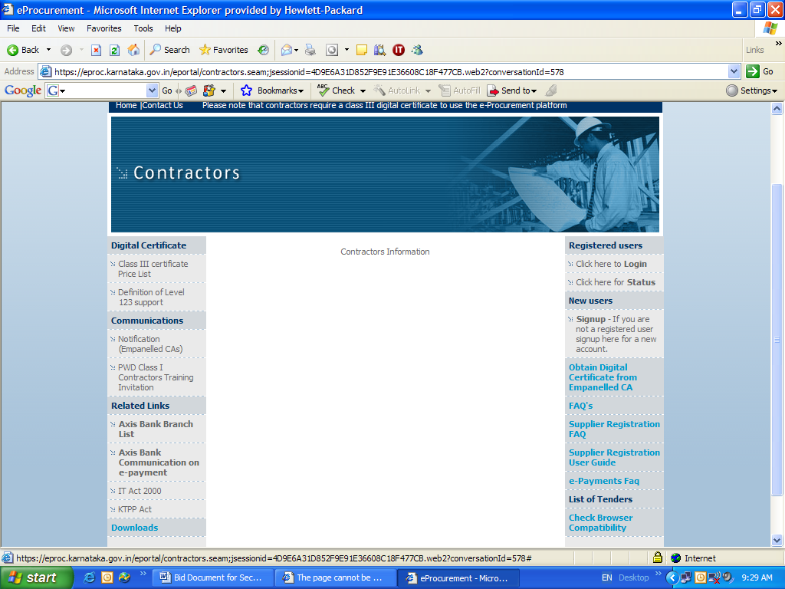
- Tenders must be accompanied by earnest money deposit which will be paid online through e-Procurement portal as in Table below.
- Tenderers must submit Electronic Tender Documents One and Two electronically (on-line through internet) within the date and time published in e-procurement portal.
First Electronic Document (Technical Bid) shall contain the following qualification documents.
For individual Bidders
- Copy of the valid KPWD/CPWD Class I Registration Certificate
- Copy of the valid Employees Provident Fund Registration Certificate along with latest paid challan copy.
- Copy of the valid GST Certificate & PAN Card.
- Income tax returns of last 5 years.
- The intending bidder/firm/company should furnish list of Man power, machinery available with them for taking up the work.
For Joint Venture
- The individual bidders of joint venture should be enrolled as KPWD/CPWD Class-1 registration contractor separately. A copy of valid KPWD/CPWD Class-1 registration certificate of individual bidders of joint venture should be uploaded.
- Copy of Valid Employees Provident Fund Registration Certificate along with latest paid challan copy.
- Copy of Valid GST Registration Certificate.
- Income tax returns of last 5 years.
- The intending bidder/firm/company should furnish list of Man power, machinery available with them for taking up the work.
- The joint venture (JV) of the individual bidders shall be formed prior to the bidding and necessary agreement for having joint venture before bidding should be uploaded.
- The lead partner should have at least 51% partnership.
Second Electronic Document (Financial Bid) shall contain the following qualification documents.
- The tender (in the format indicated in section 4)
- Priced bill of quantities
First Electronic Tender (technical bid) will be opened at prescribed time and date in the e-procurement portal, in the presence of the Tenderers who wish to attend at the Office of the Executive Executive Engineer, KNNL, Canal Division No.5, Yeramarus Camp.
Second Electronic Document (financial bid) will be opened only of those bidders who qualify in the technical bid. In case the lowest bidder fails to produce the original documents for entering into an agreement or the original documents submitted does not match with the uploaded documents or found false, then his bid is treated as non-responsive bid as per clause -26(4) of the KTPP rules and barred from participation in any of the tenders invited by the nigam apart from forfeiting the EMD paid through E-cash.
- A Pre-tender meeting will be held on --------date------at ----------Hrs. at the office of the ChiefEngineer, KNNL,Irrigation CentralZone, Munirabad, to clarify the issues if any, and to answer questions on any matter that may be raised at that stage as stated in Clause 8.2 of ‘Instructions to Tenderers’ of the tender document. The Contractor may seek clarification through e-procurement portal or through email to tender inviting authorities. The clarification will be published in the e-Procurement portal by uploading the clarifications.
- Other details can be seen in the tender documents.
Sl. No. | Name of Work | Approximate amount put to tender (Rs. In Crores) |  |  | EMD  (Rs in Crores) | Tender Processing Fee (Non refundable) | Stipulated period for Completion | Category of Contractor Eligible
Sl. No. | Name of Work | Part-A Work portion | Part-B  GST | Total
1 | 2 | 3 | 4 | 5 | 6 | 7 | 8 | 9
1 | “Survey, Investigation, Design, Supply, Installation, Testing and Commissioning of Lift Irrigation System (Head Works consisting of construction of Intake Canal, Jack well cum pump house, Vertical Turbine Pumps coupled to HT Motors, Pump house Electrical works, Necessary valves, Delivery Pipe, Manifold system, Power supply including 110 KV /33 KV transformer bay, terminal bay, 33 KV Electrical Sub Station, Transmission line, Raising Main, Pressure Distribution) for filling up of Basappa tank in Gunjalli Village & other tanks of Raichur taluk by lifting water from Tungabhadra River near Chikkamanchale village including Operation and Maintenance for a period of 5 years after successful completion of work for GUNJALLI(BASAPPA) TANK FILLING SCHEMEon Turn-Key Basis.” | 119.71 | 21.55 | 141.25 | 1.41 | As specified in the e-procurement portal | 18 Months (including Monsoon) | KPWD/  CPWD Class-1 registration
Any details/information can be had from the web site www.eproc.karnataka.gov.in

The detailed tender notification is as under


KARNATAKA NEERAVARI NIGAM LIMITED
(A Government of Karnataka Enterprise)
Office of the Executive Engineer, KNNL,Canal Division No.5,Yeramarus Camp.
Telephone: 08532 251105 Email: ee5.divisionyer@gmail.com
No: EE/KNNL/1095 Dated:02.01.2024
TENDER NOTIFICATION
On behalf of the Managing Director Karnataka Neeravari Nigama Limited, Bangalore, the Executive Engineer, KNNL,Canal Division No.5, Yeramarus Camp.Karnataka invites tenders on LUMPSUM TURN-KEY basis on e-procurement portal for the following work from registered as Class -1 Contractor in KPWD/CPWD.
The two tender document submission procedure as per Rule 28 of KTPP Act shall be followed. The bidders are requested to submit their bids in two tender document system including EMD in e-cash. The first Electronic document (Technical Bid) should contain the documents as mentioned in Para 1.1.The Second Electronic document shall contain the financial bid. The first Electronic document (Technical bid) will be opened first, thereafter Second Electronic document (financial bid) of only those bidders who have paid the requisite EMD and fulfill the conditions contained in Para.1.1 will be opened.
The blank tender documents can be obtained through website www.eproc.karnataka.gov.inand can be submitted through electronic tender only.
The Details of work put to tender are as follows:
SI.No | Name of Work | Indent No | Amount put to Tender in  (Rs. In Crores) |  |  | EMD Amount in(Rs. In Crores) | Eligibility | Stipulated period of completion (including monsoon)
SI.No | Name of Work | Indent No | Part-A Work Portion | Part-B GST  (18%) | Total | EMD Amount in(Rs. In Crores) | Eligibility | Stipulated period of completion (including monsoon)
1 | 2 | 3 | 4 | 5 | 6 | 7 | 8 | 9
1 | “Survey, Investigation, Design, Supply, Installation, Testing and Commissioning of Lift Irrigation System (Head Works consisting of construction of Intake Canal, Jack well cum pump house, Vertical Turbine Pumps coupled to HT Motors, Pump house Electrical works, Necessary valves, Delivery Pipe, Manifold system, Power supply including 110 KV /33 KV transformer bay, terminal bay, 33 KV Electrical Sub Station, Transmission line, Raising Main, Pressure Distribution) for filling up of Basappa tank in Gunjalli Village & other tanks of Raichur taluk by lifting water from Tungabhadra River near Chikkamanchale village including Operation and Maintenance for a period of 5 years after successful completion of work for GUNJALLI(BASAPPA) TANK FILLING SCHEMEon Turn-Key Basis.” | 584 | 119.71 | 21.55 | 141.25 | 1.41 | KPWD/  CPWD Class-1 registration | 18 Months (including Monsoon)
Note:
- The amount put to tender consist of the following.
a) Turn Key Amount excluding GST: Rs. 119.71 Crores. The bidder should quote for this amount.
b) GST Amount Rs. 21.55 Crores.
c) Total Amount: Rs. 141.25 Crores.
Quoted amount is exclusive of all deposits and supervision charges of GESCOM and Land Acquisition cost. The amount will be paid by the Nigam.
- Instructions to Bidders
The bids should submitted in two covers
  - FIRST ELECTRONIC DOCUMENT (TECHNICAL BID) SHALL CONTAIN THE FOLLOWING QUALIFYING DOCUMENTS:-
For Individual Bidders
- A copy of the PWD/CPWD Class –I Registration Certificate.
- Copy of Valid Employees Provident Fund Registration Certificate with recently paid challan copy.
- Copy of Valid GST Registration Certificate & PAN card
- The intending bidder/firm/company should furnish list of Man power, machinery available with them for taking up the work as per section 3.
- The details in support of qualification criteria as mentioned in para 4.0 below.
- Technical details containing document with preliminary designs, working methodology in support of their bid as per the bidding document.
For Joint Venture
- A copy of the Karnataka PWD Class –I Registration Certificate.
- Copy of Valid Employees Provident Fund Registration Certificate.
- Copy of Valid GST Registration Certificate.
- The intending bidder/firm/company should furnish list of Man power, machinery available with them for taking up the work as per section 3.
- The details in support of qualification criteria as mentioned in para 4.0 below.
- Technical details containing document with preliminary designs, working methodology in support of their bid as per the bidding document.
- The joint venture (JV) of the individual bidders shall be formed prior to the bidding and necessary agreement for having joint venture before bidding should be uploaded.
- The individual bidders of joint venture should be Class I Contractor registered in Karnataka PWD separately. A copy of valid Karnataka PWD Class Iregistration certificate of individual bidders of joint venture should be uploaded.
- The number of JVs shall not exceed 3.
- All the partners should have achieved in at least two financial years 25% of prescribed annual turnover (Qualification criteria) in the last 5 years (i.e., 2019-20 to 2023-24).
- In case of JV all the partner are jointly and severally responsible for successful performance of the contract
- The lead partner shall enter in to a joint venture agreement on Rs. 200 stamp Paper in the prescribed format which shall be concluded prior to bidding and enclosed to the bid document and submit along with the request for bid document.
- One of the partners of JV (Lead Partner) shall be duly authorized with a legally binding power of attorney to apply for tender forms and to sign the tender and to make further correspondences and deal with KNNL on behalf of JV
2.0 Second Electronic Document shall contain financial Bid.
The First Electronic Document (Technical bid) will be opened first and thereafter Second Electronic Document (financial bid) will be opened only of those bidders who qualify in the technical bid. In case the lowest bidder fails to produce the original documents for entering into an agreement or the original documents submitted does not match with the uploaded documents or found false, then his bid is treated as non-responsive bid as per clause -26(4) of the KTPP rules & his name would be recommended for cancellation of registration in Karnataka PWD and barred from participation in any of the tenders invited by the KNNL apart from forfeiting the EMD paid through E-cash.
3.0. Issue and submission of Tender Documents.
3.1. E-Procurement
3.1.1. The bidders can access and download blank tender document and submit their bidsthroughe-procurement from onward up to 4.00 PM in the E-procurement website www.eproc.karnataka.gov.in on payment (non-refundable) of such amount as prescribed in the e-procurement portal for the work towards transaction fee. The bidders can pay the transaction fee in the e-procurement portal using any of the following payment modes.
- Credit cards
- Direct debit
- National electronic fund transfer (NEFT)
- Over the counter (OTC) on or before up to 5.00 PM
3.1.2. The Pre–bid meeting will be held on 08.01.2024 at 11.00 AM in the office of the Managing Director, Karnataka Neeravari Nigam Ltd, 4th floor, Coffee Board, No 1 Dr B.R Ambedkar veedhi, Bangalore. The queries if any are to be sent not later than on by the intending bidders through e-mail to the Executive Engineer (the e-mail id for sending queries iseerandrdnatn@gmail.com.
3.1.3 Last Date & Time for tender queries / Clarifications is 10.01.2024 up to 05.30 PM
3.1.4 Last Date for Submission of completed e tendering documents is on 10.01.2024 up to 4.00 PM.
3.1.5 First Electronic Document (Technical BID) will be opened on 11.01.2024 at 11.00 AM in the Presence of the Bidders who wish to participate.
3.1.6 Second Electronic Document (financial Bid) (16.01.2023) of the successful bidders who qualify in the technical bid will be opened after approval to the technical bid from the competent authority.
3.1.7 The necessary certificates/documents in support of pre-qualification criteria fulfilled as stipulated shall be scanned and attached to e-tender document. The scanned signature of the bidder /authorized representatives of the bidder shall be attached while uploading the bid document.
3.1.8 Further information about e-tendering can be had from http//eproc.karnataka.gov.in/e-portal /lines. Seam.
4.0. Qualification Criteria: (for Individual bidders/ Joint Venture Bidding).
- The intending bidder can submit bids as an Individual/ Joint Venture bidder along with Tie –up of pump manufacturer. The Tie –up is to be formed prior to the bidding. In case of Joint Venture bidding, the lead partner should have at least 51% partnership.
Tenders from a Tie-up proposed in this bid, the bidder shall upload an agreement with only one pump manufacturer on Rs 200-00 stamp paper in the prescribed format which shall be concluded prior to bidding and enclosed to the bid document. For proof of the Tie up, in the Technical bid, the prescribed format under section 2 - instruction to tenderer (ITT) shall be followed.
- The qualification criteria can be satisfied by individually or JV (adding collectively the credentials of all JV partners). All the partners should have achieved at least 25% of prescribed annual turnover (Qualification criteria).
- To qualify for award of this contract, each tenderer in his / her name should have achieved. Inthe last five years (i.e., 2018-19 to 2022-23).should have satisfactorily completed (at least 90% of contract value) as a prime contractor, at least one lift irrigation scheme of value not less than Rs.70.63 crores. Work done certificate issued by an officer not below the rank of EE of the concerned division and countersigned by the SE of the concerned circle is to be uploaded for the technical bid. The cost of completed works of the previous year shall be given a weightage of 10% per year to bring it to the price level of financial year in which tenders are invited.
- The annual turnover from all classes of civil engineering works should be costing not less thanRs.188.34 crores, in any of the two financial years during the last five years (i.e., 2018-19 to 2022-23). In case of JV, the lead partner should have achieved 50% of the prescribed annual turnover. Audited profit and loss account certified by a practicing Chartered Accountant along with the copy of income tax returns filed for the years indicated above should be furnished. Duly mentioning UDIN on Turnover certificate (from CA). (The annual turnover of previous year shall be updated to the year of tender invitation at 10% per annum).
- Liquid asset and/or availability of credit facilities of not less than Rs.23.54 crores (unconditional credit lines/letters of credits/certificates from nationalized/scheduled banks) for meeting the fund requirement etc. The contractor should upload necessary documents issued by the nationalised/scheduled banks as per prescribed format enclosed as Annexure – XIV.
- The intending Bidder (Individual/JV)/Tie-up partner should have supplied and successfully commissioned at least 2 numbers of VT pumps with a capacity (flow rate) not less than
0.5 cumecs for each pump with a head not less than 100 m for each pump during the last 5 years (i.e., from 2018-19 to 2022-23). The necessary work done certificate issued by an officer not below the rank of EE and countersigned by the SE of the same circle should be uploaded.
- The intending bidder(Individual/JV) should have supplied, erected, tested, completed and commissioned MS pipes not less than 315 mm outer diameter for a length of at least 12 kms in any one year during last 5 years (i.e., from 2018-19 to 2022-23). The work done certificate should be obtained from a competent authority not below the rank of EE of the concerned division and countersigned by the SE of the concerned circle.
- The intending bidder(Individual/JV) should have supplied, erected, tested, completed and commissioned HDPE pipes not less than 200 mm diameter for a length of at least 12 kms in any one year during last 5 years (i.e., from 2018-19 to 2022-23). The work done certificate should be obtained from a competent authority not below the rank of EE of the concerned division and countersigned by the SE of the concerned circle.
- The intending bidder (Individual/JV)/tie-up partner should have executed in any one year, the following minimum quantities of work during the last 5 years (i.e., from 2018-19 to 2022-23). The necessary work done certificate issued by an officer not below the rank of EE and countersigned by the SE of the same circle should be uploaded.
Sl. No. | Item | Quantity
 | Earthwork Excavation | 1,02,200 Cum
 | Reinforced Cement Concrete (M-15 Grade and above) | 2,900 Cum
 | Reinforcement steel bars for RCC works | 330 MT
- BID CAPACITY
Tenderers who meet the above specified minimum qualifying criteria, will only be qualified, if their available tender capacity is more than the total tender value. The available tender capacity will be calculated as under:
Assessed available tender capacity = (A*N*1.5 - B)
Where;
A =Maximum value of civil engineering works executed in any one year during the last five years (updated to 2023-24 price level) taking into account the completed as well as works in progress.
N =Number of years prescribed for completion of the works for which tenders are invited.
B = Value, at 2023-24 price level, of existing commitments and on-going works to be completed during the next two years (period of completion of the works for which Tenders are invited)*.
“If a bidder participates in more than one bid and technically qualifies and subsequently becomes lowest in more number of bids than his/her bid capacity, then the tenderer can give his option to select the works based on his/her preference equivalent to his bid capacity. Further for the balance bids next lowest bidders will be eligible to accept at lowest bidders rates equivalent to their bid capacity provided if the competent authority accepts it.”
Note: The statements showing the value of existing commitments and on-going works as well as the stipulated period of completion remaining for each of the works listed should be countersigned by the the Employer in charge, not below the rank of an Executive Engineer or equivalent.
Even though the Tenderers meet the above criteria, they are subject to be disqualified if they have:
- made misleading or false representations in the forms, statements and attachments submitted in proof of the qualification requirements; and/or
- record of poor performance such as abandoning the works, not properly completing the contract, inordinate delays in completion, litigation history, or financial failures etc.; and/or
- participated in the previous Tender for the same work and had quoted unreasonably high tender prices and could not furnish rational justification.
5.0 General Conditions:
- The bid shall be technically evaluated based on the specifications indicated in Section-3 titled “Qualification information” in bid document.
- The Bidder/JV partner/ Tie up partner shall not be under Corporate Debt Restructuring (CDR) / Strategic Debt Restructuring (SDR) or Bureau of Industrial and Financial Reconstruction (BIFR) in the last 5 Years prior to bid submission date. In this regard, the Bidder shall submit along with Bid, a certificate from their Statutory Auditor with a declaration that, the Bidder is not under CDR / SDR or BIFR.
- Bids not satisfying minimum duty point parameters, efficiency parameters of pumps and motors and velocity parameters as specified in bid document shall be rejected.
- During technical evaluation, if the employer finds that any certificates / information furnished is false, such bidders will be disqualified and barred from participation in the bid.
- If any bidder fails to satisfy the conditions mentioned above, such bids will be rejected and their financial bids will not be opened.
- For laying M.S. pipe line the contractor shall engage only those agencies who have done similar job.
- The bidder should enclose the detailed methodology of execution of the scheme as per the scope of work.
- The Bidder shall be responsible for successful performance of the contract.
- For construction of Transmission line/Substation Works, the contractor shall engage only those agencies who are licensed to do the power line construction works in Karnataka. They should have constructed at least one similar single power line equal to 80% of the length of power line for the work tendered in a single contract. The details of the transmission line construction contractor with registration certificate and certificates of experience signed by an officer of not below the rank of Executive Engineer of KPTCL shall be submitted for KNNL’s verification post award of the work.
- The Bidder to participate in the tender under single bid basis only. Any violation will attract disqualification of the bid.
- The pump manufacturer shall not enter into Tie-up with more than one bidder.
- The contractor/authorized signatory should attach his/her scanned signature to the Schedule-B before uploading and also submitting their tenders.
- If any of the dates mentioned above happen to be a general holiday, the next working day holds good.
- The work of the construction of transmission line should be got done through a Government Licensed, Super Grade Electrical contractor CEIG approved, who have the experience of carrying out such works.
- The diameters of the rising main and thickness of the rising main shall not be less than the figures indicated in the enclosed schematic diagram. Further any discrepancies in the above shall not account to financial implications to the employer.
- Further information can be had from the undersigned during office hours on Telephone No: 08532 251105
- Conditional tenders are liable to be rejected. The officer competent to accept the tender shall have the right to reject any or all the tenders without assigning any reason whatsoever.
- Corrigendum will be published in the web site/ newspapers of all modifications /corrections if any.
- The intending bidders should note that, if any of lands either in part/ parts or in whole required for the work is not acquired by the Nigam, it shall be the responsibility of the bidder to take the possession of such land and start the work by obtaining consent of the land owners before commencement of work at no extra cost to the Nigam and no claim / delays whatsoever relating to on account of non-availability of land would be entertained.
- If the percentage quoted by the contractor for the work is below ninety percent of the updated recast estimated amount put to tender, then the contractor shall furnish an “additional performance security” in the form of Bank Guarantee for an amount equivalent to the difference between the cost as per quoted percentage and 90% of the updated cost put to tender. In case of contractor quoting above 125% of updated cost put to tender, then the over and above 125% of the updated cost put to tender will be withheld during the progress of work. The additional performance will be released proportionately to the bill amount till the contractor achieves progress of the entire cost of the work as per agreement. The withheld amount in the later case will be released only after entire work contracted is fully completed and so certified by the Executive Engineer.(If BG submitted while issuing fresh BG or extending any existing BG, claim period of a minimum one year from the date of expiry of validity period of BG is to be specified invariably)
- They should abide by the directions of Government towards recovery of 1% (or as modified by the Government from time to time) Cess from the contractor’s bill under the provisions of building and other constructions worker welfare cess Act 1996.
- The intending bidders are advised to visit the site of work, make themselves familiar with local situation about the availability of construction materials, work men, land required for construction activities, etc and shall upload along with bid with details of references for visit of different parts of the scheme in the form of photographs of site.
- The contractor is responsible for any damages due to natural calamity the government or Nigam will not give any compensation for until the completion of maintenance period.
- The work proposed as per the scope of work is off-taking from Tungabhadra River near Chikkamanchali village of Raichur taluk & district . If any additions/alteration involved for during execution, it is the responsibility of the agency to deliver the goods as per contemplated scope of the work without causing any damages to existing infrastructure. If any damages occur during execution, the same shall be restored to the original condition at no extra cost.
- The intending bidder/firm/company are advised to visit the work site before submission of the tenders.
- The contractor should mention their recent correct portal address & mail address in declaration forms.
- The tender processing charges paid by the bidder/firm/company are not refundable even if the tender is cancelled.
- All materials like steel, cement, MS pipe etc., required for successful completion of the above work should be procured by the contractor only. No supply of any materials shall be made by KNNL.
- The bidder/firm/company shall send the authorization letter for their representation duly attesting their signature.
- Maintenance period/Defect liability period for this work is 60 months from the date of completion of work.
- The bidder/firm/company shall adhere to accepted execution plan submitted by him under any circumstances without linking to the pending payment of the work & also land acquisition problems if any.
- Typographical errors if any will not be the ground for any claims by the bidder/firm/company.
- The amount put to tender is exclusive of GST. GST will be paid to the tendered amount separately as per prevailing rates. The contractor shall quote the rates excluding GST.
- The contractor shall also abide by the other conditions as laid down in Bid document.
Executive Engineer,
KNNL, Canal Division No.5,
Yeramarus Camp.

Copy submitted for kind information to:
- The Secretary, Water Resources Department, IIIrd floor, Vikas Soudha, Bengaluru- 560001 for kind information.
- The Managing Director, KNNL:, Coffee Board, IVth floorfloor, Dr. B. R Ambedkar Veedhi, Bengaluru-560 001 for kind information.
- The Chief Engineer, KNNL,Irrigation Central Zone,Munirabad. for kind information.
- The Inspector General of Police (Vigilance) Irrigation Department, Basava Bhavana, 4th Floor, Bengaluru for favour of kind information.
- The Directorate General of Commercial Intelligence and Statistics, Ministry of Commerce and Industry, Govt. of India, 565, Anandapur, Sector-1, Plot No.22 ECADP, Kolkata-700 107 with a request to publish the Notification in the Indian Trade Journal.
- The Chief Administrative Officer, Central office of KNNL, Vijaya complex, Srinagar circle, haliyal Road Dharawad.
- The Chief Accounts Officer, Central office of KNNL, Vijaya complex, Srinagar circle, haliyal Road Dharwad.
- The Superintending Engineer,KNNL,Tungabhadra Canal Construction Circle,Yeramarus Camp.for Kind information and further needful.
- The Executive Engineers coming under this zone for for Kind information and further needful.
- The Marketing Communication and Advertising Ltd, Raichur. requesting to publish in Kannada and English in daily news paper.
- The Marketing Communication and Advertising Ltd, Indian trade journal, Kolkatta requesting to publish in daily news paper.
II) Copy forward to the.
- Copy to EE’s table/ TA/Audit Officer in Division Office for information.
- Copy to Office Notice Board.
Executive Engineer,
KNNL, Canal Division No.5,
Yeramarus Camp.


Executive Engineer,
KNNL, Canal Division No.5,
Yeramarus Camp.

