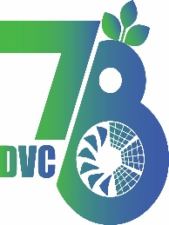
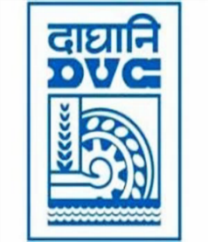
Damodar Valley Corporation
संविदा और सामग्री विभाग
Contracts and Materials Department
डीवीसी टावर्स; तृतीय तल; वीआइपी रोड; कोलकाता-७०००५४ टेली फ़ैक्स न०-०३३-२३५५-२९३६
DVC Towers; 3rd Floor; VIP Road, Kolkata – 700054 Tele fax No.-033 – 2355 –2936.

E-Tender Notice
Damodar Valley Corporation invites online bids (Open with reverse e-auction) from the eligible bidders for:
REFERENCE NO. | Description of item | Tender Downloading Period and Time
DVC NIT NO: - DVC/Tender/Head Quarter/SPE/CMM/Supply/78151 dated 13.01.2026  ****************************************  CPP Tender ID: - 2026_DVC_262693_1 | ARC for Design, Engineering, Supply, Erection including Civil Works, Testing, Commissioning of construction of new lines/diversion of existing lines/cons of new 33KV Bay/refurbishment existing 33KV bay to effect power evacuation/power supply to consumers in DVC | From:  13.01.2026 at 12:00 Hrs. (IST)  To  10.02.2026 at 12.00 Hrs. (IST)

For further details and to participate in tender, please log on:
https://etenders.gov.in/eprocure/app

Note: For any Technical Queries call: - 0120-4200 462, 0120-4001 002, 0120-4001 005,
0120-6277 787

E-Mail Support: Technical support- eproc@nic.in

