BY SPEED POST/FAX

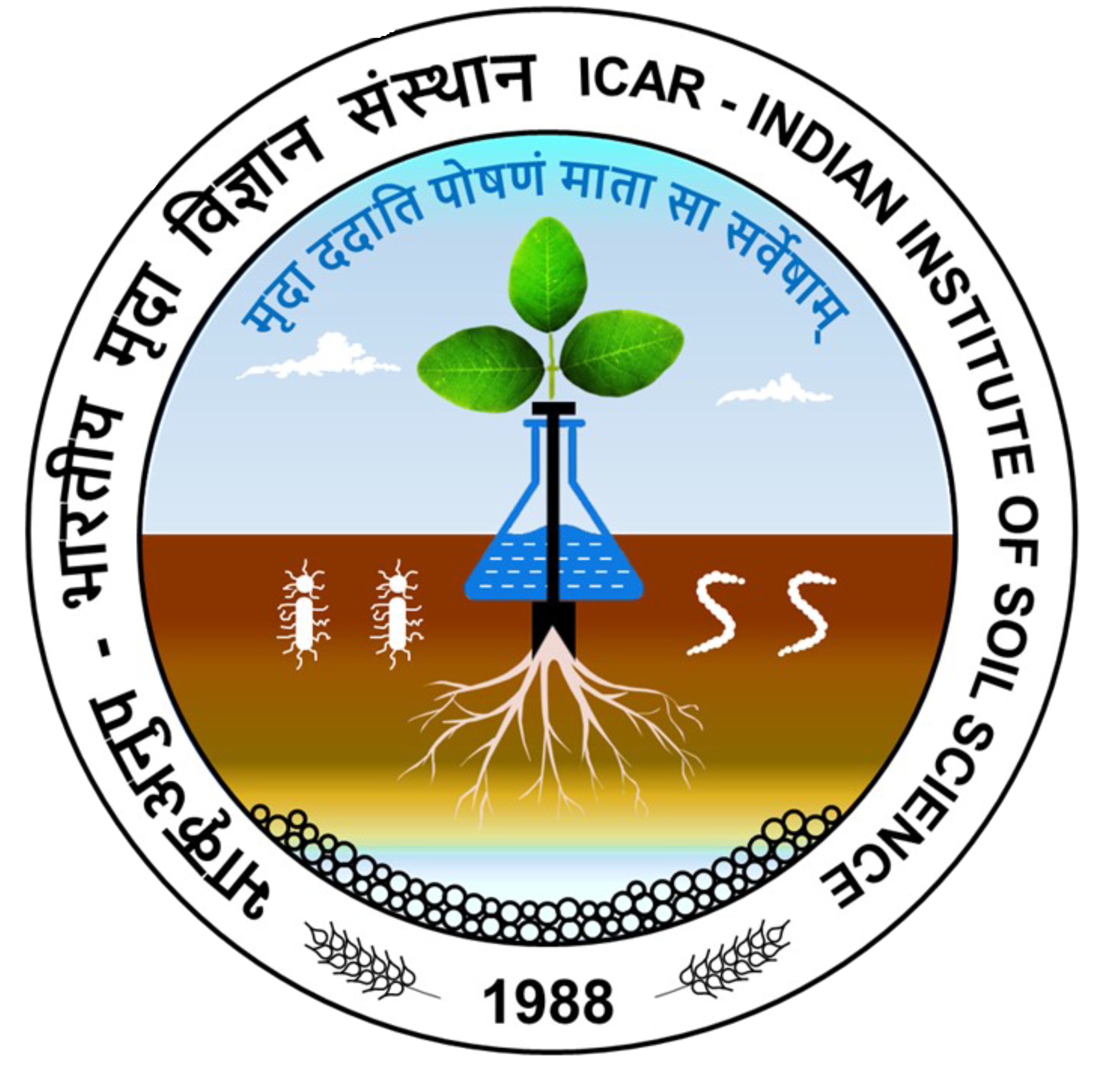
¼Hkk0d`0vuq0i0½ Hkkjrh; e`nkfoKkulaLFkku
uchckx] cSjfl;kjksM] Hkksiky& 462038
ICAR-Indian Institute of Soil Science
Nabibagh, Berasia Road, Bhopal – 462038 (M.P.)
Tel. No. (0755)2747375 EPABX:2730970/2734221 (Ext. No. 233 & 261) Fax. No. (0755) 2733310
F. No. 5-933/2023-24/P&S/IISS Dated: 23.06.2023

TENDER NOTICE

On behalf of the Director, ICAR-IISS, Bhopal, online Bid is invited through GeM portal vide bid no. GEM/2023/B/3589132 dated 23.06.2023 up to 15.07.2023 (12:00 Noon) for Supply of Fsourier-Transform Infrared Imaging Microscope with all Accessories (01 no.). The detail of GeM bid is also available in the Institute website https://iiss.icar.gov.in.

Assistant Administrative Officer

