NATIONAL INSTITUTE OF  OCEAN TECHNOLOGY | NOTICEINVITINGTENDER(NIT) |  | 
 | Form No. | NIOT/S&P/NIT
ननविदासख्य्ा/ Tender No. | NIOT/HVT/1180/2022-2023
कोजारी/ Tender Title | Preparation of Detailed Project Report for 2 modules of gross 5MW each closed cycle OTEC and 2 modules of2.5MLD each desalination plant powered by open cycle OTEC
ननविदाप्रणाली/Tender Mode | OTTB (Open Tender Two Bid)- Domestic Tender
Tender Issue date | 19.09.2022
Pre-Bid Meeting date  /Time and Venue | 30.09.2022 at 11:00 hrs IST through WebEx
  Tender Closing Date and Time | 14.10.2022 at 11.00AM
Tender Opening Date and Time | 14.10.2022 at 11.30AM
Submission of EMD/ ईएमड्जमाकरन | Rs.20,00,000/- (Rupees Twenty Lakhs only)  Scanned copy of the proof of EMD to be uploaded in e tender portal. Original EMD Instrument should be sent /submitted through courier/speed post or in person well before the closing date and time. (Refer EMD clause no 27 for Details.)
  Tender Documents available place | Tender documents can be down loaded from e-wizard https://moes.euniwizarde.com/appandMoES-NIOT website www.niot.res.in till closing Date and time of the Tender.
Bidding Type &Tender submission/ बोल्काप्रकार&ननविदाजमाकरन्ा | The tender being in Two Bid, Techno- commercial Bid and BOQ (PriceBid) should be uploaded separately and electronically through e-wizard  Portal https://moes.euniwizarde.com/ app
ई-ननविद्ाक्ललयसह्ायि््ामनअल/  Help manual for e-tender | Mr. Gagan T S, e-Wizard Team, ITI-Ltd, Bangalore,  Mobile No: 91 8448288987,  E-Mail: eprochelpdesk.01@gmail.com
  Send your queries to the email IDs | hvt@niot.res.in
NATIONAL INSITUTE OF OCEAN TECHNOLOGY
VELACHERY-TAMBARAM MAIN ROAD, NARAYANAPURAM, CHENNAI600100
NIOT WEBSITE: http://www.niot.res.in/tenders

Bid Preparation and Tender Submission Procedure

INSTRUCTION FOR BIDDERS
The bidders are required to upload the soft copies of their bid electronically on the e-Wizard Portal using valid Digital Signature Certificate. Below mentioned instructions are meant to guide the bidders for registration on the-Wizard Portal, prepare their bids in accordance with the NIT / SCC/ corrigendum and submit their bids online on the e-Wizard Portal. For more information bidders may visit the MoES e-Wizard Portal (https://moes.euniwizarde.com).

- REGISTRATION PROCESS ON ONLINE PORTAL
  - Bidders to enroll on the e-Procurement module of the portal https://moes.euniwizarde.com by clicking on the link “Bidder Enrolment”.
  - The bidders to choose a unique username and assign a password for their accounts. Bidders are advised to register their valid email address and mobile numbers as part of the registration process. This would be used for any communication from the e-Wizard Portal.
  - Bidders to register upon enrolment, with their valid Digital Signature Certificate (Class III Certificates with signing and Encryption key) issued by any Certifying Authority recognized by CCA India with their profile.
  - Only one valid DSC should be registered by a bidder. Please note that the bidders are responsible to ensure that they do not lend their DSCs to others which may lead to misuse.
  - Bidder then login to the site through these cured log-in by entering their user ID/password and the password of the DSC /e-Token.

- TENDER DOCUMENTS SEARCH
  - Various built-in options are available in the e-Wizard Portal like Department name, Tender category, Estimated value, Date, other keywords, etc. to search for a tender published on the Online Portal.
  - Once the bidders have selected the tenders they are interested in, they may download the required documents/tender schedules. These tenders can be moved to the respective “Interested tenders” folder.
  - The bidder should make a note of the unique Tender No assigned to each tender, in case they want to obtain any clarification / help from the Helpdesk.

- BID PREPARATION
  - Bidder should take into account any corrigendum published on the tender document before submitting their bids.
  - Please go through the tender advertisement and the tender document carefully to understand the documents required to be submitted as part of the bid.
  - Please note the number of covers in which the bid documents have to be submitted, the number of documents - including the names and content of each of the document that needs to be submitted. Any deviations from these may lead to rejection of the bid.
  - Bidder, in advance, should get ready the bid documents to be submitted as indicated in the tender document/schedule and generally, they can be in PDF/XLSX/PNG,etc. formats.
- BID SUBMISSION
  - Bidder to log into the site well in advance for bid submission so that he/she uploads the bid in time i.e. on or before the bid submission time. Bidder will be responsible for any delay due to other issues.
  - The bidder to digitally sign and upload the required bid documents one by one as indicated in the tender document.
  - Bidders to note that they should necessarily submit their financial bids in the prescribed format given by department and no other format is acceptable.
  - The server time (which is displayed on the bidders‟ dashboard) will be considered as the standard time for referencing the deadlines for submission of the bids by the bidders, the opening of bids, etc. The bidders should follow this time during bid submission.
  - All the documents being submitted by the bidders would been crypted using PKI encryption techniques to ensure the secrecy of the data, which cannot be viewed by unauthorized persons until the time of bid opening.
  - The uploaded tender documents become readable only after the tender opening by the authorized bid openers.
  - Upon the successful and timely submission of bids, the portal will give a successful bid submission message & a bid summary will be displayed with the bid no. and the date &time of submission of the bid with all other relevant details.
  - The Off-line tenders shall not be accepted and no request in this regard will be entertained whatsoever.

- AMENDMENT OF BID DOCUMENT
At any time prior to the deadline for submission of proposals, the department reserve the right to add/modify/delete any portion of this document by the issuance of a Corrigendum, which would be published on the website and will also be made available to all the Bidder who has been issued the tender document. The Corrigendum shall be binding on all bidders and will form part of the bid documents.
- ASSISTANCE TO BIDDERS
  - Any queries relating to the tender document and the terms and conditions contained therein should be indicated in the tender be addressed to the Tender Inviting Authority for attender or the relevant contact person.
  - Any queries relating to the process of online bid submission or queries relating to e-Wizard Portal, in general, may be directed to the 24x7 e-Wizard Helpdesk. The contact number for the help desk is Gagan (8448288987/ 89/ eprochelpdesk.01@ gmail.com),Birendra (8448288988/94/ eprochelpdesk.02@gmail.com), Rahul Singh (8448288982), Abhishek Kumar (9355030617), Tariq (9355030608), 9355030604, 9122643040, 9504661237
- The tender inviting authority has the right to cancel this e-tender or extend the due date of receipt of the bid(s).
- The bid should be submitted through e-Wizard portal (https://Moes.euniwizarde.com/)only.

INTRODUCTION

National Institute of Ocean Technology (NIOT), an autonomous body under the Ministry of Earth Sciences, (Government of India) is engaged in developing technology for utilizing ocean resources in an eco-friendly manner.

Notice Inviting Tender

National Institute of Ocean Technology invites E-bids for Preparation of Detailed Project Report 2 modules of gross 5MW each closed cycle OTEC and 2 modules of 2.5MLD each desalination plant powered by open cycle OTEC as per the scope of work enclosed in SCC.

- Submission of bids:Bidding as part of the Consortium is allowed. Bidders are requested to submit their Bid/quotation in two parts containing Technical proposal and un priced BOQ part-1 and price bid (BOQ) as part-2 should be submitted electronically through e-wizard portal https://moes.euniwizarde.com/ app. The responsibility to ensure the timely submission of bid lies with the bidder. Bids submitted through FAX or e-mail will not be considered. Bidders shall also attach scanned copies of all the requisite documents and other certificates/ documents specified in the tender documents. The bids are to be submitted (electronically) as per the bidding type indicated in the front page of the NIT. The bidders are advised to obtain DSC (Digital signature Certificate) from the authorized agent of and to register with. The bid/quotation cannot be submitted without DSC. Bidders are advised to submit their quotation in two Parts, Part-1 should contain Techno-Commercial Bid and duly signed blank price bid (without indicating the cost).Part-2 should contain only the price bid indicating the cost and applicable taxes.The Part-1 (technical bid) and Part-2 (Price bid) should be uploaded separately indicating the Tender No, Tender date Tender due date and time. The price/cost should not be revealed along with the technical bid. In case, the price/cost is revealed the bid is considered or invalid summarily rejected. Please note that to participate in the tender Digital Signature (DSC) has to be obtained. If you are a regular supplier of NIOT, it is requested to register your company with portal and to procure if not owned already.
- This NIT / SCC and corrigendum if any shall form part of the LOI / Contract.
- Terms and conditions indicated in the NIT shall be superseded by the terms and conditions mentioned in the Special conditions of contract (SCC) as at Annexure-A wherever applicable.
- Pre-BidMeeting shall be held on 30.09.2022 at 11:00 AM through video conference to clarify queries from allpotential bidders. Potential bidders are advised to send their queries sufficiently in advance in email to hvt@niot.res.in. Corrigendum issued based on the pre-bid meeting clarifications shall form part of the tender and the order to be concluded with the successful bidder.
INSTRUCTION TO BIDDERS

- Security: Any information / material /document supplied along with this tender or after placement of LOI should not be disclosed or copied without written permission from NIOT.

- Contacting NIOT:No correspondence / discussion / visits whatsoever will be entertained on the subject unless specifically called by this office after opening the tender for clarifications in writing. Any violation of this will render the quotation invalid and the firm is liable to be removed from our approved vendor list. However, if vendor requires any clarification on the NIT / SCC, the query/ clarifications maybe sent through mail ID hvt@niot.res.in before 48 hours of the closing date and time of the pre-bid meeting.
- LOI Acceptance:The successful bidder should accept the LOI within 7 days from the date of receipt of the LOI, failing which it shall be presumed that the vendor is not interested, the EMD submitted will be forfeited, In case MSE registered vendors the action will be initiated as per the bid securing declaration.
- Signing of Contract: The contractor should submit Power of Attorney and extract of commercial registrar for the official who will be authorized to sign the contract with NIOT along with the Board resolution copy. If the contract is signed by the Director of the firm, copy of the memorandum of Association (MOA) to be submitted. Upon receipt of these a formal contract in line with what has been agreed in the LOI, the Contract will be signed between NIOT and the contractor within one month from the date of acceptance of LOI. The draft contract will be uploaded along with the minutes of pre-bid meeting. All potential bidders may note that no change shall proposed by the bidder’s post declaration of L1 and unconditional acceptance of tender terms in toto is a pre-requisite and to process as a valid tender.
- Change of Name afterward:Request / intimations with regard to change of name of the Contracting company or constitution of the contracting company or after the tender opening or award of contract shall not be allowed as a matter of right. The bidders / contractors are required to submit all relevant documents with regard to change of name or/and change of constitution and the circumstances leading to such change beforehand. It shall be the discretion of NIOT to proceed with the contract after such changes and in case, NIOT decides to proceed with the contract, it may require the bidder / contractor to execute further agreements with regard to execution / implementation of the contract.
- One Bid per Bidder: A firm shall submit only one bid either individually or as a partner of a joint venture. A firm that submits either individually or, as a member of a joint venture, more than one bid by the same firm / company will result in rejection of all the bids.
- Additional Requirements for Consortiums:NIOT expects fully compliant tender by appropriately deciding the working arrangements for successful execution of tender requirements. If any bidder would like to bid as a consortium, model consortium agreement as per Annexure-II to be submitted detailing role and responsibilities of consortium member. The consortium shall not be permitted to be altered at any stage and hence the bidder shall ensure enforceability at any stage until the entire contractual obligation is fulfilled in terms of the tender requirements.
Bidders of a firm or a company or consortium shall, as part of their bid, submit a written power of attorney authorizing the signatory of the bid on behalf of the consortium.
Bids submitted by a consortium shall comply with the following requirements:
a. The successful bidder should sign the contract by the lead partner as indicated in the consortium agreement, so as to be legally binding on all partners as per model consortium agreement;
b. One of the consortium member / partners shall be authorized and exercise the power through power attorney in submitting the tender and signing all the tender related documents and to be submitted along with the consortium agreement detailing the roles and responsibility of each member/ partners.
c. The Lead Member is responsible for successful execution of contract and no division of contract can be entertained if consortium emerges as the successful bidder. No excuse shall be entertained to relieve the consortium and the lead bidder to relieve from the contractual responsibilities if awarded the contract.
d. All the partners of the consortium / joint venture shall be liable jointly and severally for the execution of the contract in accordance with the NIT / contract terms
e. All the Consortium members / partners are sole responsible against this tender / contract and shall not plead that they are not liable with reference to the contract terms for any of the reason that either there is a lead partner taking responsibility for execution of the project or that no action has been initiated against such lead partner; and,
f. All the bidders should submit the original consortium agreement on non-judicial stamp paper as per format available in NIOT web site under Part I and the power of attorney on non-judicial stamp paper in original duly authenticated by Notary public. However, all the bidders shall upload the copy of the consortium agreement along with the role and responsibilities of all consortium members and all supporting documents and bid forms as per tender. Any lack of clarity or incomplete consortium agreement shall result the tender being invalid and compliant tender. Consortium agreement shall be firm and binding until successful execution of entire scope of this tender and not subject to any change during the entire tender processing and till completion of the scope of work as per the NIT. Hence all the bidders are advised to keep in mind and firm up the consortium arrangement to ensure successful realization of the objective of this tender.

Prequalification Criteria:

12(a) Technical: -
The bidding firm or consortium should have the experience in design of as detailed in the following areas individually or along with consortia partners evidenced through a legally enforceable consortium agreement.The bidding firm or consortium should have executed at leastonesuch design projects in the last 10 yearsending on or before 31-03-2022.

- Offshore platforms such as SPAR/Semi-submersible/floating platform/oil platform in more than 800m water depth and its mooring
and
- Thermal power plant process equipment’s including power module of minimum capacity of 100 MW gross power.
and
- Subsea pipeline/risers for more than 800 m water depth
(or)
- Techno commercial costing
(or)
- Risk analysis and safety
The Documentary proofs satisfying the above criteria should be submitted along with the technical bid
12(b) Financial Criteria
- The average annual financial turnover of ‘The bidder’ during the last three years, ending 31-3-2022 should be at least INR 3 Crores, (or equivalent in foreign currency at exchange rate prevalent on ‘The Relevant Date’) for the purpose of assessing the financial strength. The documents should, duly be authenticated by a Chartered Accountant/Cost Accountant in India or equivalent in relevant countries should be submitted.
- The net worth of the Bidder (manufacture or principal authorized representative) should not be negative on “The relevant Date and also should not have eroded by more than 30% (thirty percent) in last three years, ending 31-03-2022 duly authenticated by a Chartered Accountant/Cost Accountant in India or equivalent in relevant countries

BIDDING CONDITIONS
- Due date Extension: Any corrigendum for NIT will be notified in e-wizard portal andNIOT website. Hence bidders are requested to watch both the website for such corrigendum, if any.
- IncaseoftheunscheduledholidayinChennaibeingdeclaredontheprescribedclosing/opening day of the tender, the next working day will be treated as the scheduled prescribed day of closing/ opening of the tender.
- Unsolicited correspondences: NIOT will not entertain any unsolicited correspondence or queries on the status of offer against this tender.
- Non-Receipt of Tender: NIOT will not be responsible for the non receipt of the tender due to any network problem/ connectivity issue. Hence bidders should upload their bids well before the closing hours.
- Submission of tender:Submission of tender by a tenderer implies that he has read the Notice Inviting Tender and has made himself aware of the scope and specifications of the work to be done; conditions and rates at which stores, tools and plant etc. will be issued to him by NIOT; local conditions and other factors bearing on the execution of the works.
- Bid Validity: Bids shall remain valid and open for acceptance for a minimum period of120days from the date of opening of Un-priced Techno-commercial Bids when fully compliant tender is submitted by the bidder without any requirement for NIOT to seek additional documents towards evaluation of pre-qualification and/ or in ensuring conformance to the specification / requirements of the tender. In the event of any delay in evaluation attributable to the vendor, vendor shall extend the tender by such a time taken by them in addition to above minimum tender validity period. A Bid valid for shorter validity period will be considered as a conditional tender and treated as invalid tender.
- Bid validity extension: In exceptional circumstances, prior to expiry of the original Bid validity period, NIOT may request the Bidder for a specified extension in the period of validity. The request and the responses thereto shall be made in writing. A Bidder agreeing to the request will not be required nor permitted to modify his bid.
- Conditional Offer:Conditional offers shall not be accepted. and shall be treated as invalid tender.
- Signing of bids: Each page of the tender and tender document shall be digitally signed and upload by the bidder in e-wizard Portal only.
- The broad configuration/ specification of the proposed purchase / work are given. Bidders are required to keep their proposal strictly as per the specification prescribed.
- Acceptance of bids: NIOT may accept or reject any/all tenders including the lowest tender without assigning any reasons whatsoever. NIOT also reserves its right to accept any tender in part or parts only with such conditions as it may prescribe. NIOT is not bound to accept the lowest tender. NIOT expects full technical compliance and expects full scope of integrated supply as per tender specification and do not accept partial tenders.
- Technical presentation: The bidders have to make a detailed technical presentation on the methodology, project schedule, manpower, etc. before a committee. The date of technical presentation will be intimated to the bidders after opening of the techno-commercial bids.
- The compliance sheet with reference to the specifications should be furnished against each parameter while submitting the quotation, which is absolutely necessary. THE TENDERER SHALL SUBMIT TECHNICAL & COMMERCIAL COMPLIANCE SHEETS and BOQ (Price bid) separately ALONG WITH THEIR OFFER. TENDERS WITHOUT COMPLIANCE SHEETS WILL NOT BE EVALUATED. The Price bid should be unconditional.
- Canvassing: Exerting pressure and/or offering inducement in any form by the bidder or by any other person on behalf of the bidder shall disqualify the bid and lead to its rejection.
- Commercial compliance as per the NIT shouldbe uploadedalong with the technical bid /offer.
- EMD / Bid security: The EMD for Rs.20,00,000/- (Indian Rupees Twenty Lakhs only) is mandatory. The instrument of the EMD (Original) should be dropped in the tender box or shall be sent by courier/ by person so as to reach well before the closing date and time of the e-tender. Without original EMD Tender is invalid and hence liable for rejection as invalid/ irresponsive tender. The instrument of EMD shall be scanned and uploaded along with Part I of the Bid.
The EMD/bid security may be accepted in the following form.
    - Insurance Surety Bonds
    - Account Payee Demand Draft (dranw in favour of ''NIOT other Receipt Account”Chennai in INR
    - Fixed Deposit Receipt.
    - Bankers cheque or Bank Guarantee from any of the commercial Bank (Bank Guarantee as per prescribed format available in the NIOT website at the link http://www.niot.res.in/index.php/vendor/login
    - Online payment in an acceptable form.
If the EMD (Scanned copyof the instrument EMD) is not submitted along with the Techno commercial (Part-I) the bid will be summarily rejected.The original EMD should be submitted (or) reach NIOT before closing date and time of the tender.

- MSMEClause: "Micro and Small Enterprises (MSEs) as defined in MSE Procurement Policy issued by Department of Micro, Small and Medium Enterprises (MSME)” are exempt from submission of EMD (Bid security). Bidders claiming exemption of EMD under this rule (170 of GFR) are however required to submit a signed bid securing declaration (format to be enclosed) along with the relevant and valid exemption certificate issue by the appropriate authorities. accepting that if they withdraw or modify their Bids during the period of validity, or if they are awarded the contract and they fail to sign the contract, or to submit a performance security before the deadline defined in the request for bids document, they will be suspended for the period of one year from being eligible to submit Bids for tenders with NIOT and all the departments under MoES." The bid declaration format to be attached.

TERMS AND CONDITIONS GOVERNING THE CONTRACT

- Currency of bids: Prices should be quoted in Indian Rupees (INR) only as this tender is open for Indian bidders only.
- Guaranteed time of Completion period – specific performance of contract; The Detailed Project Report 2 modules of gross 5MW each closed cycle OTEC and 2 modules of 2.5MLD each desalination plant powered by open cycle OTEC as per technical specification to be completed and to be submitted to NIOT within 12 Months from the date of signing of contract.
- Extension of delivery period: Unless the extended deliveryperiod is agreed by NIOT in writing, contractor cannot claim the extension of time as a matter of right. NIOT shall have the right to either cancel/extend the order validity/ levy penalty as appropriate.

- Price: The price shall include but not limited to
- Costs of documentation/ services covered in this contract.
- Taxes and duties
The Bidder shall indicate on the appropriate price schedule form, the unit prices and total bid prices of the service under the contract strictly as per price bid format of tender.
- Taxes
a. GST: Goods & Services Tax (GST)will be paid as per the applicable HSN code as applicable.
Deductibles:
- Deduction of Indian Income Tax Deduction at Source for the Indian bidders: TDS will be deducted as applicable for service portion at prevailing rates. Valid Permanent Account Number (PAN) is mandatory.
- GST-TDS:
GST-TDS is deductible on supply of goods or Service in respect of Intra – State supplies at the rate of 2% (CGST @1% and SGST @ 1%) and also in case of Inter-State supplies @ the rate of 2% from the payment made or credited to the supplier of taxable Service.

- Performance Security: The successful bidders should deposit 3% of the contract value as Performance Security within 2 weeks from the date of issue of Letter of Intent. The performance security shall be in one of the following forms:
- Insurance Surety Bonds,
- Account Payee Demand Draft (drawn in favour of” The Director N.I.O.T”, Chennai in INR or in equivalent foreign currency)
- Fixed Deposit Receipt from any Commercial Bank.
- Bank Guarantee from any of the Commercial Bank
- Online payment in an acceptable form

This format can be downloaded from the link ttps://www.niot.res.in/index.php/vendor/login. Performance security shall be forfeited in the event of breach of contract by the contractor in terms of the contract. If Performance Security is not paid within the specified time, NIOT reserves its right to cancel the LOI and forfeit the EMD submitted

- Force Majeure: For purposes of this Clause, "Force Majeure" means an event beyond the control of the Contractor or due acts of GOD and not involving the Contractor's fault or negligence and not foreseeable. Such events may include, but are not limited to, acts of NIOT either in its sovereign or contractual capacity, wars or revolutions, fires, floods, epidemics, quarantine restrictions and freight embargoes. If a Force Majeure situation arises, the Contractor shall promptly notify NIOT in writing of such conditions and the cause thereof. Unless otherwise directed by NIOT in writing, the Contractor shall continue to perform its obligations under the Contract as far as is reasonably practical and shall seek all reasonable alternative means for performance not prevented by the Force Majeure event.

- Mediation/Arbitrations/Disputes:
- In the event of any dispute any time during the currency of contract, both the parties shall try to resolve through mutual discussion to resolve such disputes. In case the same is not resolved, parties will submit for mediation to IEM under the Integrity Pact and as per extant instructions of Govt. Of India for resolution. No party shall rush to any court of law without completion of mediation and arbitration as contemplated.
- In the event of any dispute, difference, interpretation or application relating to this agreement arises; the same shall be settled amicably by the parties. In case the dispute or differences could not be settled amicably, the same shall be referred for adjudication through Arbitration by an Arbitrator to be appointed by the Director, NIOT. The Indian Arbitration shall be concluded in accordance with the provisions of Arbitration & Conciliation Act, 1996 or any statutory modifications or re-enactment thereof and the rules made there under and for the time being tin force shall apply to the arbitration proceedings. Venue of such arbitration shall be at Chennai in India. The language of arbitration proceedings shall be English. The Arbitrator shall make reasoned award (the “award”), which shall be final and binding on the parties. The cost of the arbitration shall be shared equally by the parties to the contract. However, expenses incurred by each party in connection with the preparation, presentation etc., shall be borne by each party.
- Termination:NIOTretain the right toterminate the contract incase of violations of any of the terms of the contract or inordinate delays to achieve the progress within the agreed time of 12 months, by giving 15 days’ notice to the contractor. Upon such termination, the contractor shall not claim and not entitled for any payment of consideration apart from NIOT‟s right to take any lawful action to protect public interest. The Contract placed will be cancelled and the security Deposit or any other Bank Guarantee amount will be forfeited.
- INDEMNITIES: The Contractor hereby agrees to indemnify and hold harmless NIOT and its Director, officers and employees, from and against any and all suits, losses, liabilities, damages, claims, settlements, costs and expenses, including reasonable attorneys ‟fees,based on arising, directly or indirectly, from:
- Breach of this Agreement by the Contractor
- Not performing the Scope of Work or any other obligation under this Agreement or Tender in accordance with the provisions and schedules of this Agreement or the Tender
- Violation or contravention of any Legislation on the part of the Contractor
- any negligence or willful misconduct of Contractor, which violates any provision of this Agreement
- Infringement of any intellectual property belonging to any third party by the Contractor
- Any breach of an agreement or understanding between Contractor and any and all Third Parties due to which a liability arises on NIOT.
- any claim that any representations or warranties contained herein are not true or any breach thereof
- any loss or damage caused by the Contractor to NIOT, its personnel or property
- any loss or damage caused by the Contractor to any and all Third Parties for which a claim against NIOT has arisen
- breach, expiry, cancellation, revocation or invalidity of any and all licenses, permits, authorizations and registrations which the Contractor is required to obtain, keep valid and comply with under any Legislation in order to perform its obligations here under
- any obligation of the Contractor performed by NIOT under this Agreement or under any Legislation.

- Penalty: If the Consultant fails to carry out the work as per the scope of work of the order, penalty charges @1% on weekly basis maximum up to 10% of contract value will be levied.
- Intellectual Property Rights and Confidentiality
- The Contractor shall treat the details of the contract as private and confidential, save in sofar as may be necessary for the purposes thereof, and shall not publish or disclose the same or any particulars thereof in any trade or technical paper or elsewhere without the previous consent in writing of NIOT or the Scientist in charge. If any dispute arises as to the necessity of any publication or disclosure for the purpose of the contract the same shall be referred to NIOT whose determination and decision shall be final and binding on both the parties.
- Since this Project is fully funded by NIOT, all IPR rights shall rest with NIOT.
- Every employee and consultant of the contractor assigned to carry out any work related to the deliverables in the scope of contractor or for taking part in the project shall be subject to a non-disclosure agreement in a format approved in advance by NIOT.
- At the time of awarding the contract the successful bidder (contractor) shall execute a detailed confidentiality agreement with NIOT in order to protect the information provided to him for the successful completion of the project.

- Integrity Pact: NIOT have to adopt an Integrity pact (IP) to ensure transparency, equity and competitiveness in major Public procurement activities. The integrity pact envisages an agreement between the prospective bidders/vendors with NIOT committing the persons/officials of both the parties with the aim not to exercise any corrupt influence on any aspect of the contract. The bidders shall agree to enter into such an integrity pact with NIOT as per forms available in the website www.niot.res.in (Attached as Bid Form).
- Non-Disclosure Agreement: Non-Disclosure Agreement (NDA) shall be signed with the successful bidder and NIOT. The Non-Disclosure Agreement (NDA) along with the NIT to be submitted by all the bidders / Consortium partners in original on a stamp paper. The Original NDA should be submitted along with Original Consortium agreement in a separate sealed cover. Scanned Copy of the same should be uploaded in Part-1.
Any confidential information such as design, fabrication & assembly drawings, know-how of the process and components specifications provided as part of the tender document shall not be used directly or indirectly in any form and anywhere by the bidder or their employees or their consortium partners except for the purposes of providing the service for which the information is provided in first place or with prior written consent of NIOT.The bidder shall do everything reasonably possible to preserve the confidentiality of the Confidential Information including execution of a confidential agreement with the members of his consortium, subcontractors and other members of his team to the satisfaction of NIOT.NIOT reserves the right to adopt legal proceedings, civil or criminal, against the bidder in relation to a dispute arising out of breach of obligation by the bidder under this clause.
- FundamentalPrincipleofPublic Buying:
- AnybidderfromacountrywhichsharesalandborderwithIndiawillbeeligible tobidin thistender onlyif thebidder isregisteredwith theCompetentAuthority.

- "Bidder"(includingtheterm'tenderer', 'consultant' or 'serviceprovider'incertain contexts) meansanypersonor firmorcompany,including anymemberof a consortiumorjoinventure(that isanassociationof severalpersons,orfirmsor companies), everyartificialjuridicalpersonnot fallinginanyofthedescriptions of bidders statedhereinbefore, including any agencybranchorofficecontrolled by such person, participating in aprocurementprocess.

- "BidderfromacountrywhichsharesalandborderwithIndia"forthepurpose of thisOrder means:-
  - An entity incorporated,establishedor registeredin such acountry;or
  - Asubsidiaryofanentityincorporated,establishedorregisteredinsuch acountry;or
  - Anentity substantially controlled through entities incorporated, establishedor registeredin such acountry;or
  - An entity whosebeneficial owner issituatedin such acountry;or
  - An Indian(or other) agentofsuch an entity; or
  - A natural person who is acitizen of such acountry;or
  - Aconsortiumorjointventurewhereanymemberoftheconsortiumor joint venturefallsunder anyor theabove.

- Thebeneficial owner for thepurposeof (iii) abovewill beasunder:

- IncaseofacompanyorLimitedLiabilityPartnership,thebeneficialowner isthenaturalperson(s), who,whetheractingaloneortogether,orthrough oneormorejuridicalperson,hasacontrollingownershipinterest orwho exercisescontrol through other means.

- "Controllingownershipinterest" meansownershipof or entitlement tomorethantwenty-fivepercent. of shares or capitalor profitsof thecompany;

- "Control" shallincludetheright to appointmajorityofthedirectors ortocontrolthe managementorpolicy decisions including by virtueoftheirshareholdingormanagementrightsorshareholders agreements or votingagreements;

- In case of a partnership firm, the beneficial owner is the natural person(s) who, whether acting alone or together, or through one or more juridical person, has ownership of entitlement to more than fifteen percent of capital or profits of the partnership;

- In case of an unincorporated association or body of individuals, the beneficial owner is the natural person(s), who, whether acting alone or together, or through one or more juridical person, has ownership of or entitlement to more than fifteen percent of the property or capital or profits of such association or body of individuals;

- Where no natural person is identified under(1) or (2) or (3) above, the beneficial owner is the relevant natural person who holds the position of senior managing official;

- In case of a trust, the identification of beneficial owner(s) shall include identification of the author of the trust, the trustee, the beneficiaries with fifteen percent or more interest in the trust and any other natural person exercising ultimate effective control over the trust through a chain of control or ownership.
- An Agent is a person employed to do any act for another, or to represent another in dealings with third person.

- The successful bidder shall not be allowed to sub-contract works to any contractor from a country which shares a land border with India unless such contractor is registered with the Competent Authority.

- Eligible Bidders

45.1This Invitation for Bids is open to all suppliers. However, only Class-I and Class-II local suppliers are eligible to participate in Domestic Tender.

45.2 Bidders should not be associated, or have been associated in the past, directly or indirectly, with a firm or any of its affiliates which have been engaged by the Purchaser to provide consulting services for the preparation of the design, specifications, and other documents to be used for the procurement of the goods to be purchased under this Invitation of Bids

45.3The bidders who have been temporarily suspended or removed from the list of registered suppliers by the purchaser or banned from Ministry/country wide procurement shall be ineligible for participation in the bidding process.

45.4Bidders who fulfill the Eligibility Criteria mentioned in SCC of NIT will be considered for Technical Evaluation of bids.

- Cost of Bidding

The Bidder shall bear all costs associated with the preparation and submission of its bid, and “the Purchaser", will in no case be responsible or liable for these costs, regardless of the conduct or outcome of the bidding process.
47. Code of Integrity for Public Procurement
47.1The purchaser requires that the bidders, suppliers and contractors observe the highest standard of ethics during the procurement and execution of such contracts.
- Corrupt practice
The offering, giving, receiving, or soliciting, directly or indirectly, of anything of value to influence the action of a public official in the procurement process or in contract execution.
- Fraudulent practice
a misrepresentation or omission of facts in order to influence a procurement process or the execution of a contract.
- Collusive practice
means a scheme or arrangement between two or more bidders, with or without the knowledge of the purchaser, designed to establish bid prices at artificial, non-competitive levels.
- Coercive practice
means harming or threatening to harm, directly or indirectly, persons or their property to influence their participation in the procurement process or affect the execution of a contract.
- Anticompetitive practice
any collusion, bid rigging or anti-competitive arrangement, or any other practice coming under the purview of the Competition Act, 2002, between two or more bidders, with or without the knowledge of the purchaser, that may impair the transparency, fairness and the progress of the procurement process or to establish bid prices at artificial, non-competitive levels 7.

- Conflict of interest
participation by a bidding firm or any of its affiliates that are either involved in the consultancy contract to which this procurement is linked; or if they are part of more than one bid in the procurement; or if the bidding firm or their personnel have relationships or financial or business transactions with any official of purchaser who are directly or indirectly related to tender or execution process of contract; or improper use of information obtained by the (prospective) bidder from the purchaser with an intent to gain unfair advantage in the procurement process or for personal gain
- Obstructive practice
materially impede the purchaser’s investigation into allegations of one or more of the above mentioned prohibited practices either by deliberately destroying, falsifying, altering; or by concealing of evidence material to the investigation; or by making false statements to investigators and/or by threatening, harassing or intimidating any party to prevent it from disclosing its knowledge of matters relevant to the investigation or from pursuing the investigation; or by impeding the purchaser’s Entity’s rights of audit or access to information

47.2The Purchaser will reject a proposal for award if it determines that the Bidder recommended for award has, directly or through an agent, engaged in corrupt, fraudulent, collusive or coercive practices in competing for the Contract in question.

47.3The bidders/suppliers should sign a declaration about abiding by the Code of Integrity for Public Procurement and submit it in the form along with bid documents. In case of any transgression of this code, the bidder is not only liable to be removed from the list of registered suppliers, but it would be liable for other punitive actions such as cancellation of contracts, banning and blacklisting or action by Competition Commission of India, and so on.

47.4Obligations for Proactive disclosures
- The Purchaser as well as bidders, suppliers, contractors and consultants, are obliged under Code of Integrity for Public Procurement to sue-moto proactively declare any conflicts of interest (coming under the definition mentioned above – pre-existing or as and as soon as these arise at any stage) in any procurement process or execution of contract. Failure to do so would amount to violation of this code of integrity.

- The bidder must declare, whether asked or not in a bid document, any previous transgressions of such a code of integrity with any entity in any country during the last three years or of being debarred by any other Procuring Entity. Failure to do so would amount to violation of this code of integrity.

- To encourage voluntary disclosures, such declarations would not mean automatic disqualification for the bidder making such declarations. The declared conflict of interest would be evaluated and mitigation steps, if possible, taken by the purchaser.

47.5Punitive Provisions
Without prejudice to and in addition to the rights of the Purchaser to other penal provisions as per the bid documents or contract, if the Purchaser concludes that a (prospective) bidder/supplier, directly or through an agent, has violated this code of integrity in competing for the contract or in executing a contract, the purchaser may take appropriate measures including one or more of the following:
- If his bids are under consideration in any procurement:
i. Forfeiture or encashment of bid security;
ii. Calling off of any pre-contract negotiations; and
iii. Rejection and exclusion of the bidder from the procurement process.

- If a contract has already been awarded
i. Cancellation of the relevant contract and recovery of compensation for loss incurred by the Purchaser;
ii. Forfeiture or encashment of any other security or bond relating to the procurement;
iii. Recovery of payments including advance payments, if any, made by the purchaser along with interest thereon at the prevailing rate.

- Provisions in addition to above:
i. Removal from the list of registered suppliers and banning/debarment of the bidder from participation in future procurements of the purchaser for a period not less than one year;
ii. In case of anti-competitive practices, information for further processing may be filed under a signature of the Joint Secretary level officer, with the Competition Commission of India;
iii. Initiation of suitable disciplinary or criminal proceedings against any individual or staff found responsible.
48.Amendment to Bidding Documents
In order to allow prospective bidders reasonable time to take the amendment into account while formulating their bids, the Purchaser, at its discretion, may extend the due date for the submission of bids in the e tender portal.

49.Confidentiality

49.1Information relating to the examination, evaluation, comparison, and post qualification of bids, and recommendation of contract award, shall not be disclosed to bidders or any other persons not officially concerned with such process until Award of the Contract. However, decisions taken during process of tender evaluation shall be hosted on e-Tenders portal.

49.2Any effort by a Bidder to influence the Purchaser in the examination, evaluation, comparison, and post qualification of the bids or contract award decisions may result in the rejection of its Bid.

50.Post qualification

50.1In the absence of pre-qualification, the Purchaser will determine to its satisfaction whether the Bidder that is selected as having submitted the lowest evaluated responsive bid is qualified to perform the contract satisfactorily, in accordance with the criteria listed in the SCC.
50.2The determination will take into account the Eligibility& Qualification criteria listed in the SCC of Tender document and it will be based upon an examination of the documentary evidence of the Bidder’s qualifications submitted by the Bidder, as well as such other information as the Purchaser deems necessary and appropriate.
50.3An affirmative determination will be a prerequisite for award of the contract to the Bidder. A negative determination will result in rejection of the Bidder’s bid.

51.Bidder’s right to question rejection
A Bidder shall have the right to be heard in case he feels that a proper procurement process is not being followed and/or his tender has been rejected wrongly. Only a directly affected bidder can represent in this regard as under:

51.1Only a bidder who has participated in the concerned procurement process i.e. pre- qualification, bidder registration or bidding, as the case may be, can make such representation.
51.2In case pre-qualification bid has been evaluated before the bidding of Technical bids, an application for review in relation to the technical bid may be filed only by a bidder who has qualified in prequalification bid.
51.3In case technical bid has been evaluated before the opening of the financial bid, an application for review in relation to the financial bid may be filed only by a bidder whose technical bid is found to be acceptable.
51.4In case a Bidder feels aggrieved by the decision of the purchaser, he may then send his representation in writing to the Purchaser’s address as indicated in special conditions of contract (SCC) within 05 working days from the date of communication of the purchaser intimating the rejection for reconsideration of the decision by the purchaser.
51.5Following decisions of the purchaser in accordance with the provision of internal guidelines shall not be subject to review:
- Determination of the need for procurement;
- Selection of the mode of procurement or bidding system;
- Choice of selection procedure;
- Provisions limiting participation of bidders in the procurement process;
- The decision to enter into negotiations with the L1 bidder;
- Cancellation of the procurement process except where it is intended to subsequently re-tender the same requirements;
- Issues related to ambiguity in contract terms may not be taken up after a contract has been signed, all such issues should be highlighted before consummation of the contract by the vendor/contractor; and
- Complaints against specifications except under the premise that they are either vague or too specific so as to limit competition may be permissible.

52.Joint Venture, Consortium or Association
If the Supplier is a joint venture, consortium, or association, all of the parties shall be jointly and severally liable to the Purchaser for the fulfillment of the provisions of the Contract and shall designate one party to act as a leader with authority to bind the joint venture, consortium, or association. The composition or the constitution of the joint venture, consortium, or association shall not be altered without the prior consent of the Purchaser.
53.Amalgamation/Acquisition etc.:
In the event the Manufacturer/Supplier proposes for amalgamation, acquisition or sale its business to any firm during the contract period, the Buyer/Successor of the Principal Company are liable for execution of the contract and also fulfillment of contractual obligations i.e. supply, installation, commissioning, warranty, maintenance/replacement of spares accessories etc. You may confirm this condition while submitting the bid.

SCC (Special Contract Conditions)- Annexure -A

TENDER SPECIFICATION FOR PREPARATION OF DETAILED PROJECT REPORT FOR 2 MODULES OF GROSS 5MW EACH CLOSED CYCLE OTEC AND 2 MODULES OF 2.5MLD EACH DESALINATION PLANT POWERED BY OPEN CYCLE OTEC



National Institute of Ocean Technology
Velachery- Tambaram Main Road, Pallikarnai,
Chennai-600100, India
Section 1

Organization Overview

The National Institute of Ocean Technology (NIOT) is an autonomous research and development institute under the Ministry of Earth Sciences, Government of India, with a major aim of developing reliable indigenous technologies for harvesting of non-living and living resources in the Indian Exclusive Economic Zone (EEZ) in a sustainable manner.
One of the main areas of focus of NIOT is the utilization of the ocean resources to find alternative technologies for fresh water and renewable energy.
NIOT has pioneered the development of the ocean thermal gradient based low temperature thermal desalination (LTTD) technology in shallow waters and had established India’s first LTTD plant with 100 m³ per day capacity in Kavaratti island of Lakshadweep in 2005. Subsequently the plants in Minicoy and Agatti islands were established in 2011 and 2012 respectively. At present, the work of establishing LTTD plants in 6 other islands is in progress. NIOT has also successfully demonstrated a 1000 m³ per day barge mounted offshore desalination plant 40 km off Chennai coast. NIOT demonstrated application of LTTD technology at coastal thermal power stations by setting up a 50 m³ per day desalination plant at the North Chennai Thermal Power Station in Chennai. The plant used hot condenser reject water from the power plant and cooler surface seawater was fed to the condenser to produce desalinated water.
Currently NIOT is in process of establishing a 2000 m³ per day LTTD plant at another coastal thermal power station in Tuticorin in South Tamil Nadu and an OTEC powered desalination plant in Kavaratti Island in Lakshadweep. The Kavaratti plant will work on the Open Cycle OTEC principle. The plant is indigenously designed by NIOT’s scientific team. It will produce desalinated potable water as the end product with a capacity of 100 m³ per day. The power generated by the turbine in Kavaratti plant will be utilized for powering all its pumps, vacuum system and other auxiliaries making it self sufficient in power and independent of island grid powered by diesel-generators. It will have a very long cold water conduit to draw cold seawater from the depth of 1000 meters.

For an LTTD plant meant for the mainland needs, NIOT has demonstrated an experimental 1000m³/day (1 Million litres per day) barge mounted desalination plant 40 km off Chennai coast. Temperature gradient of about 18ºC was utilised with surface water at 28ºC and the water at 550m depth at 10ºC. The plant was commissioned in April 2007 and the sea trials were successfully conducted for a few weeks. A DPR for 10 MLD capacity floating LTTD plant was also prepared for mainland applications.The DPR included design of Thermal system, Platform to house plant components, Instrumentation & Control, Electrical, Methodology for transportation of fresh water from platform to Mainland, Physical Model Testing for the selected Platform configuration, Stages of construction of platform, Classification society approval and Calculation of project costing.Some salient points of the 10 MLD DPR are attached in Annexure –III. This document may be referred for carrying out the project objectives.

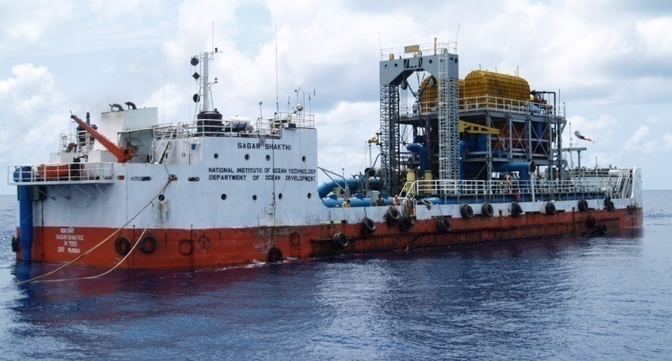
Barge mounted Desalination Plant

Section 2

Objectives

Preparation of a Detailed Project Report (DPR) for Design, Installation and O&M of an all weather platform mounted closed cycle OTEC plant for electricity generation and open cycle OTEC powered desalination plant as per process derived by NIOT involving continuous pumping of cold water from the depth above 1000 m which is about 40 km off Ennore, North Chennai, Tamil Nadu.

The detailed design to be carried out for following configuration-
- 2modules of 2.5 MLD each powered by open cycle OTEC system
- 2modules of gross 5 MW each – closed cycle OTEC system

The above modules to be designed for mounting on an offshore platform which will be moored in over 1000m water depth. The cold water from deep depths to be pumped to the platform using a specially designed conduit.

Section 3

Description of the OTEC and LTTD process

The Technology
As stated earlier NIOT hasbeen involved in developing and demonstrating technologies such as Ocean Thermal Energy Conversion (OTEC) and Low Temperature Thermal desalination (LTTD) that uses the availability of a temperature gradient in ocean. The temperature difference that exists between the warm surface sea water (28~31ºC) and deep sea cold water (7~8ºC) available below 1000 m depth could be effectively utilized for co-generation of energy and fresh water.
In general, there are three main types of OTEC power generation systems, namely:
(a) Open cycle (OC) OTEC
(b) Closed cycle (CC) OTEC
(c) Hybrid OTEC, basically a combination of a) and b).

These types can be explained as follows, all of which require a minimum warm to cold seawater temperature difference of approximately 20°C.

Open Cycle (OC) OTEC
In OC-OTEC, a warm seawater stream is partially vaporized inside a flash chamber kept under a high vacuum condition using a pump. This vapour, in a desalinated state, expands inside a large diameter low-pressure turbine and generates mechanical power, which drives a generator to produce electricity.The expanded vapour is then condensed using cold seawater. The condenser is kept at a lower pressure than the flash chamber due to the gas to liquid phase change. The pressure difference between the flash chamber and the condenser provides the driving force for the vapour to flow towards the condenser via the turbine.
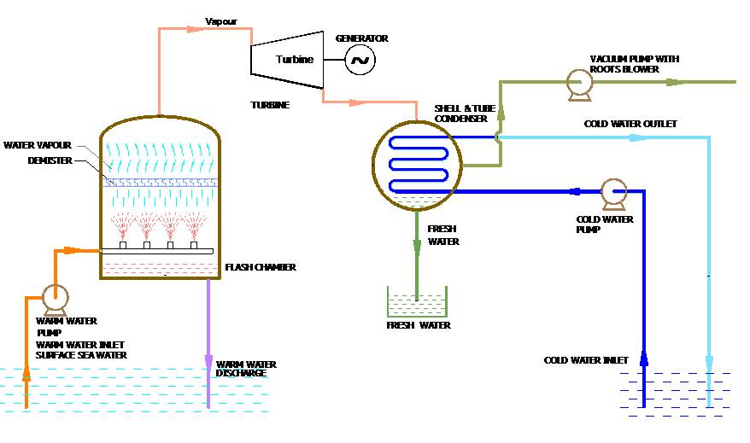
Schematic of open-cycle OTEC

The main equipmentsof open cycle OTEC process plant are:

Sl. No. | Equipment
1 | Flash chamber
2 | Condenser
3 | Low pressure Turbine
4 | Vacuum System
5 | Warm water pump
6 | Fresh water pump
7 | Cold water pump
8 | Valves and piping

Closed Cycle(CC) OTEC

Closed cycle OTEC operates between pressures of 9.7 bar and 7 bar (1 bar = 1 atm pressure), corresponding to the chosen working fluid (anhydrous ammonia in this case) at temperatures of 24°C and 14°C, respectively. In a closed cycle system liquid ammonia is pumped into an evaporator (heat exchanger) heated by warm seawater. The resulting ammonia vapour expands in a turbine producing mechanical power, which can drive a conventional electricity generator. The expanded vapour is then condensed back to a liquid using cold seawater in another heat exchanger. The liquid ammonia is then pumped back to the evaporator, thus allowing the cycle to continue.
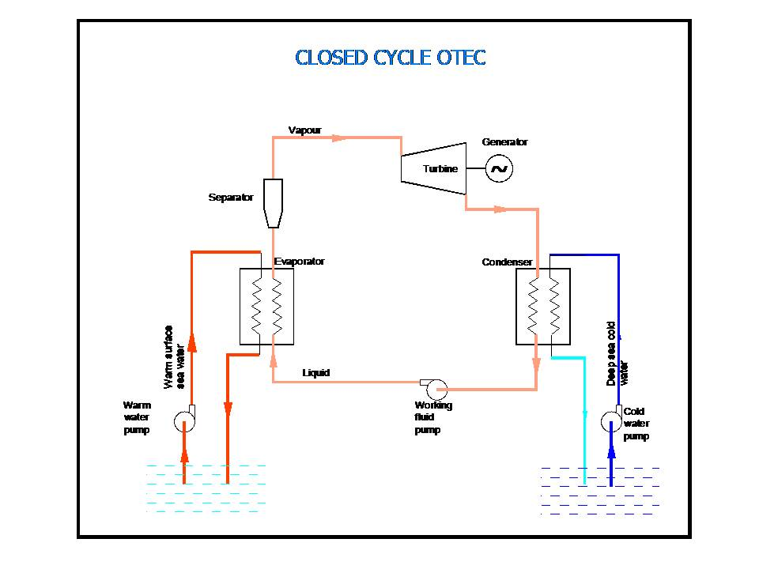
Schematic of closed-cycle OTEC

The main equipmentsof closed cycle OTEC process plant are:
Sl. No. | Equipment
1 | Evaporator
2 | Condenser
3 | Warm water pump
4 | Cold water pump
5 | Liquid ammonia pump
6 | Ammonia storage tank
7 | Separator
8 | Turbine
9 | Sea water pumps
10 | Valves and piping

Section 4

Required System Configuration of the Offshore OTEC Plant

- The configuration for which the detailed design to becarried outwill befor :-
- 2modules of 2.5 MLD each powered by open cycle OTEC system
- 2modules of gross 5 MW each – closed cycle OTEC system

All the modules to be housed on the same platform.

- Various major components of project is as follows: -
- Process components:Major plant equipments for closed and open cycle OTEC system are listed in Section 3.

- Open cycle OTEC with 5 MLD LTTD plant

2 modules of 2.5MLD each desalination plants will be based on open cycle OTEC principle and will be self-powered by open cycle OTEC. The plant will resemble LTTD system with ultra low pressure turbine incorporated between flash chamber and desalination condenser.

- Closed cycle OTEC
Two modules of gross 5 MW each are proposed for closed cycle OTEC.

- Offshore components:The offshore components include floating platform, mooring lines, warm and cold water intake and discharge conduits and freshwater delivery riser system.

- Platform and mooring system:
The hull would be designed to support the main equipments along with the necessary utilities need to be defined in the main deck to generate requisite electricity and fresh water.The following major design needs to be carried out for the hull and topside –

- Platform Hull Sizing
- Scantling Calculations
- Stability Analysis
- Hydrodynamic Motion Analysis
- Mooring Design and Analysis
- Towing and installation at site

- Cold water Pipeline:

The large diameter HDPE pipes would be used for drawing surface warm water and deep sea cold water (min. 1000 m length) and the pipe will be designed to withstand the environmental loads with return periods of both 50 and 100 years. The following major design exercises need to be carried out such as –

- HDPE Conduits – Global In Place Analysis
- Modal / VIV / Fatigue Analysis
- Load out, Towing & Upending methodology
- Integration with platform
- Method of Transportation of freshwater from platform to mainland and pipeline / riser configuration
- Design and analysis of offshore connection components
- Design and analysis of subsea cables for electricity transmission to mainland.

- Other Important Components

- The subsea pipeline for freshwater (5 MLD) transportation from the plant to the mainland needs to be designed. In addition, the power export cable to supply net electricity to nearest shore generated from the closed cycle OTEC system needs to be incorporated in the plant system.

- Instrumentation and control and data acquisition for all system parameters and also for behavior of platform, mooring and cold water conduit. Provision for periodic calibration of all instruments during operation.

- Manning and safety requirements of platform

- Modules of green Hydrogen/Ammonia production units with transportation systemto be designed for and which is powered by the OTEC system to enhance the commercial viability of the OTEC system.

Section 5

Scope of DPR

The DPR should contain the following details: -

1. Plant design for covering the system configuration outlined in section 4 including -

- Cycle design - Open cycle OTEC and Closed Cycle OTEC
- Detailed sizing of plant equipment’s including power modules (i.e. turbines and generators) for both open cycle OTEC and closed cycle OTEC systems
- Simulations for thermal cycles (OC &CC separately) and turbines
- Sensitivity analysis for complete processequipment
- Number of modules, location and layout
- Design and materials of construction for turbines, generators and all heat exchangers
- Piping layout head, loss calculations, pump selection, location and material selection
- Vacuum system load calculations, no. of modules, etc.
- All other associated accessories like separators, special pumps, valves, piping etc., power loading devices if required.
- Power generation, consumption of open cycle OTEC and closed cycle OTEC plants including utilities.

All designs and selections should be backed with detailed calculations /analyses.

*Baseline parameters and tentative equipment sizing of Open Cycle and Closed Cycle modules are outlined in section 6.

- Platform to house plant components

- A suitable platform should be selected for accommodating the plant components as listed above in (1)

- Complete hydrodynamic analysis and motion response of the platform (like RAOs) should be presented in the report.

- Details of mooring selection, loads considered, mooring analysis to be presented.

- Detailed design of conduit for cold water (sizing should come out of plant design) i.e. it should include design loads, material used and its properties, stresses induced, long term behaviour under all weather conditions , Fatigue analysis and VIV, etc., also to be addressed and detailed. Global analysis of platform, mooring and pipeline to be detailed and addressed.

- Stages of construction of platform (shipyard for construction should be identified along with details like draft available & handling facilities, etc.) infrastructure for offshore construction, if any should be detailed. Deployment sequence including load out, towage and installation of platform (or stage of platform), cold water conduit and mooring components. If floats like buoys or spar, etc. are used, the detailed in-place and installation analysis is to be presented.The list of shipyards, possible contractors and designers should be provided.

- Mechanism of connection of cold water conduit/conduits to the platform should be detailed with proper calculations.

- Disconnection strategy for platform and mooring during cyclone conditions, if required

- Apart from installation and deployment analysis a detailed in place analysis of platform / cold water conduit / mooring should be presented with relevant load conditions and detailed results like time histories, stresses, strains in all components.

- Final design of each component should be as per standard offshore design codes, which need to be referred and relevant portions attached.

- Scaled downPhysical model studies for assessing hydrodynamic behavior of platform / conduit / mooring motion in-place condition.
- The platform design to be certified by the relevant classification society.

3. Instrumentation, Control, Data Acquisition, Electrical:

- A detailed P & ID shall be provided

- Instrumentation should be provided for flows, vacuum, temperatures at critical locations

- If control is desired proper integration into the system with appropriate control software to be detailed.

- Data acquisition should be continuous for monitoring and / or control purposes. Standard good software / hardware to be used.

The central control for power for plant, platform, instrumentation and all utilities should be properly designed with appropriate redundancies incorporated.
- As the plant is to be operated offshore, all subsystems selected should qualify environmentally

- Periodic calibration of all control instruments, electronic equipments etc.

- Detailing of electrical systems- sizing of transformer, generator, protection systems, illumination systems, etc.

- Design of power system such as short-circuit, voltage drop, load flow analysis, etc.,

- Installation methodology of sub-sea cable and sequence of operation of electrical power transmission system

- Design of on-shore and offshore substation, component sizing such as power transformer, breaker, protection relay, etc.

4. Implementation/ Installation / Commissioning:

The DPR should contain the detailed installation sequence inclusive of shipyard fabrication and construction in offshore if any, and all these stages should be substantiated as specified in No.2.

5. Water Transport and electricity transmission:

The design for transporting the fresh water and electricity transmission to shore from the offshore platform40km off Ennore,North Chennai should be detailed. The transfer location will be identified by NIOT. Whichever method is suggested, it should be backed by technical and commercial calculations.

6. Techno-commercial viability
A detailed cost analysis is required to be presented with actual costs including O&M for the life of the plant and transportation of fresh water generated from open cycle OTEC and power generated from closed cycle OTEC. Viability or otherwise by projecting Internal Rate of Return and calculations to this effect are to be presented in the document.

Option to enhance commercial viability of the OTEC by augmenting with a hydrogen/ammonia production unit onshore/offshore to be explored. Vendors have to envisage the best possible way of producing green hydrogen considering any one of the following choices

- Producing hydrogen onboard using power generated by OTEC plant and transportation to shore for further use
- Producing ammonia onboard using power generated by OTEC plant and transportation of ammonia as hydrogen carrier to shore for further use
- Producing hydrogen/ammonia on shore using the power transmitted by the OTEC plant to shore

Vendor shall submit detailed document covering all techno-commercial viability aspects for all choices and should come up clearly with the methodology of transportation of ammonia or hydrogen, as the case may be, to be adopted for all choices.

The recommended choice of either hydrogen generation or ammonia generation should be duly incorporated in the detailed design of the plant and the hydrogen/ammonia unit with gas transportation method should suitably reflect in all documents and drawings related to the plant.

The successful bidder shall as far as possible obtain valid offers from potential bidders / subcontractors for all components forming part of the DPR with view to ensure the cost estimates made in the DPR are realistic.

Note:Wherever cost estimates are being made, the same need to be authenticated with valid offers.

Section 6

Baseline Design

The section gives a baseline parameters / design for the process. This baseline is only for reference and detailed design has to be done by the vendor while preparing DPR.

1. Baseline design parameters for 2.5MLD open cycle OTEC
Total temperature difference between warm surface sea water(28ºC) and deep sea cold water(8ºC) at ~1000m depth is 20ºC and is to be utilized to generate electricity using open cycle OTEC turbine to suffice the power requirement to produce a nominal production rate of 2500m³/day fresh water by desalination. A temperature drop of 3.2ºC is considered for warm water in the flash chamber and a temperature rise of 3.6ºC is allowed for the cold water in the condenser. The inlet temperature of warm seawater is taken as 28ºC and that of cold water 8 ºC. Considering an approach temperature of 1ºC towards Boiling Point Elevation(BPE) and Non Equilibrium Allowance(NEA) , the vapour temperature in flash chamber is considered as 23.8ºC.An approach temperature of 3ºC is considered in the condenser and vapour temperature at the turbine outlet is fixed as 14.6ºC. The vapour from flash chamber at a pressure of 29.5mbar corresponding to 23.8ºC enters the open cycle OTEC turbine and leaves the turbine at 16.63 mbar corresponding to 14.6ºC. Total temperature difference across turbine is considered as 9.2ºC. The heat and mass balance diagram is shown in Figure 1.

Figure 1. Heat and mass balance for the 2.5 MLDopen cycle OTEC module
Successful Bidder shall carry out detailed engineering design for two modules of 2.5 MLD open cycle OTEC system. Baseline thermal design parameters for the detailed design of open cycle OTEC module of 2.5MLD is shown in Table 1.Tentative mass flow rates of both warm and cold sea water are given for a nominal fresh water capacity of 2.5MLD with 10% overdesign considered.Each 2.5MLD module consists of flash chamber, condenser, turbine, vacuum system, pumps,valves etc.
Table 1. Preliminary thermal design parameters of 2.5MLD open cycle OTEC module
SI.No | Parameter | Units | Value  (typical)
1 | Nominal capacity | m³/day | 2500
2 | Overdesign | % | 10
3 | Mass flow rate of vapour | Kg/s | 32
4 | Vapour pressure at turbine inlet | mbar | 29.5
5 | Vapour pressure at turbine outlet | mbar | 16.7
6 | Warm water flow rate | kg/s | 6325
7 | Cold water flow rate | Kg/s | 5600
8 | Heat load of evaporator and condenser | MW | 41

  - Baseline design of the 2.5 MLD open cycle OTEC components

    - Flash Chamber
A vapour velocity of 6 m/s is considered in the design of flash chamber.Vapour generation rate in each flash chamber is about 32 kg/s and the specific volume of the water vapour at 24.8ºC is 43.8 m³/kg. A rectangular cross section with 6m width is considered for flash chamber and length arrived.

    - Condenser
Low pressure water vapour exiting the open cycle OTEC turbine enters on shell side of the condenser. Deep sea cold water is allowed to pass through the tube side to extract latent heat from vapour. Vapour generated in 2.5MLD flash chamber will be passed over the open cycle turbines by means of suitable vapour ducts and piping arrangement and the collective exhaust from turbines would be condensed in condensers to obtain fresh water.

Design of flash chamber and condenser shall be as per ASME section VIII division 1 &TEMA Class C, ASME section VIII, Division I. Material of construction for shell of both flash chamber and condenser is considered as ASTM A240 316L.

    - Open cycle OTEC turbine
Power module in open cycle OTEC plant comprises of a turbine and an electrical generator mechanically coupled to each other. Turbine is connected to the flash chamber on upstream side and to the condenser on downstream side by appropriately designed vapour ducts. The pressure difference between flash chamber and condenser drives the water vapour to flow towards condenser after expansion inside the turbine. Plant design should ensure that the vapour ducts, carrying water vapour from flash chamber to turbine and from turbine to condenser, should cause minimum pressure drop. The design should also ensure that the pressure drop taking place inside the turbine leading to power is maximised by minimizing pressure losses by carefully designed vapour flow path.
The turbine in open cycle OTEC system operates in a similar way as the turbines in steam based conventional thermal power plants operate. However in the system under consideration, the turbine governing system does not use any water vapour bypass for governing the flow to the turbine and the turbine speed has to be controlled either by controlling water vapour generation rate or by regulating load on the electricity generator coupled to the turbine or both.
Due to absence of conventional governing system, system response in emergency situation needs a careful consideration as the turbine might accelerate to fly away speeds when the load on the turbine is cut-off due to malfunctioning in generator or its load management or damaged coupling between turbine and generator. It will be important in such situation to reduce or stop altogether the water vapour generation. However, the acceleration of turbine rotor can be controlled by choosing an optimum inertia of turbine rotor assembly in such a way that time needed for turbine rotor to accelerate to fly away speed always remains larger than the response time of vapour generation control measures.
Efficient operation of power module is of paramount importance for OTEC powered desalination plant. The contractor shall ensure that power module supplied by him is capable to self power the whole system to produce fresh water at a nominal capacity of 2500 m³/day with 10% over design.Four nos. of turbines for a 2.5 MLD module are considered. However bidder shall do detailed design and arrive the size and number of turbines.
Turbine will use saturated water vapour from flash chamber as the working fluid. Owing to violent flashing of water vapour inside flash chamber, the water vapour reaching turbine may occasionally be laden with mist in spite of provision of mist eliminator on the top of flash chamber. Due consideration shall be given to this aspect while designing the turbine. Typical theoretical design parameters are given in Table 2 and design should be carried out for minimum values mentioned. However the efficiency of turbine should be maintained over the entire operating range mentioned in the table.Testing of turbine shall be as per API 612 and shall adhere to standard industry practice.
Table2. Typical theoretical design parameters of 2.5 MLD open cycle OTEC turbine
Sl. No. | Parameters | Units | Value  (typical)
1 | Turbine inlet temperature | °C | 23.8
2 | Design pressure ratio | - | 1.72
3 | Turbine inlet pressure | Pa | 2950
4 | Diffuser outlet pressure | Pa | 1720
5 | Total to static efficiency of turbine | - | 0.85

    - Vacuum system
Vacuum system is needed to create the necessary vacuum in the system and maintain it to sustain continuous production of the fresh water. The flash chamber unit, turbine, shell and tube condenser, vapour duct, bypass arrangement including fresh water’s suction piping are maintained under vacuum using a vacuum pump. The evaporation of seawater in the flash chamber takes place under low vacuum, and water vapour is generated and condensed in the condenser. Total volumetric load on vacuum system of a 2.5MLD module is taken as 50000m³/hr approximately.
Successful bidder shall do as detailed engineering to arrive the total number of vacuum pumps and sea water pumps considering the total capacity required, commercial availability of pumps.

  - Tentative quantity of Open cycle OTEC system equipments

The tentative quantities and weight of the equipments needed for open cycle OTEC system are given in Table 3. Bidder shall arrive actual quantities and dimensions of all equipments to arrive floor area required.

Table 3. Tentative quantities open cycle OTEC system components
SI.No | Equipment | Capacity | Total Qty for 5 MLD  (nos) | Total expected operated weight in tons-(approx)
1 | Flash chamber | 2.5MLD | 2 | 2000
2 | Shell & condenser | 1.25MLD | 4 | 3000
3 | Vacuum systems | 2.5 MLD | 4 | 120
4 | Warm seawater pumps | 6325 kg/s | * | 250
5 | Cold sea water pumps | 5600kg/s | * | 250
Note: * Vendor to arrive the actual quantities

- Closed Cycle OTEC system
Anhydrous ammonia would beused as working fluid in the closed cycle OTEC system. Liquid ammonia from storage vessel is pumped into the evaporators where it gains heat of surrounding warm sea water and converted into vapour under pressure. This high pressure vapour ammonia is passed over the closed cycle OTEC turbine where ammonia vapour expands and the turbine exhaust is condensed in a condenser where the low pressure ammonia vapour rejects heat to the surrounding deep sea coldwater and gets condensed into ammonia liquid which flows back to the storage tank and the cycle goes on. Closed cycle OTEC system is targeted at producing a gross output of10MWe from two modules of gross 5 MWe each with a net to gross output ratio of 0.6.Necessary deep sea cold water is drawn from a ocean depth of about 1000m.Baseline design parameters considered for the each 5MWe gross closed cycle OTEC module are given in Table 4.Each 5MWe closed cycle OTEC module consists of evaporator, condenser, turbine,Ammonia storage tank, separator, seawater pumps,valves etc. If any fluid other than ammonia is proposed, suitable calculations and verification to be provided.
Table 4. Baseline design inputs of 5MWe Closed cycle OTEC system
SI.NO | Parameter | units | Value
1 | Total Gross power target | MWe | 10
2 | No. of Closed Cycle OTEC modules considered | Nos | 02
3 | Gross power output of each CC OTEC modules | MWe | 5
4 | Temperature drop across turbine | °C | 10
5 | Seawater temperature drop in evaporator | °C | 4
6 | Seawater temperature rise in condenser | °C | 4
7 | Cold water flow rate per module | kg/s | 11880
8 | Warm water flow rate per module | kg/s | 12240

  - Baseline design of the 5MWeclosed cycle OTEC components

    - Ammonia evaporator and condenser
Ammonia evaporator is used to evaporate liquid ammonia using warm surface sea water whereas ammonia condenser utilizes deep sea cold water to condense vapour ammonia. It is preferred to use Plate Heat Exchanger(PHE) forammonia evaporator and condenser. Successful Bidder shall do detailed design of evaporator and condenser to find the total number of such units to be stacked, total floor area required andtotal operational weight of evaporators and condensers.A tentative heat duty and total heat transfer area of about 200MW and23800m²are considered for evaporator and condenser design respectively.

    - Ammonia turbine
Ammonia vapour from evaporator is directed onto the blades of a turbine to generate electricity. Each of the ammonia turbine module is to be designed for 5MWe gross power output. Typical design input parameters of closed cycle OTEC turbine power module is given in Table 5.
Table 5. Typical design parameters of closed cycle OTEC Turbine

SI.NO | Parameter | units | Value  (typical)
closed cycle OTEC turbine
1 | No.of turbine modules | -- | 2
2 | Shaft power required/module | MW | 5.25
3 | Turbine inlet temperature | °C | 23
4 | Turbine inlet pressure | bar | 9.5
5 | Turbine outlet pressure | bar | 6.8
6 | Turbine outlet temperature | °C | 13
7 | Turbine pressure ratio | -- | 1.40
8 | Dryness fraction at turbine inlet& outlet | -- | 1& 0.97

    - Ammonia storage system and ammonia separator
A storage tank is to be designed for storing and supplying liquid ammonia for the operation of the closed cycle OTEC plant. Suitable ammonia pump for pumping liquid ammonia from storage tank to evaporators to be designed to meet the requirement.A vertical cylindrical vessel with proper mist eliminators is to be designedfor removing any possible liquid ammonia droplets from the vapour ammonia before being impinged onto turbine blades.

  - Tentative quantities of Closed cycle OTEC system equipment’s
Tentative quantity and operational weight of the process equipment’sofclosed cycle OTEC system are given in Table 6.Bidder shall arrive actual quantities and dimensions of all equipment’s to arrive floor area required.

Table 6. Tentative quantitiesof closed cycle OTEC system components
SI.No | Equipment | Capacity  Per unit | Total Qty | Total expected operated weight in tons(approx)
1 | Ammonia turbine | 5MWe | 2 | 40
2 | Liquid ammonia storage tanks | 151 m³ | 2 | 170
3 | Ammonia separators | 144 m³ | 2 | 50
4 | Evaporators(PHE) | 200MW | * | 450
5 | Condensers(PHE) | 200 MW | * | 450
6 | Warm seawater pumps | 12240 kg/s | * | 350
7 | Cold sea water pumps | 11830kg/s | * | 350
8 | Liquid ammonia pumps | 161kg/s | 2 | 30
9 | Ammonia and seawater piping |  | Lumpsum
10 | Diesel generators |  | 2 | 100
Note: * Vendor to arrive the actual quantities

- Floating platform and pipeline
A floating platform with good station-keeping characteristics such as column stabilized units/deep draft platforms such as Spar should be considered for the detailed design. The platform should be designed for 25 years life time. All the process equipments should be housed within the platform in an optimized lay-out configuration. Disconnection strategy of the sea water conduit with the platform, if considered, needs to be elaborated with detailed simulation and design. The design of platform should be approved by Classification society such as LR/DNV/IRS /equivalent. A scaled down model testing should be carried out in a wave flume for real time assessment of hydrodynamic behavior of floating platform in operating and survival conditions.
High Density Polyethylene(HDPE) pipe conduits/conduit bundles of about 1000m long is to be considered to draw cold sea water of about 7ºC from about 1000m water depth. Bidders shall consider critical parameters like total flow rate through the pipes, head loss due to friction, total number of conduits and their commercial availability in the detailed design of HDPE pipe.
Detailed simulation steps for integration of process equipments on the platform and installation involving load out, towing methodology of conduit and top side with the platform should be provided.
- Augmentation of OTEC systemwith generation of green hydrogen/ammonia

A techno-commercial feasibility study report is to be submitted by the vendor to enhance the viability of OTEC byaugmenting with an offshore/on shore green hydrogen /ammonia generation unit powered by closed cycle OTEC. Different options of augmentation to be explored and detailed methodology of transportation of power/water/green hydrogen/ammonia to shore has to be workedout by the vendor.

Note :Successful Bidder shall do detailed engineering design calculations for all the individual equipments of both open cycle and closed cycle OTEC modules and shall determine the actual design, quantity and operational weight of all equipments to obtain the necessary size of the offshore platform.

Section 7
Requirements from Bidders in the proposalfor DPR

The bidder should submit the following details along with the proposal for bidding for the DPR:-

- The conceptual design of the platform, cold water conduit and mooring.

- Preliminary Hydrodynamic analysis to motions and behaviors of items in S.No.1.

- Preliminary thermal design calculations/simulations for all equipments including power modules for both cycles and locations of components on the proposed platform.

- Fresh Water Transportation and electricity transmission methodology options should be conceptualized and explained.

- Instrumentation & control envisaged and / or parameters to be measured during operation.

- Costing methodology including capital recovery period for transportation of fresh water generated from open cycle OTEC and power generated from closed cycle OTEC and also for augmenting with a green hydrogen/ammonia generation unit to enhance the viability of OTEC.

- Planned methodology for preliminary model testing for platform, cold water conduit and moorings etc.

Section 8
Price Bid Format
Sl. No | Item Description | Unit | Qty | Unit rate - INR) | Total Amount- (- INR)
1 | Preparation of Detailed Project Report as mentioned for the entire scope of work in the tender (1.1to 1.11)
1.1 | Conceptual Design and sizing for platform, cold water conduit and mooring | Nos | Lumpsum
1.2a | Hydrodynamic Analysis & Mooring Analysis | Nos | Lumpsum
1.2b | Scaled down Physical model testing for platform, cold water conduit and moorings | Nos | Lumpsum
1.3 | Design calculations and simulations for open cycle and closed cycle OTEC turbines | Nos | Lumpsum
1.4 | Thermal design calculations and simulations for heat exchangers, vacuum systems and other process equipment’s of both open cycle and closed cycle OTEC modules | Nos | Lumpsum
1.5 | Design of Fresh water transportation and electricity transmission system | Nos | Lumpsum
1.6 | List of Shipyard and identifications & Contractors | Nos | Lumpsum
1.7 | Fabrication, Erection and installation Sequence | Nos | Lumpsum
1.8 | Periodic Instrumentation and Control measurements | Nos | Lumpsum
1.9 | Power generation and consumption for plant and other elements such as vessel utilities | Nos | Lumpsum
1.10 | Classification society approval for the platform | Nos | Lumpsum
1.11 | Feasibility study for augmentation of OTEC with hydrogen/ammonia production unit | Nos | Lumpsum
1.12 | Costing Methodology for Techno-commercial viability | Nos | Lumpsum
1.13 | Subtotal for SI.NO 1.1 to 1.11
2 | Other costs such as project management consultant fee, if any | Nos
3 | Total cost without taxes (1.12 +2)
4 | GST | Percentage
5 | Total cost with taxes and duties (3+4)

Note:
- The price bid should contain the pricing information according to the above format.
- The price schedule forms the part of the price bid to be submitted by the bidders.

Section 9

Special Terms and Conditions

- Deliverables
Deliverables to include
- Stage wise reports with drawings for various disciplines
- Final DPR
- Detailed report containing techno commercial viability/feasibility study for augmenting the OTEC with green hydrogen/Ammonia generation.
- CAD/simulation files in flash/hard drive

- Work schedule
The work should be completed and the deliverables should be submitted within 12 months upon signing of contract. The bidder should submit detailed time schedule for completion of scope of work.

- Non Disclosure Agreement:
Non-Disclosure Agreement (NDA) shall be signed with the successful bidder and NIOT. The IPR for the technical details submitted for review and modifications thereof will rest with NIOT. The format for NDA is attached in bid form no 8.

Section 10

Payment Schedule

SI. No. | Stages/Deliverables | Payment payable on completion of each stage
1 | On submission and acceptance of  Detailed plan of action for carrying out the task of the contract of DPR indicating the activities, deliverables, schedules, etc in conformity with agreed requirements. | 10% of the total contract value (excluding taxes) shall be paid against submission of BG for 110% of the total value paid. This B.G should be valid for 3 months beyond the stage 5 of this table.
2 | On submission and acceptance item no. 1.1 of Price Bid Format given in section 8. | 15% of the contract value shall be paid
3 | On submission and acceptance of items under SI.No 1.2 a, 1.2 b, 1.3, 1.4 and 1.5 of Price Bid Format given in section 8. | 25% of the contract value shall be paid
4 | On submission and acceptance remaining items of Price Bid Format given in section 8. | 25% of the contract value shall be paid
5 | On submission of final DPR and acceptance by NIOT | 25 % of the contract value shall be paid

BID FORM -01
Bid Securing Declaration Form
Date:
E-Tender No:
E-Tender Title:
To,
NATIONAL INSTITUTE OF OCEAN TECHNOLOGY
VELACHERY TAMBARAM MAIN ROAD,
NARAYANAPURAM,CHENNAI600 100
I/We. The undersigned, declare that:
I/We understand that, according to your conditions, bids must be supported by a bid Securing Declaration.
I/We accept that I/We may be disqualified from bidding for any contract with you for a period of one year from the date of notification if I am/ We are in a breach of any obligation under the bid conditions, because I/We
  - Have withdrawn/modified /amended impairs or derogates from the tender, my / our Bid during the period of bid validity specified in the form of Bid: or
  - Having been notified of the acceptance of our Bid by the purchaser during the period of bid validity (i) fail or reuse to execute the contract, if required, or (ii) fail or refuse to furnish the performance Security, in accordance with the Instructions to Bidders.

I/We understand this Bid Securing Declaration shall cease to be valid if I am/we are not the
successful Bidder, upon the earlier of (i) the receipt of your notification of the name of the
successful Bidder:
Signed : (Insert signature of person whose name and capacity are shown)
In the capacity of (insert legal capacity of person signing the Bid Security
Declaration)
Name: (insert complete name of person signing the Bid Security
Declaration)
Duly authorized to sign the bid for an on behalf of (insert complete name of Sole bidder/ Joint
Venture /Leader of Consortium)
Dated on __________ day of _____________ (insert date of signing)
Corporate Seal (where appropriate)
(Note: In case of a Joint Venture, the Bid Security Declaration must be in the name of all
partners to the Joint Venture that submits the bid)
(Note: In case of a Consortium, the Bid Security Declaration to be signed by consortium lead
partners that submits the bid)

BID FORM-02
Technical compliance sheet

Please tick Yes or NO in the appropriate box in the table given below for which details have been made available in the bid document
Sl. No | Work Details | Activities
1 | Conceptual Design and sizing | Platform | Cold Water Conduit | Mooring
1 | Conceptual Design and sizing | Yes / No | Yes / No | Yes / No

 |  | Yes / No |  | Yes / No
2. | Preliminary Hydrodynamic analysis to motions and behaviors | Platform | Cold water conduit |  | moorings
2. | Preliminary Hydrodynamic analysis to motions and behaviors | Yes / No | Yes / No |  | Yes / No

3 | PreliminaryThermal design calculations | Heat exchangers sizing-Shell &tube(open cycle OTEC) and Plate Heat Exchangers(closed cycle OTEC) | Turbine Sizing | Vacuum System Sizing
3 | PreliminaryThermal design calculations | Yes / No | Yes / No | Yes / No

4 | Fresh water transportation and electricity transmission | Methodology Presented
4 | Fresh water transportation and electricity transmission | Yes / No

5 | Instrumentation and Control | Parameters to be measured
5 | Instrumentation and Control | Yes / No

6 | Planned methodology for preliminary model testing for platform | Methodology Presented
6 |  | Yes / No

7 | Costing Methodology and Augmenting hydrogen/ammonia generation unit | Techno-commercial viability | Augmentation with hydrogen/ammonia production
7 |  | Yes / No | Yes / No

8 | Time for successful completion of DPR from the date of award from NIOT | 12months
8 |  | Yes / No

10 | Submission of documents as per Section 7 | Acceptance for submission
10 | Submission of documents as per Section 7 | Yes / No

11 | Submission of all relevant documentary proofs satisfying PQ criteria as per NIT | Acceptance for submission
11 |  | Yes / No

Bid Form -03

Commercial Terms Compliance sheet (To be filled by bidder)

Sl.  No | Particulars | Yes | No | Page Ref
1. | Whether every page of the tender document is digitally signed and uploaded in the e-wizard portal along with the other documents.
2. | Whether proof of EMD is uploaded in the portal and original is dropped in the tender box?
3. | Whether Taxes and duties are shown separately in the quote. (Registration numbers for claiming the same to be strictly indicated and the copy of the certificates enclosed)
4. | Whether accepted to submit the LOI acceptance within 7 days from the date of receipt of work order?
5. | Whether submission of 3% of the value as Performance Security is acceptable?
6. | Whether Quote is valid for 120 days from the date of tender opening or time specified in the tender document whichever is later?
7. | Whether payment terms of the tender are accepted unconditionally
8. | Whether the tender is fully complying with tender specification  Adjustment if no, list out deviations very clearly along with the appropriate reason for the deviation?
9. | Whether item-wise price is quoted in Indian rupees as per price bid and quoted price is realistic?
10. | Bidder is responsible for all performance benchmarks and the quote should contain an undertaking certifying the same.
11. | Whether the Bid Securing declaration form is uploaded in the e-wizard portal
12 | Whether the authorization letter exclusively for this tender, from the original manufacturer is enclosed?
13 | Whether list of deliverables attached and comply as per tender?
14 | Whether copy of duly signed (all pages) tender document with all corrigenda are uploaded along with blank price bid (price should not be revealed and ensure and confirm that it is not uploaded part of techno commercial bid.
15 | Whether Integrity Pact duly filled in and signed as per the Format given and submitted

Bid Form -04
Pre-Qualification / Eligibility Criteria Proforma

Project No. | Bidder Response |  |  |  | Documentary Proof Attached?  (Yes / No.)
Project No. | Description | Description of Executed work Orders | Aspects of work covered | Value  as per work order | Documentary Proof Attached?  (Yes / No.)
Project - 1 | i) Offshore platforms such as SPAR/Semi-submersible/floating platform/oil platform in more than 800m water depth and its mooring
Project - 1 | ii) Thermal power plant process equipments including power module of minimum capacity of 100 MW gross power.
Project - 1 | iii) Subsea pipeline/risers for more than 800 m water depth (or)Techno commercial costing (or)Risk analysis and safety

Note: The Bidder should provide the necessary details under the ‘bidder response’ place. Only Projects/work completed before the Tender issue date should be mentioned. Sufficient documentary evidence (work order & completion certificate) of the work satisfying the condition should be attached. If the copy of work order, completion certificate are not attached for any project/work then that project shall not considered for the Pre-Qualification of bidder.

BID FORM-05
Abstract of Eligible Projects of Bidder
Sl.  No | Name of Project* | Name of Bidder  (Email, phone & address.) | Capital cost of project  (in Rs.cr.) | Name of firm for which the bidder worked | Date of commencement of the Project | Date of Completion of the Project | Duration of the  Project
1

2

Note: If required the Bidder may attach separate sheets to provide brief particulars of other relevant experience of bidder. Only Projects/work completed before the Tender issue date should be mentioned. Sufficient documentary evidence (work order & completion certificate) of the work satisfying the condition shall be attached.

BID FORM- 06
Proforma for submission of details of the firm
Techno-commercial capabilities of the contractor shall be submitted as per the format below and to be enclosed in Part-A of the offer. Documentary proof shall be attached wherever necessary. NIOT reserves the right to reject any bid for not containing support documentation.

Sl. No | Description of Requirement |  | Bidder Response
1 | Name & address of the firm
2 | Telephone number
2 | fax number
2 | e-mail ID
3 | Contact person for further clarifications with | Name
3 | Contact person for further clarifications with | Telephone No.
3 | Contact person for further clarifications with | fax number
3 | Contact person for further clarifications with | e-mail ID
4 | Status of the company with date of establishment (enclose the proof)
5 | List of works carried out for past 10 years comprising following category of works: (Provide work order copy and work completion certificate)
6 | Provide key photographs of the works
7 | Provide the list of works currently being done by you for inspection by NIOT to assess the quality
8 | Time schedule of projects already carried out with their actual date of completion listed (work completion certificate issued by the authorized signatory)
9 | Have you ever abandoned / left incomplete any work awarded to you? Pls. Provide details and reasons thereof
10 | Have you had any legal / arbitration proceedings instituted in connection with the works?
11
  Furnish the certificate, from responsible clients, which should mention about the quality as well as past performance of your organization.
12 | The bidder shall furnish work orders/agreement copy
13 | Any other information, highlighting your strengths, which you feel is relevant to the requirement indicated in the advertisement for pre-qualification.
14 | Registration Details (mandatory)  PAN  GST |  | Details & Pls. attach proofs
15 | Copy of IT Clearance Enclosed |  | Yes/No
16 | Local office Address in Chennai with Contact person details if any |  | Yes/No

Bid Form – 07

Pre-Contract Integrity Pact
General

This pre-contract Agreement (herein after called the Integrity Pact)is made on ------day of the month of 2022, between on one hand, the President of India acting through Shri------Designation of the Officer, Ministry/Department, Government of India (hereinafter called the "BUYER", which expression shall mean and include, unless the context otherwise requires, his successors in office and assigns)of the First part and M/s-------represented by Shri----, Chief Executive Officer (hereinafter called the "BIDDER/Seller" which expression shall mean and include, unless the context otherwise requires, his successors and permitted assigns)of the Second Part.

WHEREAS the BUYER proposes to bid for Tender on ……… and the BIDDER/Seller is willing to offer/has offered the stores and WHEREAS the BIIDER is a private company/public company/ Government undertaking/partnership/registered export agency, constituted in accordance with the relevant law in the matter and the BUYER is a Ministry/Department of the Government of India/PSU performing its functions on behalf of the President of India.
NOWTHEREFORE,
To avoid all forms of corruption by following a system that is fair, transparent and free from any influence/prejudiced dealings prior to, during and subsequent to the currency of the contract to be entered in to with a view to:-
Enabling the BUYER to obtain the desired said stores/equipment at a competitive price in conformity with the defined specifications by avoiding the high cost and the distortionary impact of corruption on public procurement, and Enabling BIDDERs to abstain from bribing or indulging in any corrupt practice in order to secure the contract by providing assurance to them that their competitors will also abstain from bribing and other corrupt practices and the BUYER will commit to prevent corruption, in any form, by its officials by following transparent procedures.
The parties here to here by agree to enter in to this Integrity Pact and agree as follows:
Commitments of the BUYER
1.1 The BUYER undertakes that no official of the BUYER, connected directly or indirectly with the contract, will demand, take a promise for or accept, directly or through intermediaries, any bribe, consideration, gift, reward, favour or any material or immaterial benefit or any other advantage from the BIDDER, either for themselves or for any person, organization or third party related to the contract in exchange for an advantage in the bidding process, bid evaluation, contracting or implementation process related to the contract.
1.2 The BUYER will, during the pre-contract stage, treat all BIDDERs alike, and will provide to all BIDDERs the same information and will not provide any such information to any particular BIDDER which could afford an advantage to that particular BIIDER in comparison to other BIDDERs
1.3 All the officials of the BUYER will report to the appropriate Government office any attempted or completed breaches of the above commitments as well as any substantial suspicion of such a breach.

2. In case any such preceding misconduct on the part of such official(s) is reported by the BIDDER to the BUYER with full and verifiable facts and the same is primafacie found to be correct by the BUYER, necessary disciplinary proceedings, or any other action as deemed fit, including criminal proceedings may be initiated by the BUYER and such a person shall be debarred from further dealings related to the contract process. In such a case while an enquiry is being conducted by the BUYER the proceedings under the contract would not be stalled.

Commitments of BIDDERs
3. The BIDDER commits itself to take all measures necessary to prevent corrupt practices, unfair means and illegal activities during any stage of its bid or during any pre-contractor post- contract stage in order to secure the contract or in furtherance to secure it and in particular commit itself to the following:-
3.1. The BIDDER will not offer directly or through intermediaries, any bribe, gift, consideration, reward favour, any material or immaterial benefit or other advantage, commission, fees, brokerage or inducement to any official of the BUYER, connected directly or indirectly with the biding process, or to any person, organization or third party related to the contract in exchange for any advantage in the bidding, evaluation, contracting and implementation of the contract.
3.2. The BIDDER further undertakes that it has not given, offered or promised to give, directly or indirectly any bribe, gift, consideration, reward favour, any material or immaterial benefit or any other advantage, commission, fees, brokerage or inducement to any official of the BUYER, or otherwise in procuring the Contractor for bearing to do or having done any act in relation to the obtaining or execution of the contractor any other contract with the Government for showing or for bearing to show favouror disfavor to any person in relation to the contractor any other contract with the Government.
3.3. BIDDERs shall disclose the name and address of agents and representatives and Indian BIDDERs shall disclose their foreign principles or associates.
3.4. BIDDERs shall disclose the payments to be made by them to agents/brokers or any other intermediary in connection with this bid/contract.
3.5. The BIDDER further confirms and declares to the BUYER that the BIDDER is the original manufacturer/integrator/authorized government sponsored export entity of the defence stores and has not engaged any individual or firm or company whether Indian or foreign to intercede, facilitate or in any way to recommend to the BUYER or any of its functionaries whether officially or unofficially to the award of the contract to the BIDDER, nor has any amount been paid, promised or intended to be paid to any such individual, firm or company in respect of any such intercession, facilitation or recommendation.
3.6. The BIDDER, either while presenting the bid or during pre contractnegotiations or before signing the contract, shall disclose any payments he has made, is committed to or intends to make to officials of the BUYER or their family members, agents, brokers or any other intermediaries in correction with the contract and the details of services agreed upon for such payments.
3.7. The BIDDER will not collude with other parties interested in the contract to impair the transparency, fairness and progress of the bidding process, bid evaluation, contracting and implementation of the contract.
3.8. The BIDDER will not accept any advantage in exchange for any corrupt practice, unfair means and illegal activities.
3.9. The BIDDER shall not use improperly, for purposes of competition or personal gain, or pass on to others, any information provided by the BUYER as part of the business relationship, regarding plans, technical proposals and business details, including informationcontained in any electronic data carrier. The BIDDER also undertakes to exercise due and adequate care lest any such information is divulged.
3.10. The BIDDER commits to refrain from giving any complaint directly or through any other manner without supporting it with full and verifiable facts.
3.11. The BIDDER shall not instigate or cause to instigate any third person to commit any of the actions mentioned above.
3.12. If the BIDDER or any employee of the BIDDER or any person acting on behalf of the BIDDER, either directly or indirectly, is a relative of any of the officers of the BUYER, or alternatively, if any relative of an officer of the BUYER has financial interest/stake in the BIDDER's firm, the same shall be disclosed by the BIDDER at the time of filling of tender. The term 'relative' for this purpose would be as defined in Section 6 of the Companies Act1956.
3.13. The Bidder shall not lend to or borrow any money from or enter into any monetary dealings or transactions, directly or indirectly, with any employee of the BUYER.
3.14 The bidders shall not commit any offence under the Indian Penal Code and the Prevention of Corruption Act.
4. Previous Transgression
4.1. The BIDDER declares that no previous transgression occurred in the last three years immediately before signing of this Integrity Pact, with any other company in any country in respect of any corrupt practices envisaged hereunder or with any Public Sector Enterprise in India or any Government Department in India that could justify BIDDER’s exclusion from the tender process.
4.2. The BIDDER agrees that if it makes incorrect statement on this subject, BIDDER can bed is qualified from the tender process or the contract, if already awarded, can be terminated for such reason.
5. Earnest Money (Security Deposit)
5.1. While submitting commercial bid, the BIDDER shall deposit an amount------- (to be specified in RFP) as Earnest Money/ Security Deposit, with the BUYER through any of the following instruments:
i) Bank Draft or a Pay Order in favourof---------
ii) A confirmed guarantee by an Indian Nationalized bank, promising payment of the guaranteed sum to the BUYER on demand within three working days without any demur what so ever and without seeking any reasons what so ever. The demand for payment by the BUYER shall be treated as conclusive proof of payment.
iii) Any other mode or through any other instrument (to be specified in the RFP).

5.2 The Earnest Money/Security Deposit shall be valid up to a period of five years or the complete conclusion of the contractual obligations to the complete satisfaction of both the BIDDER and the BUYER, including warranty period, whichever is later.

5.3 In case of the successful BIDDER a clause would also be incorporated in the Article pertaining to Performance Bond in the Purchase Contract that the provisions of Sanctions for Violation shall be applicable for forfeiture of Performance Bond in case of a decision by the BUYER to forfeit the same without assigning any reason for imposing an action for violation of this pact.

5.4 No interest shall be payable by the BUYER to the BIDDER on Earnest Money/Security Deposit for the period of its currency.
6. Sanctions for Violations
6.1 Any breach of the aforesaid provisions by the BIDDER or any one employed by it or acting on its behalf (whether with or without the knowledge of the BIDDER) shall entitle the BUYER to take all or any one of the following actions, wherever required:-
i) To immediately call off the pre contractnegotiations without assigning any reason or giving any compensation to the BIDDER. However, the proceedings with the other BIDDER(s) would continue.
ii) The Earnest Money Deposit (in pre – contract stage) and/or Security Deposit/Performance Bond (after the contract is signed) shall stand forfeited either fully or partially, as decided by the BUYER and the BUYER shall not be required to assign any reason therefore.
iii) To immediately cancel the contract, if already signed, without giving any compensation to the BIDDER.
iv) To recover all sums already paid by the BUYER and incase of an Indian BIDDER with interest there on at 2% higher than the prevailing Prime Lending Rate of State Bank of India, while in case of a BIDDER from a country other than India with interest thereon at 2% higher than the LIBOR. If any outstanding payment is due to the BIDDER from the BUYER in connection with any other contract for any other stores, such outstanding payment could also be utilized to recover the afore said sum and interest.
v) To encash the advance bank guarantee and performance bond/warranty bond, if furnished by the BIDDER, in order to recover the payments, already made by the BUYER, along with interest.
vi) To cancel all or any other Contracts with the BIDDER. The BIDDER shall be liable to pay compensation for any loss or damage to the BUYER resulting from such cancellation/rescission and the BUYER shall be entitled to deduct the amount so payable from the money(s) due to the BIDDER.
vii) To debar the BIDDER from participating in future bidding processes of the Government of India for a minimum period of five years, which may be further extended at the discretion of the BUYER.
viii) To recover all sums paid in violation of this Pact by BIDDER(s) to any middle man or agent or broker with a view to securing the contract.
ix) In cases where irrevocable Letters of Credit have been received in respect of any contract signed by the BUYER with the BIDDER, the same shall not be opened.
x) Forfeiture of Performance Bond in case of a decision by the BUYER to forfeit the same without assigning any reason for imposing sanction for violation of this pact.
6.2 The BUYER will be entitled to take all or any of the actions mentioned at para 6.1 (i) to (x) of this Pact al soon the Commission by the BIDDER or any one employed by it or acting on its behalf (whether with or without the knowledge of the BIDDER) of an offence as defined in Chapter IX of the Indian Penal code, 1860 or Prevention of Corruption Act, 1988 or any other statute enacted for prevention of corruption.

6.3 The decision of the BUYER to the effect that a breach of the provisions of this Pact has been committed by the BIDDER shall be final and conclusive on the BIDDER. However, the BIDDER can approach the Independent Monitor(s) appointed forthepurposes of this Pact.
7. Fall Clause
7.1 The BIDDER undertakes that it has not supplied/is not supplying similar product/systems or subsystems at a price lower than that offered in the present bid in respect of any other Ministry/Department of the Government of India or PSU and if it is found at any stage that similar product/systems or subsystems was supplied by the BIDDER to any other Ministry/Department of the Government of India or PSU at a lower price, then that very price, with due allowance for elapsed time, will be applicable to the present case and the difference in the cost would be refunded by the BIDDER to the BUYER, if the contract has already been concluded.

8. Independent Monitors

8.1 The BUYER has appointed Independent Monitors (here in after referred to as Monitors) for this Pact in consultation with the Central Vigilance Commission
Dr. S K Sarkar, IAS(Retd)
e-mail: sksarkar1979@gmail.com
Mobile: 9811149324
Address: B 104, Nayantara Apartment,
Plot no: 8 Sector 7, Dwarka,
New Delhi – 110075.

Shri. Rakesh Goyal , IRSE (Retd)
e-mail:goyal1259@gmail.com
Mobile: 9717644264
Address: 2094 Joy Apartment
Sector 2, Dwaraka,
New Delhi – 110075.
8.2 The task of the Monitors shall be to review independently and objectively, whether and to what extent the parties comply with the obligations under this Pact.
8.3 The Monitors shall not be subject to instructions by the representatives of the parties and perform their functions neutrally and independently.
8.4 Both the parties accept that the Monitors have the right to access all the documents relating to the project/procurement, including minutes of meetings.
8.5 As soon as the Monitor notices, or has reason to believe, a violation of this pact, he will so inform the Authority designated by the BUYER.
8.6 The BIDDER(s) accepts that the Monitor has the right to Access without restriction to all Project documentation of the BUYER including that provided by the BIDDER. The BIDDER will also grant the Monitor, upon his request and demonstration of a valid interest, unrestricted and unconditional access to his project documentation. The same is applicable to Subcontractors. The Monitor shall be under contractual obligation to treat the information and documents of the BIDDER/Subcontractor(s) with confidentiality.
8.7 The BUYER will provide to the Monitor sufficient information about all meetings among the parties related to the Project provided such meetings could have an impact on the contractual relations between the parties. The parties will offer to the Monitor the option to participate in such meetings.
8.8 The Monitor will submit a written report to the designated Authority of BUYER/Secretary in the Department/within8 to 10weeksfromthedateof reference or intimation to him by the BUYER/BIDDER and, should the occasion arise, submit proposals for correcting problematic situations.
9. Facilitation of Investigation
In case of any allegation of violation of any provisions of this Pact or payment of commission, the BUYER or its agencies shall be entitled to examine all the documents including the Books of Accounts of the BIDDER and the BIDDER shall provide necessary information and documents in English and shall extend all possible help for the purpose of such examination.
10. Law and Place of Jurisdiction
This Pact is subject to Indian Law. The place of performance and jurisdiction is the seat of the BUYER.
11. Other Legal Actions
The actions stipulated in this Integrity Pact are without prejudice to any other legal action that may follow in accordance with the provisions of the extant law in force relating to any civil or criminal proceedings.
12. Validity
12.1 The validity of this Integrity pact shall be from date of its signing and extend up to 5 years or the complete execution of the contract to the satisfaction of both the BUYER and the BIDDER/Seller, including warranty period, whichever is later. In case BIDDER is unsuccessful, this Integrity Pact shall expire after six months from the date of the signing of the contract.
12.2 Should one or several provisions of this pact turn out to be invalid; the remainder of this act shall remain valid. In this case, the parties will strive to come to an agreement to their original intentions.
13. The parties here by sign this Integrity Pact at-----on-----

DIRECTOR | BIDDER
NATIONAL INSTITUTE OF OCEAN TECHNOLOGY | CHIEF EXECUTIVE OFFICER
MINISTRY OF EARTH SCIENCES

Witness Witness

1. --------------------------- 1. -----------------------

BID FORM-08
NDA

ANNEXURE-1

Format for declaration by the Bidder for Code of Integrity & conflict of interest
(On the Letter Head of the Bidder)

No: ______________________ Date _________________
To,
______________________________
______________________________
(Name & address of the Purchaser)

Sir,

With reference to your Tender No.________________ dated _____________ I/We hereby declare that we shall abide by the Code of Integrity for Public Procurement as mentioned under Para 1.3.0 of ITB of your Tender document and have no conflict of interest.
It is certified that we are not associated, or have been associated in the past, directly or indirectly, with a firm or any of its affiliates which have been engaged by the Purchaser to provide consulting services for the preparation of the design, specifications, and other documents to be used for the procurement of the goods to be purchased under this Invitation of Bids / Tender. The details of any previous transgressions of the code of integrity with any entity in any country during the last three years or of being debarred by any other Procuring Entity are as under:
a
b
c
We undertake that we shall be liable for any punitive action in case of transgression/ contravention of this code.

Thanking you,

Yours sincerely,

Signature

(Name of the Authorized Signatory)

Company Seal

Annexure –II
Consortium agreement
This Consortium Agreement (“Agreement”) entered into at Chennai, India on this day of 2022
BY AND BETWEEN
M/s.__________________, an entity constituted in accordance with the laws of [Name of the Country] and having its Office at ___________________________________, acting through its duly authorized representative, Mr. / Ms.______________________________ [Please insert name and designation] (hereinafter referred to as the ‘First Participant Member’ which expression unless excluded by or repugnant to the subject or context be deemed to mean and include its successors-in-interest, authorized representatives, administrators, and permitted assigns) of the First Part;
AND
M/s.__________________, an entity constituted in accordance with the laws of [Name of the Country] and having its Office at ___________________________________, acting through its duly authorized representative, Mr. / Ms.______________________________ [Please insert name and designation] (hereinafter referred to as the ‘Second Participant Member’ which expression unless excluded by or repugnant to the subject or context be deemed to mean and include its successors-in-interest, authorized representatives, administrators, and permitted assigns) of the Other Part.

WHEREAS National Institute of Ocean Technology, being a Society incorporated under the laws of Government of India and having its Registered Office at NIOT Campus, Velachery-Tambaram Main Road, Pallikaranai, Chennai – 600 100, Tamilnadu, India (hereinafter called “NIOT”) had invited bids for ------------------------------------------------------------ (hereinafter called the “Project”) and the bid conditions require that the applicants bidding for the same should form a Consortium for bidding as well as executing the Project.
AND WHEREAS the Parties of the First and Second Parts jointly satisfy the eligibility criteria laid down by NIOT for participating in the bidding process by forming a Consortium between themselves.
The Parties hereby form such a Consortium subject to the following terms and conditions and this Agreement shall form a part and parcel of the Agreement for Design, fabrication, testing and supply of spherical pressure hull for 6000 m depth rated manned submersibleif and when awarded to the Parties hereto:
1. Object:
The object of this agreement is for the parties herein to arrive at a strategic understanding with each other to pool their resources, cooperate with each other and jointly prepare and submit their bid and in case the Agreement for Design, fabrication, testing and supply of spherical pressure hull for 6000 m depth rated manned submersible awarded for execution of the Project by NIOT, to take up the same and implement it as per its terms.
2. Exclusivity:
2.1 The Parties herein agree that no party shall withdraw from this Agreement at the time of bidding as well as during the execution of the Project and the Agreement for Design, fabrication, testing and supply of spherical pressure hull for 6000 m depth rated manned submersible (if awarded) for any reason, whatsoever, without the prior written approval and consent of NIOT.
2.2 The Parties herein also have represented and assured each other that they will abide by and be bound by the terms and conditions stipulated by NIOT for awarding the Agreement for Design, fabrication, testing and supply of spherical pressure hull for 6000 m depth rated manned submersible including signing contract with all stake holders/foreign principal in the execution of this Agreement and the above-mentioned Agreement for Design, fabrication, testing and supply of spherical pressure hull for 6000 m depth rated manned submersible
3. Project Coordinator:
After the bidding process, if the contract is awarded to the Parties herein as a Consortium, the Parties hereby agree that the Party of the First Part shall act as the Lead Partner for self and on behalf of the other parties and shall enter into and execute the Agreement for Design, fabrication, testing and supply of spherical pressure hull for 6000 m depth rated manned submersible for itself and on behalf of the other parties. The parties herein further declare and confirm that they are jointly and severally bound to NIOT for execution of the Agreement for Design, fabrication, testing and supply of spherical pressure hull for 6000 m depth rated manned submersible in accordance with its terms and shall jointly and severally be liable to NIOT to perform all contractual obligations, including technical guarantees mentioned therein and in this Agreement. The Lead Partner is authorized to incur liabilities and receive instructions for and on behalf of any or all Partners of the Consortium.
4. Responsibility and Obligations of the Parties:
The responsibilities and obligations of each of the Parties herein shall be as delineated in Appendix-1 to this Agreement. In line with the past experience and specialization of the Parties herein each Party will be responsible for the work allocated to them as per Appendix-1 aforesaid. It is agreed that the financial responsibility of the works identified in Appendix-1 shall be as described against each item by respective consortium partner. It is further agreed that the above-mentioned sharing of responsibilities and obligations shall not in any way be a limitation to the joint and several responsibilities of the Parties herein to NIOT under the project or the Agreement Design, fabrication, testing and supply of spherical pressure hull for 6000 m depth rated manned submersible (if awarded by NIOT).
5. Cooperation:
5.1 The Lead Partner undertakes to cooperate with the other Parties in order to ensure smooth performance and execution of the Project and the Agreement for Design, fabrication, testing and supply of spherical pressure hull for 6000 m depth rated manned submersible (if awarded by NIOT). The Lead Partner undertakes to provide NIOT with all information at its disposal for due performance of the Agreement for Design, fabrication, testing and supply of spherical pressure hull for 6000 m depth rated manned submersible, (in case the same is awarded by NIOT). The Parties herein also undertake to inform in time each other and NIOT regarding any financial problems or other impediments which may have an impact on the timely execution of the Project or performance of the Agreement for Design, fabrication, testing and supply of spherical pressure hull for 6000 m depth rated manned submersible,(if awarded by NIOT) and shall take all remedial measures to ensure successful performance of all the obligations of the consortium hereunder and under the Agreement for Design, fabrication, testing and supply of spherical pressure hull for 6000 m depth rated manned submersible, (if awarded by NIOT).
5.2 Notwithstanding the Lead Partner’s liability in terms of this Agreement, each Party shall be fully responsible, liable and accountable for all financial transactions under this Agreement and the Agreement for Design, fabrication, testing and supply of spherical pressure hull for 6000 m depth rated manned submersible and each Party shall pay its own taxes and make other statutory and mandatory payments / taxes / duties. The Parties herein further undertake to ensure that all applicable legal regulations are observed, appropriate records are kept of all financial transactions and appropriate documentation, including, but not limited to contracts, orders and confirmations, receipts and invoices, time sheets of staff and payroll calculations are retained for all matters pertaining to this Agreement and the Agreement for Design, fabrication, testing and supply of spherical pressure hull for 6000 m depth rated manned submersible, (if awarded by NIOT).
5.3 The Lead Partner shall be responsible to maintain contact with NIOT and request clarification, guidance or advice whenever needed. The other Parties herein shall route all their requests with regard to clarification and guidance through the Lead Partner.
6. Conflict of Interest:
The Parties herein undertake to take all necessary measures in order to avoid any conflict of interest during the performance of the Agreement or the project or the Agreement for Design, fabrication, testing and supply of spherical pressure hull for 6000 m depth rated manned submersible, (if awarded by NIOT) and also to identify any conflict of interest so that NIOT can consult with the Lead Partner and other Parties to sort out such conflicts.
7. Post Contract Liabilities:
For any loss or damage on account of any breach of this Agreement or the Agreement for Design, fabrication, testing and supply of spherical pressure hull for 6000 m depth rated manned submersible, (if awarded by NIOT) or any shortfall in the execution of the Project (if awarded by NIOT) meeting the guaranteed performance / parameters as per technical specifications / documents relating to the Tender or the Agreement for Design, fabrication, testing and supply of spherical pressure hull for 6000 m depth rated manned submersible, (if awarded by NIOT), the Lead Partner as well as the other Parties undertake to promptly make good such loss or damage on NIOT’s demand without any demur. NIOT shall have the right to proceed against any one of the Parties herein in this regard and it shall neither be necessary nor obligatory on the part of NIOT to proceed against the Lead Partner before proceeding against the other Parties herein.
8. Assignment:
The rights and obligations of First and Second Participant Member under this Agreement shall not be assigned to any third party without the prior written consent of NIOT.
9. Employers’ responsibility:
Each Party will be responsible according to the applicable laws and rules for their own personnel and property.
9.1 Roles and Responsibilities:
The role and responsibilities of each of the consortium partners is indicated at Appendix I.
10. Insurance:
The Parties herein shall at their own expense take out and maintain insurance cover as may be necessary to cover their liabilities.
The contractor shall obtain and maintain insurance policies for self and his subcontractors of adequate value for its personnel, property, to cover workmen’s compensation insurance as per law, employers liability insurance for bodily injuries & occupational diseases, comprehensive general liability insurance for bodily injuries and property damages to cover legal liabilities in India to third parties in respect of third party property damage or loss or personal injury or death of any third party in connection with the work and copies of such policies shall be provided to NIOT for review.

11. Applicable Law:
This Consortium Agreement shall be governed, construed and interpreted in accordance with the laws of India and the Courts in Chennai shall have the exclusive jurisdiction in all matters arising hereunder.
12. Further documents:
To meet the requirements of bid documents or any other stipulations of NIOT, if it becomes necessary to execute and record any other documents amongst the Parties to this Agreement, the Parties herein undertake to do the needful and to participate in the same for the performance of the said Project (if awarded).
13. Part of Contract:
It is further agreed by the Parties herein that this Consortium Agreement shall be irrevocable and shall form an integral part of the Agreement for Design, fabrication, testing and supply of spherical pressure hull for 6000 m depth rated manned submersible, (if awarded)and shall continue to be enforceable against the Parties herein by NIOT till the terms of the Agreement for Design, fabrication, testing and supply of spherical pressure hull for 6000 m depth rated manned submersible (if awarded) are fulfilled. It shall be effective on the date first mentioned above for all purposes and intends.
IN WITNESS WHEREOF, the Parties herein have through their respective authorized representatives have executed these presents and affixed their hands and common seal of the respective companies on the day, month and year aforementioned.

For M/s.___________________________ (To be signed by all Consortium partners duly indicating their designation and official seal)

WITNESS
Name:
Designation:
For M/s.___________________________

(_________________)

Annexure III- Highlights from DPR of 10 MLD capacity offshore LTTD plant

SCOPE

The scope of work of the DPR included Thermal system design, Optimized equipment sizing and layout, Platform to house plant components, Instrumentation, Control, Data Acquisition, Electrical, Methodology for transportation of fresh water from platform to Mainland, Physical Model Testing for the selected Platform configuration, Stages of construction of platform, Classification society approval and Calculation of project costing.

PROJECT DEFINITION
The final definition for the 10 MLD plant arrived at is pictorially depicted in Fig 3.1. The details of the various aspects of the definition are described in the subsequent sections.
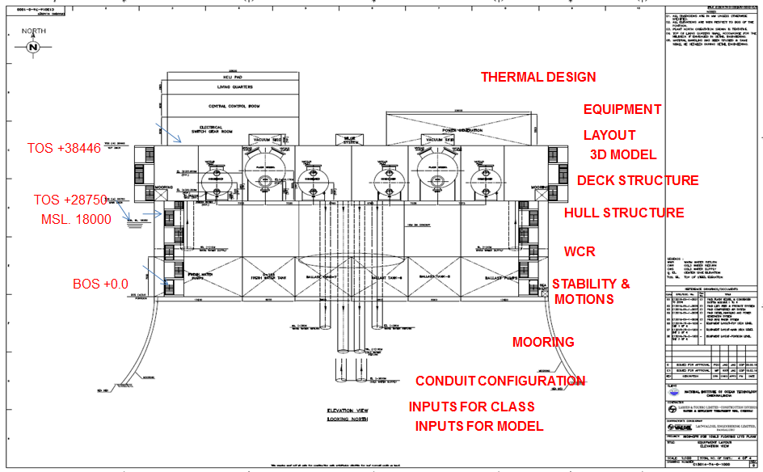
Fig 3.1 Overall Elevation View of the Plant

Thermal Process & Equipment Design
The overall thermal system concept is shown in Fig 3.2. Process parameters and 10 MLD LTTD configurations-
Process Parameters

- Fresh water generation rate : 10MLD (10000 m³/day)
- Working fluid : Seawater
- Warm water inlet temperature (Tw) : 27°C at MSL
- Cold water inlet temperature (Tc) : 10°C at 800 m depth below MSL
- Dissolved Oxygen content in the warm water : 4 ppm
- Dissolved Nitrogen content in the warm water : 16 ppm
- Operating time per day : 24 hours
- TDS of produced water : < 500 ppm

No. of Modules
- 4 X 25% Modules selected, and each of 2.5 MLD capacity
- Each 2.5 MLD module mainly consists of –
  - 1 no. of Flash Vessel
  - 2 nos. of Condensers
  - 1 no. of Vacuum system
Fig 3.2: Thermal system concept (2.5 MLD)
Major Equipment Parameters
The equipment required for the process is listed in Table 3.1.
Table 3.1: Major Equipment Parameters
Sl. No. | Equipment | No. | Dimension /  LxBxH | Parameter/  unit | Feature
1 | Flash chamber | 4x25% | 6 m ID x 20 m x 7.5m | 2.5 MLD | MOC – CS with internal lining of Glass Flaked Vinyl Ester  Internals – Spout pipe, Spouts & Demister pad
2 | Condenser | 8x12.5% | 4.6m ID x 18m L x 6.5m | 1.25 MLD | MOC – Cu-Ni alloy tube & CS shell  with internal lining of SS  - TEMA type – AXM  ii) Tube side Radial inlet & Axial outlet  iii) 2 pass tube cross flow arrangement
3 | Vacuum System | 4x25% | 9m x 5m x 2m | 40716 m3/hr | 2 stage blower with intercooler & 1 stage LRVP
4 | Warm water pump | 4x25% |  | 14100 m³/hr @7.12m WC | MOC as per D2 of Annexure – H of API 610.
5 | Cold water pump | 4x25% |  | 8300 m³/hr @ 20.5m WC | MOC as per D2 of Annexure – H of API 610.
6 | DG sets | (4+1)x25% |  | 2.2 MW | 4 working at 25% and one (1X25%) stand by.
7 | Fresh Water pump | (1+1)x100% |  | 460 m³/hr @ 488m WC | 1working + 1 stand by  MOC as per D2 of Annexure – H of API 610.
The schematic of flash chamber, shell and tube condenser, worm water and cold water pump is shown in Fig 3.3 - 3.6.

Fig 3.3 Schematic of Flash Chamber

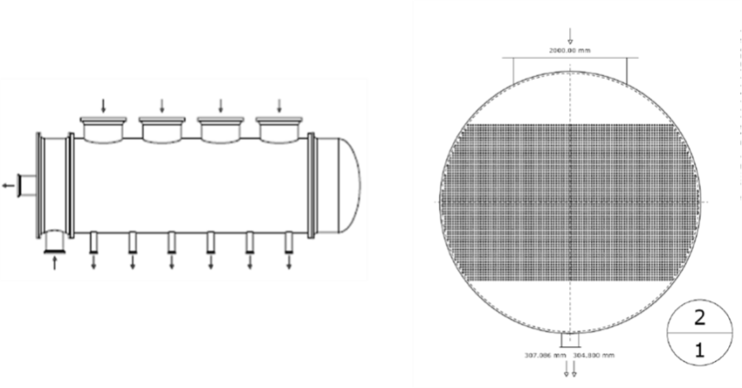
Fig 3.4 Schematic of Shell and tube condenser with tube bundle

Fig 3.5 Warm water pump | Fig 3.6 Cold water pump

Floating Systems & Structural Design
The following major analyses and studies were carried out for the hull and topside design -

The hull is designed to support the main equipments along with the necessary utility systems in the main deck to generate 10-MLD fresh water. The hull consists of a square ring pontoon with outer lengths of 60m, a height of 7m and a width of 13.4m and ring pontoon is topped with four square columns of 13.4m × 13.4m side at the corners and a height of 21m. Four columns support the square truss type deck of size 60m × 60m. The pontoons are subdivided into compartments for ballast water, diesel fuel oil, produced fresh water and pump rooms, and also taking into account damage stability requirements. An access tunnel runs through the pontoon providing access to various tanks and the pump rooms connecting the four columns. The pump rooms are subdivided with watertight bulkheads and doors in order to comply with damage stability requirement. The columns are subdivided by vertical and horizontal watertight bulkheads considering the damage stability requirements. The access to the pontoon is via stairs through columns.The motion and top side structural analysis was performed in Bentley MOSES and SACS software tool respectively.
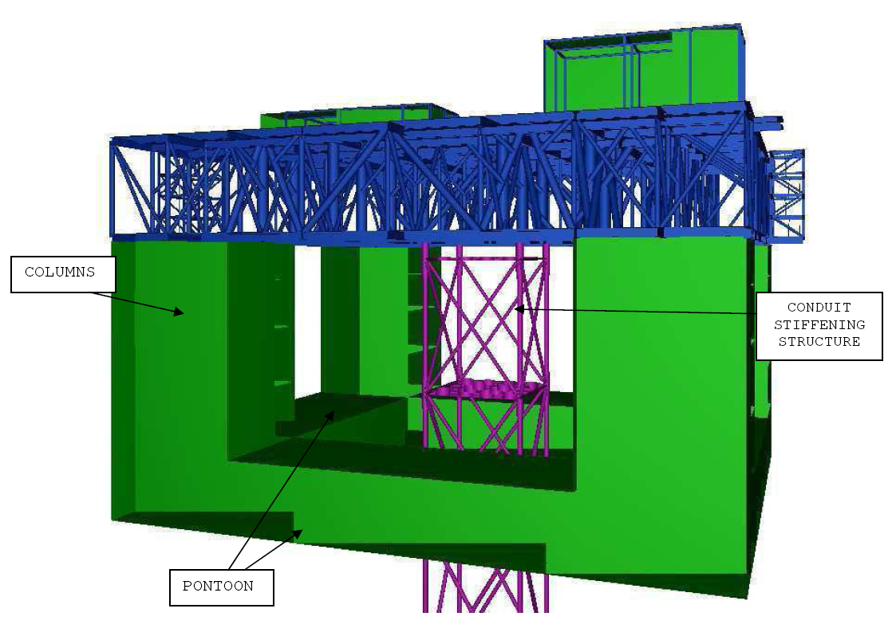
Fig 3.7 Platform with deck and conduit stiffening structure

Integration of Hull and Top-side

A brief schematic of the method of integration of hull and top-side is presented in Fig. 3.8.

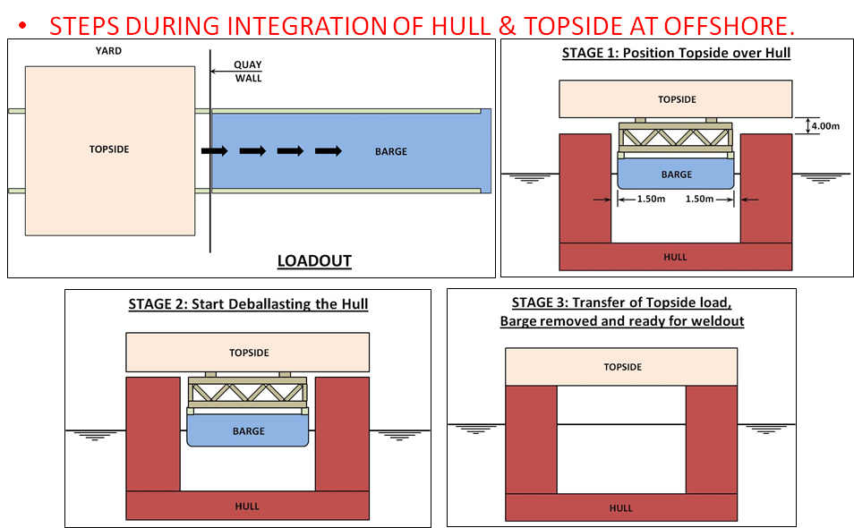
Fig 3.8 Schematic of integration of Hull and Top-side
Final weight summary for various disciplines for operating and survival conditions is listed in Table 3.3.
Table 3.2 Platform Weight Summary

SL.NO | CATEGORY | UNIT | CONDITION
SL.NO | CATEGORY | UNIT | Operating | Survival
1 | Strl Hull | MT | 7006 | 7006
2 | Strl Deck | MT | 4530 | 4530
3 | Conduit Stiffening Structure | MT | 422 | 422
4 | Mechanical | MT | 4,609 | 3545
5 | Piping | MT | 1,854 | 1,193
6 | Instrumentation | MT | 63 | 63
7 | Electrical | MT | 80 | 80
 | Sub-Total |  | 18564 | 16839
8 | Pipelines (HDPE Conduit) | MT | 1562.58 | 1591
9 | Tank Filling (Ballast) | MT | 5571 | 2792
10 | Mooring Pretension (each line) | MT | 122 | 356
 | Draft | m | 18 | 13.05
 | Displacement | MT | 26311 | 22655
 | VCG | m | 16.21 | 16.52
 | GM CORRECTED | m | 5.05 | 5.58

Pipeline & Conduit Bundle Design
The following major analysis and studies were carried out for the HDPE conduit and freshwater transportation pipeline design using ANSYS, ORCAFLEX and using other recommended softwares and design methods -
- HDPE Conduits – Global In Place Analysis
- Modal / VIV / Fatigue Analysis
- Loadout, Towing & Upending Schematics
- Method of Transportation of Fresh Water From Platform to Mainland and pipeline / riser configuration
- Design and Analysis of Connection Clamp between HDPE Conduit Bundle and Platform

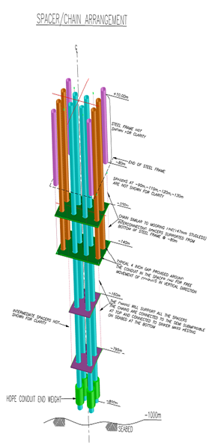 | 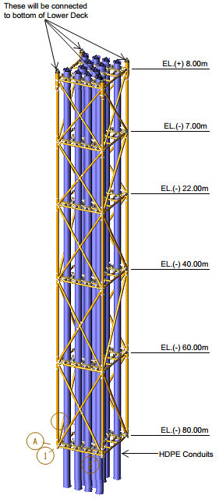
Fig 3.9 Conduit Bundle | Fig 3.10 Protection Frame

Fresh water delivery by riser/pipeline system

The transporting of fresh water is by combination of flexible riser from plant to seabed and rigid pipeline from there onwards to the main land for distribution. The proposed flexible riser will pass through a hang off I tube attached to offshore LTTD Plant. The flexible riser is held in position at one end by a dead weight clamp at platform deck level and other end is connected to pipeline end manifold resting on seabed.
The offshore rigid pipeline starts from the pipeline end manifold and terminates at onshore fresh water receiving terminal. Flexible pipe of 12 inch inner diameter with carcass, inner liner, pressure and tensile armour with outer sheath is selected for riser and 14’’ inch OD pipe made of carbon steel is selected for the pipeline.
The pipeline has been checked for on-bottom stability, lateral and vertical stability based upon the guidelines given in DNV code.

Highlights of Electrical & Instrumentation Design
The total amount of power required is shown in Table 3.7

Table 3.3(a): Main Power Requirement
100% of Continuous Load | :6167.06 kW
50% of the total intermittent load or the largest intermittent load, whichever is greater | :177.49 kW
10% of total standby loads or the single largest standby load | :980.35 kW
Total Load | :7324 kW
With 10% design margin for Future growth | :8057.39 kW

Table 3.3(b): Emergency Power Requirement
Total Continuous Load (During Emergency) | :103.48 kW
50% of the total intermittent load or the largest intermittent load, whichever is greater | : 65.93 kW
With 10% design margin for Future growth | :186.36 kW

- Main & Emergency Power Generators provided
- Facility provided in the Unit Control Panel (UCP) for monitoring engine parameters
- Main Power Generation provided with synchronization, load sharing and load shedding features.
- Unit Control Panel (UCP) include Multi-Function Relay (MFR), control and metering equipment
- The ingress protection for all outdoor auxiliary equipment shall be as follows :
  - Electrical equipment : IP-56 as minimum
  - Instrumentation equipment : IP-65 as minimum.
- IP protection for the auxiliary equipment mounted indoor is IP-41 as a minimum.

Sizing of Major Electrical Equipment

Main Power Generation
Based on the load requirements 5 nos. of DG sets (4 working + 1 standby) each of 2.2MW (site rated), 6.6kV, 0.8pf (lag), 50Hz was considered for 10MLD plant.

Emergency Power Generation
Based on the emergency power requirement 1 no. of 190kW (site rated), 415 V, 0.8 pf, 50Hz emergency generator was considered for the plant.

Transformer for LV Power Distribution
Based on the load requirement 2 nos. of 2 x 100% (1 working + 1 standby) 3 MVA, 6.6kV/0.433kV Outdoor Cast Resin dry type Transformer was considered for powering LV loads of the plant.
Instrumentation and data acquisition
- Apart from control & monitoring at offshore platform by Integrated Control System, the provision is also made to repeat the offshore parameters at On-Shore via SCADA connectivity.
- PLC based Integrated Control System (ICS) is envisaged over SCADA system due to the fact that PLC based ICS will perform more functionalities effectively than SCADA in terms of process monitoring, control & Interlock, supervision & alarm functions.

