


TENDER DOCUMENT
(Open Domestic Tender through GeM Portal: http://gem.gov.in)
Hiring of Drone/ UAV Services for Acquisition of Data from PPK enabled UAV for Mapping in North Karanpura and South Karanpura Coalfields in Central Coalfields Limited, Jharkhand.

TENDER REFERENCE NO.:CMPDI/GEOM/CMC/2023-24/19
Offers are invited online in two packet system namely Technical bid (packet-1) and Financial bid (packet-2) on the website http://gem.gov.in for Hiring of Drone/ UAV Services for Acquisition of Data from PPK enabled UAV for Mapping in North Karanpura and South Karanpura Coalfields in Central Coalfields Limited, Jharkhand.

- (A) Scope of work :

Job description | Project Location  (Priority wise) | Estimated Cost of Service in Rupees  (Including GST) | Earnest Money  (In Rs.) | Completion period of work  from the date of issue of LoA  (In Days)
Acquisition of Data from PPK enabled UAV based Optical sensor for preparation of High resolution orthophotomosaic images, Contour maps and Topographical Maps using photogrammetry technique at North Karanpura Coalfields (NKCF) and South Karanpura Coalfields(SKCF) in Central Coalfields Limited, Jharkhand.  (Ref. Plate I & II enclosed ) | - Ashoka Project, NKCF  (Area 20 Sq. Kms) | 5,23,920.00 | 1,00,600.00 | 30 days
 | - Magadh Project, NKCF  (Area: 26 Sq Kms) | 6,81,096.00 | 1,00,600.00 | 40 days
 | - Amrapali Project, NKCF  (Area: 28 Sq Kms.) | 7,33,488.00 | 1,00,600.00 | 45 days
 | - South Karanpura Coalfield (SKCF)  (Area: 233.00 Sq Kms.) | 61,03,668.00 | 1,00,600.00 | 60 Days
 | TOTAL 307.00 Sq. Km | 80,42,172.00 | 1,00,600.00
NOTE: Project-wise payment will be released on completion of each project.
The area mentioned above in ‘Project Location’ are tentative and may vary slightly as per site condition during execution.

Tender Inviting Authority | Contact Person(s)/ Tender Dealing Officer(s)
General Manager (CMC*)  Contract Management Cell, CMPDI (HQ)  Gondwana Place, Kanke Road,  Ranchi – 834031, Phone – 8987788787 | General Manager (Geomatics)  Central Mine Planning & Design Institute Limited  Gondwana Place, Kanke Road, Ranchi – 834031,  Jharkhand, India  Phone/FAX: +91-651-2230041  Email ID: gmgeomatics.cmpdi@coalindia.in
* Contract Management Cell

(B) Time Schedule of Tender: : As given on the on-line on GeM Portal: https://gem.gov.in.

NOTE (Important):
- If the due date of opening falls on a holiday, the Tender will be opened on the next working day.
- One extension of bid submission date by four days in case of number of bids received is less than three.. No separate corrigendum shall be issued and published by the Bid Inviting Authority for extending the due dates. This extension will be also applicable in case of receipt of zero bid.
- After extension, the bid shall be opened irrespective of available number of bids on the extended date of opening of bid.
- There will be no physical / manual sale of the Tender Document.
- There is no tender fee and the bidders can download the Tender Document free of cost.
- Bidders are advised to download the complete set of the Tender Document, including the tender details.

- (A) Details of Work:
Acquisition of Data from PPK enabled UAV based Optical sensor for preparation of High resolution orthophotomosaic images, Contour maps and Topographical Maps using photogrammetry technique at North Karanpura Coalfield (NKCF) and South Karanpura Coalfield (SKCF) in Central Coalfields Limited, Jharkhand.The Project-wise Area of survey is tabulated above. The deliverables of the work are as tabulated below.
The required deliverables for the above mentioned work shall be as follows:
Sl. | Type of Data | Deliverables Format |  | Remarks
Sl. | Type of Data | Softcopy | Hard copy | Remarks
1. | Orthophoto mosaic | In Geo tiff Format . | In 1:5000 scale, Five(5) copies in Glossy paper. | Shape file / kml file/ dxf file of boundary of Area of Interest (AoI) will be provided by CMPDI. (Refer Plate-I& II).  Base Station Coordinates in Coalgrid as well as in UTM/ WGS84 system,with location will be provided by CMPDI.
2. | Point cloud data | XYZ in the form of industry standard format like (*.las) | -
3. | Soft copies of DEM & DTM | In Geo tiff Format | -
4. | Contour maps having contours at an interval of 1 meter | In industry standard GIS Format alongwith DXF format compatible with Auto-cad. | -
5. | Digitisation of features like Roads, Railways, Nalah, Habitation Areas, Forest, Railway Lines, Water-bodies, Transmission Lines Towers, Thermal Power Plants & Substations (Location and Boundary Only) and superimposition of the above layers on the orthophotomosaic images. | In industry standard GIS Format alongwith with shapes and the dxf files of all the digitised layers | In 1:5000 scale, Five (5) copies in Glossy paper showing boundary of Projects / Blocks, DigitisedFeatures and Contours.
6. | DGPS Surveyed GCP Points | Raw file of DGPS/ ETS data acquisition as well as processed data in excel format. | -
7. | A Report on UAV based Survey of the above work. | MS Word / PDF Format | 3 copies in hard bound
The desired GSD of acquired data should be less than 3 cm. It may be noted that the area indicated in the Scope of Work may vary slightly as per requirements.

Note:

- The report mentioned at Sl. 7. of the above Table should be submitted by vendor with the followings details:

- Location of the Area
- Plans/Maps as per above table.
- Equipment used for UAV Survey with specifications and UIN of UAV used.
- Detailed description of methodology used in data processing and analysis.
- Water bodies, Trees, Buildings etc. should be excluded while generating contours from DTM.
- Projection system of UTM WGS84 shall be used.
- Topographical Map shall also be prepared in Coal Grid. All GCPs surveyed in WGS 84 coordinate system may be converted into Coal Grid by CMPDI.
- Soft-copy of Data shall be provided to CMPDI in two external Hard Disk Drives for each project.
- DGPS survey with respect to known base station: Sufficient nos. of Ground Control Points (GCP) to be surveyed with sufficient duration to achieve desired accuracy.

- The bidder shall provide Flight log book showing details as per DGCA guidelines and Drone/ UAV rules.

- Any third party liability or losses incurred due to damage caused by Drone/ UAVs and/or its operations to other equipment or individual during Drone/ UAV operations shall be the responsibility of the bidder.

- Compliance to DGCA guidelines related to equipment, manpower and operations shall be the responsibility of the bidder.

(B) Other service requirements :
- The inputs for the above job such as KML/ shp/ dxf file, Base Station details related to the work shall be provided by CMPDI and the bidder will work under instructions of GM (Geomatics), CMPDI, Gondwana place, Kanke Road, Ranchi.
- Provision for field survey equipment, manpower, logistics for survey, data processing at site/ CMPDI(HQ)/ bidder’s premises, during contract period shall be responsibility of the bidder.

- On receipt of LoA, the successful bidder will have to send a technical person to Geomatics Division, CMPDI, Ranchi for detailed discussions and for getting instructions prior to start of work at site.
- Representatives from CMPDI may visit the site during acquisition of data through Drone/ UAV based sensors for coordination and necessary instructions.

- Quality of acquired data should be checked on day to day basis in the field itself to avoid any discrepancy during processing and thus ensuring quality output.

- It is the duty of the service provider to check the quality, suitability and coverage of area surveyed on daily basis. A report to this effect shall be sent to any communication means such as email/ whatsapp etc daily.

- The time schedule as detailed in the Scope of Work has to adhered strictly.

- Availability of Tender Documents:
Detailed Tender Notice & Tender Documents including terms and conditions of works shall be available on Government E-Market Place (GeM) portal https://gem.gov.in and Tender Notice shall be available at websites www.cmpdi.co.in.& http://eprocure.gov.in/cppp. . The Tender document can be downloaded by any prospective bidder from the GeM Portal free of cost. The download of tender document may start immediately after e-Publication of NIT and shall continue till the last date and time specified for downloading the document.
- Clarification of Bid:
The bidder may seek clarification online through e-tendering portal http://gem.gov.in within the specified period. No other mode of seeking clarifications shall be entertained. The identity of the Bidder will not be disclosed by the system. The department will clarify, as far as possible, the relevant queries of bidders. The clarifications given by department will be visible to all the bidders intending to participate in that tender. The clarifications may be asked from the day of e-Publication of NIT. The period for seeking clarification by bidder will be as per provision of GeM portal.

- Bid Security / Earnest Money Deposit (EMD):
  - Deposit of EMD:
The bidder will have to make the one-time payment of EMD through NEFT/ RTGS only and have to furnish UTR Number during submission of bid. Bidder will have to submit the proof of payment of EMD. Bidder should upload a copy of NEFT/ RTGS payment confirmation document consisting UTR Number along with confirmatory documents.
The Earnest Money/ Bid Security of the unsuccessful bidder will be refunded and will not bear any interest.
EMD of the successful Bidder (on Award of Contract) will be retained by CIL/ Subsidiary and will be adjusted to Performance Security Deposit at the option of the Bidder.
No Bid will be accepted unless accompanied by the requisite Earnest Money Deposit as stated above.

Our bank detail for EMD is as below:
Name of Bank: State Bank of India,
Branch: CMPDI Branch,
IFSC: SBIN0005598
A/c No: 10106155087
Address: Gondwana Place, Kanke Road, CMPDIL Campus, Ranchi – 834031.
The bidders should submit MANDATE FORM for e-Payment along with EMD, as per the format given in the tender document as Annexure-II.
  - Exemption of EMD
The bidders under the category of Sate/ Central Govt./ PSUs/ firms registered with NSIC/ MSEs (Micro & Small Enterprises) / Start-up having valid registration and recognized by DPIIT(Department for Promotion of Industry and Internal Trade, GoI) for the tendered works are exempted from submission of EMD against uploading of valid documentary evidence.
In case of exemption of EMD, the scanned copy of document in support of exemption will have to be uploaded by the bidder during bid submission.

- User Portal Agreement:
The bidders have to accept unconditionally the online user portal agreement which contains the acceptance of all the Terms and Conditions of NIT including ‘General Terms & Conditions’ and ‘Special Terms & Conditions’ and other conditions, if any, along with on-line undertaking in support of the authenticity of the declarations regarding the facts, figures, information and documents furnished by the Bidder on-line through https://gem.gov.in in order to become an eligible bidder. No conditional bid shall be accepted / tender document, undertakings and the e-Procurement system through https://gem.gov.in in order to become an eligible bidder. This will be a part of the agreement.

Deadline for Submission of Bids
    - Online bids must be uploaded by the bidders at GeM portal by the last date and time as specified in e-tender notice.
    - In case, three (03) bids are not received within originally stipulated time, the due date of tender shall be extended by 4 (four) days. If, even after granting extension (Four days), less than three (03) bids are received, tender shall be opened without further extension. No separate corrigendum shall be issued and published by the Tender Inviting Authority for extending the due dates. In case no offer is received, tender will be cancelled.

- Qualification of the Bidders:
8.1 In order to submit the bid, the bidders have to get themselves registered online on GeM portal (https://gem.gov.in).
Bidders are advised to upload the scanned copy of documents specified under the eligibility criteria of the tender in support of their qualification, as Cover-I, against the tender. The CHECK LIST of such documents is also available under the heading Confirmatory Document to verify the submission of required information. Non-submission of requisite documents/ information will be considered as a non-responsive bid, which is liable for rejection.
8.2 The invitation for bid is open to all bidders including an individual, proprietorship firm, partnership firm, company or a Joint Venture having eligibility to participate as per eligibility criteria stipulated in clause No.9 of NIT.
8.3 Joint Venture (JV): Two or three Companies/Contractors may jointly undertake contract(s). Each entity will be jointly and severally responsible for completing the task as per the contract.
Joint Venture details:
Name of all Members of a JV (not more than 3):
1. Lead Member (minimum participation share – 50%)
2. Member (minimum participation share – 20%)
3. Member (minimum participation share – 20%)
Joint Venture must comply the following requirements:
- The qualifying criteria parameter e.g. experience, financial resources (of the relevant period) and the equipment/fleet strength of the individual member of the JV will be added together and the total criteria should not be less than as spelt out in clause 10 of NIT as qualifying/eligibility criteria as specified in e-tender Notice. However, the required Working Capital shall be met by individual members of JV as spelt out in Clause 9.2 of NIT.
- The formation of JV or change in the JV character/ members after submission of the bid and any change in the bidding regarding JV will not be permitted.
- The bid, and in case of a successful bid - the agreement, shall be signed so as to legally bind all members jointly and severally and any bid shall be submitted with a copy of the JV Agreement providing the joint and several liabilities with respect to the contract.
- The pre-qualification of a JV does not necessarily pre-qualify any of its member individually or as a member in any other JV. In case of dissolution of a JV, each one of the constituent firms may pre-qualify if they meet all the pre-qualification requirements, subject to written approval of the employer.
- The bid submission must include documentary evidence to the relationship between JV members in the form of JV Agreement to legally bind all partners jointly and severally for the proposed agreement which should set out the principles for the constitution, operation, responsibilities regarding work and financial arrangements, participation (percentage share in the total) and liabilities (joint and several) in respect of each and all of the firms in the JV. Such JV Agreement must evidence the commitment of the parties to bid for the facilities applied for (if pre-qualified) and to execute the contract for the facilities if their bid is successful.
- One of the members shall be nominated as ‘In-charge’ of the contract and shall be designated as Lead Partner. This authorization shall be evidenced by submitting with the bid a Power of Attorney signed by legally authorized signatories of all the members.
- The JV must provide that the Lead Member shall be authorized to incur liabilities and receive instructions for and on behalf of any and all members of the JV and the entire execution of the contract shall be done with active participation of the Lead Member.
- The contract agreement should be signed by each JV members. Subsequent declarations/letters/documents shall be signed by lead member authorized to sign on behalf of the JV or authorized signatory on behalf of JV.
- The bid should be signed by authorized signatory on behalf of JV.
- An entity can be a member in only one JV. Bid submitted by JVs including the same entity as member will be rejected.
- The JV agreement may specify the share of each individual member for the purpose of execution of this contract. This is required only for the sole purpose of apportioning the value of the contract to that extent to individual member for subsequent submission in other bids if he intends to do so for the purpose of the qualification in that Bid.
- The JV agreement must specifically state that it is valid for the project for which bidding is done. If JV breaks up midway before award of work and during bid validity period bid will be rejected. If JV breaks up midway before award of work and during bid validity/after award of work/during pendency of contract, in addition to normal penalties as per provision of bid document, all the members of the JV shall be debarred from participating in future bids for a minimum period of 12 months.
- JV agreement shall be registered in accordance with law so as to be legally valid and binding on the members before making any payment.
Note: If the work is awarded to a JV firm, they will register the JV agreement under Registration Act in accordance with law.
- JV shall open a bank account in the name of JV and all payments due to the JV shall be credited by employer to that account only. To facilitate statutory deductions all statutory documents like PAN, GST registration etc. shall be submitted by JV before making any payment.
- The JV must enroll in the GeM portal (https://gem.gov.in) with the name of the firm as appearing in the JV agreement.
- If a Bidder participates as Joint Venture (JV), the benefits as per Public procurement Policy for MSEs Order-2012 shall not be applicable for them.
- Lead partner of JV will participate in the bid on behalf of other members of JV since the JV at this stage of bid has not been registered as a Company. The agreement among JV partners can be attached with the bid by the lead partner.
- Once Lead partner of JV has been identified as L1 bidder, LOA shall be issued to the L1 partner of the JV. L1 Bidder will thereafter register the JV as per the law to form the Company and register on GeM as a new Service Provider (SP). GeM will update the new SP details in demand through back-end which will enable Buyer to create final contract with the JV along with PAN, GST of the newly formed company.

- Eligibility Criteria:The bidder has to fulfil the following eligibility criteria:
  - A) Work Experience
The bidder must have experience of works (includes completed / ongoing) of similar nature in UAV Photogrammetry Survey for the Central/State Government or any PSU in one of the following manner;
- One completed similar work of 80% of total tender value. or
- Two completed similar work each of 50% of total tender value. or
- Three or more completed similar work each of 40% of total tender value.

The Bidder must have experience of works (includes completed / ongoing) of similar nature valuing 50 % of the annualized estimated value of the work put to bid (for period of completion over 1 year) / 50 % of the estimated value of the work (for completion period up to one year) put to Bid in any year (consecutive 365 days) during last 7(seven) years ending last day of month previous to the one in which bid applications are invited.
“Annualised value” of the work shall be calculated as the “Estimated value/Period of completion in Days x 365”.
The value of executed works shall be given a simple weightage to bring them at current price level by adding 7% for each completed year (total number of days/365) after the end date of experience till the last day of month previous to one in which e-Bid has been invited.

Defination of Similar nature of work: Drone/ UAV photogrammetry survey in coal mining area together with web platform or web portal access for data visualization and/or analysis.
In respect of the above eligibility criteria, the bidders are required to furnish the following information:
          - Start date of the year for which work experience of bidder is to be considered for eligibility.
          - Start date & end date of each qualifying experience (similar nature).
          - Work Order Number/ Agreement Number of each experience.
          - Name & address of Employer/ Work Order Issuing authority of each experience.
          - Percentage (%) share of each experience (100% in case of an Individual/ Proprietorship firm or a partner in a partnership firm and the actual % of share in case of a Joint Venture).
          - Executed Value of work against each experience.
          - In case the bidder is a Joint Venture, the work experience of any one, two and three of the individual partners of JV or the JV itself may be furnished as the work experience of the bidder.

Note:
    - In case any of the experiences does not fall in the selected period of 365 days (continuous), such experiences will be excluded from evaluation. Hence the bidder shall have to furnish the value of work executed only during the selected period of 365 days (continuous).
    - The weightage of 7% every year will be on simple rate and will not be compounded on yearly basis for the purpose of calculating the value of each qualifying experience."
    - The work experience of the bidder may be an ongoing work and the executed value of work shall be considered for evaluation.
    - In case the experience has been earned by the bidder as an individual or proprietor of a proprietorship firm or partner of a partnership firm, then 100% value of the experience will be considered against eligibility. But if the experience has been earned by the bidder as a partner in a Joint Venture firm /partnership firm then the proportionate value of experience in proportion to the actual share of bidder in that Joint Venture /partnership firm will be considered against eligibility.

Scanned copy of documents to be uploaded by bidders (CONFIRMATORY DOCUMENT):

For work experience, Bidders are required to submit Work Experience Certificate issued by the employer against the experience of similar work containing all the information as sought on-line.

Work order, BOQ, TDS etc. may be sought during clarification or along with deficient documents, if felt necessary by the Bid Committee.
NOTE: For eligibility Total Amount of Work Experience (adding all the Experience Value during the consecutive 365 days) should be at least 50% of the Annualized value or estimated value whichever is less.
Work order, BOQ, TDS etc. may be sought during clarification or along with deficient documents, if felt necessary by the Tender Committee.

The Bidder must have experience of works (completed work) of similar nature which includes UAV photogrammetry survey valuing 50% of the Annualized estimated value of the work put to tender (for period of completion over 1 year) / 50% of the Estimated value of the work (for completion period up to one year) put to Tender, in any year (consecutive 365 days) during last 7(seven) years ending last day of month previous to the one in which bid applications are invited.

“Annualised value” of the work shall be calculated as the “(Estimated value/Period of completion in Days) x 365”.

The value of executed works shall be given a simple weightage to bring them at current price level by adding 7% for each completed year (total number of days/365) after the end date of experience till the last day of month previous to one in which e-Tender has been invited.

Data to be furnished by Bidder online:
- Start date of the year for which work experience of Bidder is to be considered for eligibility.
- Start date & end date of each qualifying experience (similar nature).
- Work Order Number/Agreement Number of each experience.
- Name & address of Employer/Work Order Issuing authority of each experience.
- Executed Value of work against each experience.

B) Key Personnel Strength
In respect of the above eligibility criteria the Bidders are required to furnish the following information online:
- Particulars of key personnel including experience.
- Scanned Copy of document as explained at Clause 1.6 related to key personnel.
- The documentary evidence to this effect would be self-attested CVs duly countersigned by the authorized representative of Bidder.
- The following Key personnel must be associated with the bidder on regular pay roll basis and has to provide supporting documents for relevance of the same.

Key Personnel | Qualifications | Total Experience
Team Leader | PhD/Master’s/Bachelor Degree | At least 3 Years
Key Person with specialization in Geoinformatics/ Remote Sensing / GIS / Geomatics  (Atleast 1 No.) | Bachelor Degree / Certificate Course / Diploma or higher | At least 3 Years
Civil/ Mining Engineer  (Atleast 1 No.) | Bachelor’s Degree | At least 3 Years
Surveyor  (Atleast 2 No.) | Bachelor’s Degree/Diploma/ ITI | At least 3 Years
Drone/ UAV/ UAV Pilots | Intermediate (10+2) or above with valid pilot licences | At least 1 Year

9.2 Working Capital
Evidence of possessing adequate working capital (at least 20% of the “Annualized value or Estimated value whichever is less” of this work) inclusive of access to lines of credit and availability of other financial resources to meet the requirement. The bidder should possess the working capital within three months prior to the date of opening of tender.
In case of JV, the requirement of Working Capital under this clause shall be met as per following proportion:
a. The lead member shall have to possess at least 50% share in the required Working Capital in order to qualify in this tender.
b. All other members shall have to possess at least 25% share in the required Working Capital, in order to qualify in this tender.
If a bidder participates as a Joint Venture(JV), the benefits as per Public Procurement Policy for MSEs order-2012 shall not be applicable for them.
In respect of the above eligibility criteria, the bidders are required to furnish the following information:
          - Amount of available working capital inclusive of lines of credit and availability of other financial resources.
          - Date on which the bidder possesses the required working capital.
          - Name of the Chartered Accountant (CA) .
          - Membership Number of CA with UDIN who certifies the bidder's working capital on a particular date.
          - Date of Issue of Certificate.
          - In case the bidder is a Joint Venture, the working capital of the individual partners of the JV will be added together for each financial year and is to be furnished as the working capital of the bidder for that particular financial year.
Scanned copy of documents to be uploaded by bidders (Confirmatory Document):
The intending bidder must submit Certificate of Working Capital from Practicing Chartered Accountant having a membership number with Institute of Chartered Accountants of India containing the information as furnished by Bidder online.
Note: Relevant clause of GEM bid document in respect of “The minimum average annual financial turnover” is not applicable in this bid as provisions mentioned under clause 9.2 is applicable in respect of Working Capital as per relevant manuals of Coal India Ltd.
Certificate of Working Capital issued by a Practicing Chartered Accountant having a membership number with Institute of Chartered Accountants of India containing the information as furnished by bidder on-line or equivalent certificate of foreign partner issued from the respective country.Such certificate should contain the Unique Document Identification Number (UDIN).
  - Fleet Requirement:
The bidder is required to give an undertaking in the form of an Affidavit (Annexure VII) in the prescribed format to deploy PPK enabled UAV/ Drone/ UAV alongwith suitable sensors, equipment and related software as per NIT.
Scanned copy of documents to be uploaded by bidders (Confirmatory Document):
An affidavit confirming acceptance to deploy sufficient numbers of UAV/Drone/ UAV alongwith suitable sensors, equipment and related software as per NIT as per Annexure VII.

  - Permanent Account Number:
The bidder should possess a Permanent Account Number (PAN) issued by Income Tax Department, Govt.of India.
Data to be furnished by Bidder online: In respect of the above eligibility criteria, the bidders are required to furnish the following information online:
Confirmation in the form of YES/NO regarding possessing of PAN
Technical evaluation by the System:
The system will evaluate “Yes” as eligible and “No” as not eligible.
Scanned copy of documents to be uploaded by bidders (Confirmatory Document):PAN CARD of the bidder.
  - Goods and Service Tax (Not Applicable for Exempted Goods / Services):
The bidder should be either
- GST Registered Bidder under regular schemeOR
- GST Registered Bidder under composition schemeOR
- GST unregistered Bidder during bid submission.
Registration:
The bidder is required to be registered under GST unless they are specifically exempt from registration under specific notification / circular / section / rule issued by statutory authorities.
The bidder claiming exemption in this respect shall submit supporting documents as well as certificate from Practicing CA having membership number with Institute of Charted Accountants of India certifying that the bidder is GST unregistered bidder/exempted bidder in compliance with the relevant GST rules of India.
For Example:: If the bidder is exempt from Registration under CGST ACT, 2017 due to his aggregate turnover in the relevant financial year being less than 20/40 lakhs as per applicable in respective state then bidder shall submit the copy of Notification along with Certificate from Practicing CA/CMA/CS to the effect that Aggregate turnover from his all business operation during the relevant financial year is less than 20/40 Lakhs as per applicable in respective state and hence he is exempt from Registration under GST Act, 2017.
The expression “aggregate turnover” shall include all supplies made by the taxable person, whether on his own account or made on behalf of all his principal.
Explanation:
    - Every supplier shall be liable to be registered under this Act in the State or Union territory, other than special category States, from where he makes a taxable supply of goods or services or both, if his aggregate turnover in a financial year exceeds twenty lakh rupees.
    - Provided that where such person makes taxable supplies of goods or services or both from any of the special category States, he shall be liable to be registered if his aggregate turnover in a financial year exceeds ten lakh rupees.
"Special category States” shall mean the States as specified in sub-clause (g) of clause (4) of article 279A of the Constitution: States of Arunachal Pradesh, Assam, Jammu and Kashmir, Manipur, Meghalaya, Mizoram, Nagaland, Sikkim, Tripura, Himachal Pradesh and Uttarakhand are specified in sub-clause (g) of clause (4) of article 279A of the Constitution.

Scanned copy of documents to be uploaded by bidders (CONFIRMATORY DOCUMENT):
The scanned copy of documents regarding status w.r.t. GST to be uploaded by bidders in support of information/ declaration furnished online by the bidder in the BOQ sheet against Eligibility Criteria.
- Status: GST Registered Bidder under regular scheme:
Document: GST Registration Certificate (i.e. GST identification Number) issued by appropriate authority of India.
- Status: GST Registered Bidder under composition scheme:
Document:GST Registration Certificate under composition certificate (i.e. GST identification Number) issued by appropriate authority of India
- Status: GST unregistered bidder:
Document: A Certificate from a practicing Chartered Accountant having membership number with Institute of Chartered Accountants of India certifying that the bidder is GST unregistered bidder/ dealer in compliance with the relevant GST rules of India.
Note:
i). If turnover of bidder exceeds exemption/threshold limit, the bidder must have GST registration as per GST Act and rules.
ii) During the execution of the contract if the GST status of the bidder changes, then the payment of GST, if any, to the contractor will be made as per the GST status declared by the bidder during tender stage based on which cost to company has been ascertained or at actuals, whichever is lower.
  - An Undertaking:
An Undertaking on the bidder’s letter-head regarding genuineness of the information furnished by him on-line and authenticity of the scanned copy of documents uploaded by him on line in support of his eligibility, as per the format given in the bid document at Annexure-IV.

9.7 Legal Status of the bidder:
Bidders must be an individual, proprietorship firm, partnership firm,company registered under company’s act.
Any one of the following documents:
- Affidavit or any other document to prove proprietorship/individual status of the bidder.
- Partnership deed containing name of partners.
- Memorandum & Article of Association with certificate of incorporation containing name of bidder.
- In case of MSEs firm, a declaration to be submitted if the firm is owned by SC/ST/Women.
Data to be furnished by Bidder online: In respect of the above eligibility criteria, the bidders are required to furnish the following information online:

9.8 Confirmatory Documents:A Tabulated list of documents is required to be submitted in support of the Eligibility Criteria.
The documents submitted by the bidder should be numbered and indexed.
Sl No. | Eligibility Criteria | Scanned copies of documents to be uploaded by bidders in support of eligibility criteria
1. | Letter of Bid (LOB): | Letter of Bid (LOB) on the bidder’s letter head, in prescribed format (Annexure-I).
2. | Earnest Money Deposit: | Refer Clause No. 5 of NIT.
3. | The Work Experience:  The Bidder must have experience of works (includes completed/ ongoing) of similar nature valuing 50 % of the annualized estimated value of the work put to bid (for period of completion over 1 year) / 50 % of the estimated value of the work (for completion period up to one year) put to Bid in any year  (Consecutive 365 days) during last 7(seven) years ending last day of month previous to the one in which bid applications are invited.  * Similar Nature – Drone/ UAV photogrammetry survey in coal mining area together with web platform or web portal access for data visualization and/or analysis. | For work experience, Bidders are required to submit Work Experience Certificate issued by the employer against the experience of similar work containing all the information as sought on-line. Work order, BOQ, TDS etc. may be sought during clarification or along with deficient documents, if felt necessary by the Bid Committee.  If a bidder participates as a Joint Venture(JV), the benefits as per Public Procurement Policy for MSEs order-2012 shall not be applicable for them.
4. | Key Professionals: | The bidders are required to submit copy of the self-attested CV for each professional as declared by them. (Refer Clause 9.1 B)
5. | The Availability of Working Capital (Refer clause 9.2) :  Evidence of possessing adequate working capital (at least 20% of the “Annualized value or Estimated value whichever is less” of this work) inclusive of access to lines of credit and availability of other financial resources to meet the requirement. The bidder should possess the working capital within three months priorto the date of opening of tender. | Certificate of Working Capital issued by a Practicing Chartered Accountant having a membership number with Institute of Chartered Accountants of India containing the information as furnished by bidder on- line or equivalent certificate of foreign partner issued from the respective country. Such certificate should contain the Unique Document Identification Number (UDIN).  If a bidder participates as a Joint Venture(JV), the benefits as per Public Procurement Policy for MSEs order-2012 shall not be applicable for them.
6. | Fleet Requirement (Refer clause 9.3):  The bidder is required to give an undertaking in the form of an Affidavit in the prescribed format to deploy PPK enabled UAV/Drone/ UAV alongwith its sensors and equipment and related software as per NIT. | An Affidavit in the prescribed format to deploy UAV/ Drone/ UAV alongwith its sensors and equipment and related software as per NIT (Annexure-VII).
7. | Permanent Account Number (PAN) (Refer clause 9.4: The bidder should possess a Permanent Account Number (PAN) issued by Income tax Department. | In respect of the above eligibility criteria, the bidders are required to furnish the Scanned copy of PAN CARD of the bidder.  (In case of JV , PAN card for each Indian partner of JV and Verifiable Tax Residency Certificate of respective country for each foreign partner or JV itself).  If a bidder participates as a Joint Venture(JV), the benefits as per Public Procurement Policy for MSEs order-2012 shall not be applicable for them.
8. | Goods and Service Tax (Not Applicable for Exempted Goods/ Services)  (Ref. Clause No. 9.5 of NIT) | The following documents establishing the status of bidder w.r.t GST as declared by Bidder in the BOQ sheet:  - Status: GST registered Bidder under regular scheme.  Document: GST Registration Certificate (i.e. GST identification Number) issued by appropriate authority of India.  II. Status: GST Registered Bidder under composition scheme.  Document: GST Registration Certificate (i.e. GST identification Number) issued by appropriate authority of India.  III. Status: GST unregistered bidder:  Document: A Certificate from a practicing Chartered Accountant having membership number with Institute of Chartered Accountants of India certifying that the bidder is GST unregistered bidder/ dealer in compliance with the relevant GST rules of India.  [In case of JV a Certificate from a practicing Chartered Accountant having membership number with Institute of Chartered Accountants of India confirming the status of JV w.r.t GST in compliance with relevant GST rules or GST Registration Certificate of JV.]  If a bidder participates as a Joint Venture(JV), the benefits as per Public Procurement Policy for MSEs order-2012 shall notbe applicable for them.
9 | Legal Status of the bidder (Refer clause 9.7): | Any one of the following documents:  - Affidavit or any other document to prove proprietorship/ Individual status of the bidder.  - Partnership deed containing name of partners  - Memorandum & Article of Association with certificate of incorporation containing name of bidder.  - Joint Venture agreement as per the format given in the bid document.  - The document(s) regarding legal status of all the individual partners of JV as mentioned in Sl. No.1 or 2 or 3 above, as applicable and  - Authorization to all the signatories of JV agreement by the respective partners of JV either in the form of Power of Attorney or any sort of legally acceptable document as applicable.  4.In case of MSEs firm, a declaration to be submitted if the firm is owned by SC/ST/Women  (The partnership firm / JV is required to submit written consent of all the partners to Arbitration clause as per the provision stipulated in the NIT).
10. | Mandate Form for Electronic Fund Transfer: | Copy of Mandate form duly filled in as per Performa. (As per Annexure - II).
11. | Banning / Delisting:  (Ref. Clause No. 39 of NIT)  The bidders would give a declaration that they have not been banned or delisted by any Govt. or Quasi Govt. agencies or PSUs. | If a bidder has been banned or delisted by any Govt. or Quasi Govt. agencies or PSUs, this fact must be clearly stated and it may not necessarily be a cause for disqualification. If the declaration is not given, the bid will be rejected as non-responsive as per Annexure – III.
12. | Local supplier status of the Bidder:  (Ref. Clause No.21 of NIT) | All the Bidders at the time of bidding shall submit, if applicable, self-certification indicating the percentage of local content in the offered items as per Order No. P-45021/2/2017 PP (BE II) dated 16.09.2020 issued by Govt. of India regarding preference to Make in India.
13. | Undertaking as per “One bid per Bidder”(Clause-43 of NIT) | Undertaking for Clause 43/ Annexure IX
14. | Undertaking regarding genuineness: | An undertaking in the bidder’s Letter Head regarding genuineness of the information furnished by him online and authenticity of the scanned copy of documents uploaded by him online in support of his eligibility, as per the format given in Annexure IV.
15. | Quality Certificates | Quality certificates of ISO 9001:2015 (Quality Management System), ISO 27001-2018 (Information Security System) and Capability maturity model integration compliant certificate (CMMI 3) shall be provided
16. | Any other document to support the qualification information as submitted by bidder online.
Note: | Only one file in .pdf format can be uploaded against each eligibility criteria. Any additional/ other relevant documents to support the information/ declaration furnished by bidder online against eligibility criteria may also be attached by the bidder in the same file to be uploaded against respective eligibility criteria

- Contract Value:

The Contract Value will be the value of the ‘Rates quoted by bidder plus amount of GST. The liability of payment of GST by the contractor registered under GST will lie with the contractor. The payment of GST would be made to the contractor only on submission of Bill / Invoice in accordance with the provision of GST Rules. In case of unregistered bidder, the applicable GST will be paid by CMPDIL directly to the concerned Tax Authority, if any.
The Price-bids of the tenderers shall have no condition. The Price Bid which is incomplete and not submitted as per instruction given above will be rejected.
- Submission of Bid:

  - The bidder will submit their bid online. No off-line bid shall be accepted.
  - In order to submit the Bid, the bidders have to get themselves registered online on the GeM portal i.e. at http://gem.gov.in. The registration should be in the name of bidder.
  - It is the bidder’s responsibility to comply with the system requirement i.e. hardware, software and internet connectivity at bidder’s premises to access the GeM website. Under any circumstances, CMPDIL shall not be liable to the bidders for any direct/indirect loss or damages incurred by them arising out of incorrect use of the GEMs bidding system or internet connectivity failures.
  - In the undertaking given by bidder online, there will be provision for penal action, if any information/ declaration furnished online by the bidder against eligibility criteria is found to be wrong at any stage which changes the eligibility status of the bidder.
  - The information will be provided by the bidder by filling up relevant data through a form in an objective and structured manner. The software will use the information provided by the bidders to evaluate the technical bid.
  - All the bidders need to submit the information in objective manner confirmed by the uploaded documents. The documents related to the furnished online information, based on which the evaluation takes place will only be considered. If the bidder uploads any other document, it will be given no cognizance.
  - General Instructions for Submission of Tender: A bidder should strictly comply with the following instructions:
Bidders are required to submit offers online giving reference to this Tender Notice No. and Date, containing offers in double Packet only.
Packet-I: Letter of Bid, Information regarding Eligibility Criteria (as mentioned above), Confirmatory documents as mentioned in the NIT.
Packet-II: Bidder has to upload the Price bid i.e. BOQ in the Packet-II itself.
For online submission of tender the bidders will have to upload “Letter of Bid”, Information regarding Eligibility Criteria, working capital and all the confirmatory documents as prescribed in the NIT in Packet-I and “Price-bid” in Packet-II.
Letter of Bid: The format of Letter of Bid (LOB) will be downloaded by the bidder and will be printed on Bidder’s letter head and the scanned copy of the same will be uploaded during bid submission in Packet-I. This will be the covering letter of the bidder for his submitted bid. The content of the “Letter of Bid” uploaded by the bidder must be the same as per the format downloaded from website (Annexure-I)and it should not contain any other information.
If there is any change in the contents of Letter of Bid uploaded by bidder as compared to the format of Letter of Bid uploaded by the department with NIT document, then the bid will be rejected.
The Letter of bid will be signed by the bidder submitting bid online. However, if the Letter of Bid (LOB) bears the digital signature of DSC holder in addition to the physical signature, it will be accepted without questioning the identity of person signing the Letter of Bid.

- Evaluation of L-1 Status:
- The evaluation of tender shall be done based on cost to company. The cost to company shall be ascertained by reducing the total Value (including taxes and duties) quoted by the bidder by the amount of CGST & SGST or IGST, GST (Compensation to state) cess eligible for input tax credit. The L-1 shall be decided based on cost to company ascertained in manner suggested above.
Where the vendor is an unregistered one i.e. (exempt from registration under GST) supplying taxable service causing CMPDIL liable to deposit tax under reverse charge (Applicable after 31.03.2018 as decided by GOI), the CGST & SGST or IGST and GST (Compensation to state) cess, as applicable and payable by CMPDIL under reverse charge, if any, shall be added to quoted price while ascertaining the landed price. However, in this case also the L-1 shall be decided based on Cost to Company ascertained after deducting the CGST & SGST or IGST and GST (Compensation to state) Cess amount eligible for Input Tax Credit, if any, from the total value including tax arrived as above.

- The rate quoted by the supplier shall be exclusive of CGST, SGST, IGST and GST (Compensation to state tax) Cess and it should be strictly as per the format of BOQ. Item wise each element of cost shall be indicated, where applicable, in respective column specifically provided for that. Item wise rate of CGST & SGST or IGST and GST (Compensation to state tax) Cess, applicable at the time of bidding, shall be indicated by the bidder in respective column of the BOQ.
- The Tax Invoice raised by the supplier must be in compliance of relevant GST Acts, rules & notifications made thereunder and should bear the GSTIN number for the supply to CMPDIL HQ and its Regional Institutes located at different states as given below:
State | Unit / HQ | City | GSTIN
Jharkhand | HQ / RI-III | Ranchi | 20AAACC7475N1ZI

The rate and amount of CGST, SGST, IGST, and GST (Compensation to state) Cess, related to supply of goods/Services, shall be shown separately in tax invoice.
- The CGST & SGST, IGST and GST (Compensation to state tax) Cess, as applicable at the time of supply, shall be paid extra against submission of proper Tax Invoice, as referred above, by the supplier so that CMPDIL could be able to avail Input Tax Credit of such CGST, GST, IGST, GST (compensation to state) Cess reflected in the invoice.
- If CMPDIL fails to claim Input Tax Credit (ITC) on eligible Inputs and Capital Goods or the ITC claimed is disallowed due to failure on the part of supplier of goods and services in incorporating the Tax Invoice issued to CMPDIL in its relevant returns under GST, payment of CGST & SGST or IGST, GST (Compensation to State) Cess shown in Tax Invoice to the tax authorities, issue of proper tax invoice or any other reason whatsoever, the applicable taxes &Cess paid based on such Tax Invoice shall be recovered from the current bills or any other dues of the supplier.
- The amount of CGST & SGST or IGST and GST Cess, as indicated in the Tax Invoice shall be paid only when they appear in GSTR 2A of CMPDIL and the supplier has filed the valid return in accordance with the provisions of the GST Act and the rules made there under.
- If the Tax invoice submitted by the supplier is found defective causing disallowance of Input Tax Credit (claimed by CMPDIL based on such invoices) by the tax authorities, the applicable taxes &Cess paid based on such Tax invoice shall be recovered from the current bills or any other dues of the supplier.
- In the event of any additional tax liability accruing on the supplier of goods and/or services due to classification issue or for any other reason, the liability of CMPDIL shall be restricted to the amount of GST charged on the original tax invoice issued by the supplier.
- In addition to above, if any other tax/duties are levied over supply of such goods or services in future, it shall be paid extra.
- TDS: The TDS, if applicable, shall be made at applicable rate from the payment made or credited to the supplier.
If a bidder participates as a Joint Venture(JV), the benefits as per Public Procurement Policy for MSEs order-2012 shall not be applicable for them.

- Taxes and Duties:
All duties, taxes [excluding Goods and Services Tax (GST) and GST Compensation Cess (if applicable) only] and other levies payable by the bidder/ Contractor under the Contract, or for any other cause as applicable on the last date of submission of Bid, shall be included in the rates, prices and the total Bid Price submitted by the Bidder. Applicable GST either payable by bidder or by company under reverse charge mechanism shall be computed by system in BOQ sheet as per predefined logic. All investments, operating expenses, incidentals, overheads etc. as may be attendant upon execution and completion of works shall also be included in the rates, prices and total Bid price submitted by the bidder.
However, such duties, taxes, levies etc. which is notified after the last date of submission of Bid and/ or any increase over the rate existing on the last date of submission of Bid shall be reimbursed by the company on production of documentary evidence in support of payment actually made to the concerned authorities.
Similarly, if there is any decrease in such duties, taxes and levies the same shall become recoverable from the contractor. The details of such duties, taxes and other levies along with rates shall be declared by the bidder.
The item wise rate quoted by bidder shall be inclusive of all taxes, duties & levies but excluding GST & GST Compensation Cess, if applicable. The payment of GST and GST Compensation Cess by service availer (i.e. CMPDIL) to bidder/ contractor (if GST payable by bidder/ contractor) would be made only on the latter submitting a Bill/ invoice in accordance with the provision of relevant GST Act and the rules made thereunder and after online filing of valid return on GST portal. Payment of GST & GST Compensation Cess is responsibility of bidder/contractor.
Further, any GST credit note required to be issued by the bidder / contractor under the GST provisions should be issued within the time limit prescribed under the GST law.
However, in case bidder/ contractor is GST unregistered bidder/ dealer or GST registered under composition scheme in compliance with GST rules, the bidder/dealer shall not charge any GST and/or GST Compensation Cess on the bill/invoice. In case of unregistered dealer/bidder, GST, if applicable will be deposited by CMPDIL directly to concerned authorities, in terms with GST provisions.
Input tax credit is to be availed by paying authority as per rule.
If CMPDIL fails to claim Input Tax Credit (ITC) on eligible Inputs, input services and Capital Goods or the ITC claimed is disallowed due to failure on the part of supplier / vendor of goods and services in incorporating the tax invoice issued CMPDIL in its relevant returns under GST, payment of CGST & SGST or IGST, GST (Compensation to State ) Cess shown in tax invoice to the tax authorities, issue of proper tax invoice or any other reason whatsoever, the applicable taxes & cess paid based on such Tax invoice shall be recovered from the current bills or any other dues of the supplier / vendor along with interest and penalty, if any.
The rates and prices quoted by the Bidder shall be fixed for the duration of the contract and shall not be subject to variations on any account except to the extent variations allowed as per the conditions of the contract of the bidding document.
The company reserves the right to deduct/ withhold any amount towards taxes, levies, etc. and to deal with such amount in terms of t he provisions of the Statute or in terms of the direction of any statutory authority and the company shall only provide with certificate towards such deduction and shall not be responsible for any reason whatsoever.
In case of collection of minor minerals in area (both virgin and non virgin), acquired by the Company under the Coal Act, the contractor will have to produce a royalty clearance certificate from the District Authorities before full and final payment.
Further, where any damages or compensation be comes payable by either the Company or the bidder / contractor pursuant to any provision of this Agreement, appropriate GST wherever applicable as per the GST provisions in force shall also apply in addition to such damages or compensation.
Note: During the execution of the contract if the GST status of the bidder changes, then the payment of GST, if any, to the contractor will be made as per the GST status declared by the bidder during tender stage based on which cost to company has been ascertained or at actuals, whichever is lower.
- Modification and Withdrawal of Bid:
Modification of the submitted bid shall be allowed online only before the deadline of submission of tender and the bidder may modify and resubmit the bid online as many times as he may wish.
Bidders may withdraw their bids online within the end date of bid submission. However, if the bidder once withdraws his bid, he will not be able to resubmit the bid in that particular tender. For withdrawal of bid after the end date of bid submission, the bidder will have to make a request in writing to the Tender Inviting Authority.
  - If the request of withdrawal is received before online notification for opening of price bid, the EMD will be forfeited and bidder will be debarred for 1 (one) year from participating in tenders in CMPDIL. The Price-bid of remaining bidders will be opened and the tender process shall go on.
  - If the request of withdrawal is received after online notification for opening of price bid, the EMD will be forfeited and the bidder will be debarred for minimum 1 (one) year from participating in tenders in CMPDIL. The Price-bid of all eligible bidders including this bidder will be opened and action will follow as under:
i). If the bidder withdrawing his bid is other than L 1, the tender process shall go on.
ii). If the bidder withdrawing his bid is L-1, then re-tender will be done.
“The standard operating procedure to handle withdrawal of bid after end date of submission shall be as given in Clause 13 below:”
Note :In case of clause 14.1 & 14.2 above, a letter will be issued to the bidder by Tender Inviting Authority with the approval of Tender Accepting Authority.
15. Standard Operating Procedure for Withdrawal of Bid:
I. The Mode of withdrawal: -
- Online Withdrawal of Bids:
- The system of online withdrawal is available on the portal up to end date of bid submission, where any bidder can withdraw his/her bid which will attract no penal action from department side.
- The system of online withdrawal beyond end date of bid submission and till award of contract is also available but not fully functional and under development stage. Once it is developed and implemented only online withdrawal shall be considered except for some exceptional cases as mentioned in clause below.
- Offline Withdrawal of Bids :
- A partner of bidder (in case of partnership firms) whois registered on the GeM portal can access the portal for online withdrawal but when there is a split in the business relationship, the partners whois not registered on the portal do not have the option of online withdrawal of bid. Hence such partners may opt to use offline method of withdrawal of his/ her offer (or express his disassociation from the bidder organization).
- Offline withdrawal of bid, beyond end date of bid submission and till award of contract, may be considered by the tender committee.
- Acceptance of withdrawal by Tender Committee:
Every case of withdrawal under Clause 14.I-(A) (b) and Clause 14.I-(B) shall be put up to Tender Committee for deliberation and further course of action.
The decision of Tender Committee will be binding on the tenderer.

- Tender Status:
It will be the bidder’s responsibility to check the status of their Bid online regularly, after the opening of bid till award of contract. Additionally, information shall also be sent by system generated e-mail and SMS at nodal points (Date of bid opening, Requisition for Clarification on Confirmatory document from bidder(s), award of work etc.). No separate communication will be required in this regard. Non-receipt of e-mail and SMS will not be accepted as a reason of non-submission of Confirmatory documents within prescribed time. This will be specifically mentioned in the NIT. The Tender Status will be in public domain and anyone visiting the site can view it by identifying the tender.
It is the bidder’s responsibility to comply with the system requirement i.e. hardware, software and Internet connectivity at bidder’s premises to access the GeM portal. Under any circumstance, CMPDIL shall not be liable to the bidders for any direct/indirect loss or damages icurred by them arising out of incorrect use of the GeM portal or Internet connectivity failures.
- Opening of Technical Bid:
  - Opening of Technical bid: The Technical bid (Packet-I) will be opened on scheduled date and time after the Bid submission end date or next working day whichever is later. Technical bid will be decrypted and opened online by the “Bid Openers” on the prescheduled date & time of Tender Opening.
  - If the parameter given by bidder in objective and structured manner does not confirm to required eligibility criteria as specified in the tender document then the bid will be rejected.
  - All the documents uploaded by bidder(s) including Letter of Bid & EMD exemption documents (if any) shall be downloaded after opening of Technical bid for technical bid evaluation.
- Technical Evaluation of Tender:
  - After opening of Technical bid, the documents submitted by bidder(s) in packet-1 as enlisted in the NIT will be downloaded by the Evaluator and shall be put up to the Tender Committee. The Tender Committee will examine the uploaded documents against information/declarations furnished by the bidder(s) online. If it confirms to all of the information/ declarations furnished by the bidder online and does not change the eligibility status of the bidder then the bidder will be considered eligible for opening of price bid.
  - In case the Tender Committee finds that there is some deficiency in uploaded documents corresponding to the information furnished online or in case corresponding document have not been uploaded by bidder(s) then the same will be specified online by Evaluator clearly indicating the omissions/shortcomings in the uploaded documents and indicating start date and end date allowing 7 days (7 x 24 hours) time for online re-submission by bidder(s). The bidder(s) will get this information on their personalized dashboard under “Upload confirmatory document” link. Additionally, information shall also be sent by system generated email and SMS, but it will be the bidder’s responsibility to check the updated status/information on their personalized dash board regularly after opening of bid. No separate communication will be required in this regard. Non-receipt of e-mail and SMS will not be accepted as a reason of non-submission of documents within prescribed time. The bidder(s) will upload the scanned copy of all those specified documents in support of the information/ declarations furnished by them online within the specified period of 7 days. No further clarification shall be sought from Bidder. Any related document(s) submitted online or offline beyond these specified period of 7 days shall not be considered for evaluation.
  - It is responsibility of Bidders to upload legible/clearly readable scanned copy of all the required documents as mentioned in 9.10 .
  - The tender will be evaluated on the basis of documents uploaded by bidder(s) online. The bidder(s) is/are not required to submit hard copy of any document through offline mode. Any document submitted offline will not be given any cognizance in the evaluation of tender.
  - In case the bidder(s) submit(s) requisite documents online as per NIT, then the bidder(s) will be considered eligible for opening of Price Bid.
  - Seeking clarification shall be restricted to confirmation of submitted document/online information only and it should be only for one time for a period of upto 7 days. The clarification shall be taken in online mode in the GeM portal only.
The shortfall information / documents should be sought only in case of historical documents which pre-existed at the time of the tender opening and which have not undergone change since then. These should be called only on basis of the recommendations of the Tender Committee. So far as the submission of documents is concerned with regards to qualification criteria, after submission of the tender, only related shortfall documents should be asked for and considered. For example, if the bidder has submitted a work order document related to a particular contract without its completion / performance certificate, the certificate can be asked for and considered. However, no work order for new contract should be asked for so as to qualify the bidder.
  - The verification of Document from source shall be done only in case of complaints received or on suspicion. This would be done either through speed post or through electronic communication. No anonymous/pseudonymous complaints shall be entertained.
  - In case bidder(s) fails to confirm the online submitted information(s)/ declaration(s) by the submitted documents (9.10) above, their/his bid shall be rejected; however, if the confirmatory documents do not change eligibility status of the bidder in connection his submitted online information(s)/declaration(s), then his/their bid will be accepted for opening
  - Even though the bidders meet the above qualifying criteria, they are subject to be disqualified if they have made misleading or false representations in the form of statements and attachments submitted in proof of the qualification requirement.
  - After Technical evaluation of tender, Technical Evaluation Summary will be uploaded by the evaluator and price bid shall be opened on schedule date and time online in the GeM portal. However, in case there is any extension of date and time of price bid opening, it shall be notified online and price bid shall be opened online on GeM portal at rescheduled date and time.
  - In case none of the bidder(s) complies the technical eligibility criteria as per NIT, then bidder(s) will be rejected online and tender will be cancelled. Re-tender (if required) will be done (with the same or different quantity, as per the instant requirement).
  - Preference to MSEs (For applicable services) and Make in India (as applicable) would be applicable as per Government directives issued and as amended from time to time.

- Financial Evaluation of the bids:
  - The Tender Committee will recommend for award of work to the successful bidder after evaluating their techno-commercial eligibility based on the evaluation sheet prepared by evaluator of the scanned documents uploaded by bidder(s) in support of the information furnished by them online and after evaluation of the reasonableness of L-1 rates as per provisions of Manual of CIL and other guidelines issued from time to time.
  - After competent approval and financial concurrence of TCR, the Letter of Acceptance (LoA) to the L-1 bidder will be issued.
  - If L1 bidder backs out, the EMD will be forfeited and the bidder will be debarred for minimum one (01) year from participating in tenders in CMPDIL.
- Bid Extension:
If number of bids received online is found to be less than three on end date of bid submission then the following critical dates of the Tender will be extended for a period of four days:
- Last date of submission of Bid
- Bid Opening date.
- Last date of receipt of EMD

- A. Preference to Make in India:
Preference to Make in India (as applicable) vide Order No. P-45021/2/2017-PP (BE-II) dated 04.06.2020,issued by Govt. of India as amended from time to time shall be applicable.
In terms of the above said policy, purchase preference shall be given to local suppliers in the following manner :
I. In the procurement of works which are divisible in nature, the following procedure shall be followed :
i) Among all qualified biddders, the bidder with lowest price quoted will be termed as L-1. If L-1 is from a Class-I local supplier, the contract for full quantity will be awarded to L-1 at L-1 price by the Purchaser/ Contractor.

ii) If L-1 is not a Class-I local supplier, 50% of the order quantity shall be awarded to L-1. Thereafter, the lowest bidder among the Class-I local suppliers will be invited to match the L-1 price for the remaining 50% quantity subject to Class-I local supplier’s quoted price falling within the margin of purchase preference, and the contract for that quanti-ty shall be awarded to such local supplier subject to his matching the L-1 price. In case such lowest eligible Class-I supplier fails to match the L-1 price or accept less than the offer quantity, the next higherClass-Ilocal supplier within the margin of purchase pref-erence shall be invited to match the L-1 price for remaining quantity and so on, and contract shall be awarded accordingly. In case some quantity is still left uncovered on Class-I local supplier, then such balance quantity may also be ordered on L-1 bidder.

- In the procurement of works which are not divisible, and in procurement of services where the bid is evaluated on price alone, the following procedure shall be followed:-
    - Among all qualified bids, the lowest bid will be termed as L-1. If L-1 is from a Class-I local supplier, the contract will be awarded to L-1.

ii) If L-1 is not from a Class-I local supplier, the lowest bidder among the Class-Ilocal suppliers, will be invited to match the L-1 price subject to Class-I local supplier's quoted price falling within the margin of purchase preference, and the contract shall be awarded to such Class-I local supplier subject to matching the L-1 price.

iii) In case such lowest eligible Class-I local supplier fails to match the L-1price, theClass-Ilocal supplier with the next higher bid within the margin of purchase preference shall be invited to match the L-1 price and so on and contract shall be awarded accordingly. In case none of the Class-I local suppliers within the margin of purchase preference matches the L-1 price, then the contract may be awarded to the L-1 bidder.

Note: The confirmation from the bidder regarding matching of L-1 price may be taken in confirmatory document link of GEM portal by recycling ‘Any other document’ link.

- Verification of local content :
    - If the estimated value of Procurement is less than Rs. 10 crores, all the Bidders at the time of bidding shall submit either self-certification indicating the percentage of local content in the offered items.
    - If the estimated value of procurement is more than Rs. 10 crores, all the Bidders shall submit along with its bid a certificate from the statutory auditor or cost auditor of the company (in case of companies) or from a practicing cost accountant or practicing chartered account (in respect of suppliers other than companies) giving the percentage of local content.
    - CIL/ Subsidiarymay constitute committees with internal and external experts for independ-ent verification of auditor’s / accountant’s certificates on random basis and in the case of complaints.
    - False declarations will attract banning of business of the bidder for a period up to two years.
    - A local supplier who has been debarred by any procuring entity for violation of above order shall not be eligible for preference under this Order for procurement by any other procuring entity for the dura-tion of debarment. The debarment for such other procuring entities shall take effect prospectively from the date on which it comes to the notice of other procurement entities.
C. Procurement from Micro and Small Enterprises (MSEs) (APPLICABLE FOR SERVICE NATURE OF TENDERS)
i) Subject to meeting terms and conditions stated in the tender document including but not limiting to prequalification criteria, 25% of the work will be awarded to MSE as defined in MSE Procurement Policy issued by Department of Micro, Small and Medium Enterprises (MSME) for the tendered work/item. Where the tendered work can be split, MSE quoting a price within a price band of L-1 + 15% shall be awarded at least 25% of total tenderedwork provided they match L-1 price. In case the tendered work cannot be split, MSE shall be awarded full work provided their quoted price is within a price band of L-1 + 15% and they match the L-1 price.

ii) In case of more than one such MSEs are in the price band of L-1 + 15% and matches the L-1 price, the work may be shared proportionately if the job can be split. If the job cannot be split, then the opportunity to match the L-1 rate of the tender shall be given first to MSE who has quoted lowest rate among the MSEs and the total job shall be awarded to them after matching the L-1 price of the tender. If the MSE who have quoted lowest rate among the MSEs in the price band of L-1 + 15% do not agree to match the rate of L-1 of the tender, then the MSE with next higher quoted rate in the price band of L-1 + 15% shall be given chance to match the rate of L-1 for award of the complete job. This process to be repeated in till work is awarded to MSE or MSE bidders are exhausted.

iii) Out of the 25% target of annual procurement from micro and small enterprises 3(three) percent shall be earmarked for procurement from micro and small enterprises owned by women. In the event of failure of such MSEs to participate in the tender process or meet the tender requirements and L-1 price, 3(three) percent sub-target so earmarked shall be met from other MSEs.

iv) Out of the 25% target of annual procurement from micro and small enterprises 4(four) percent shall be earmarked for procurement from micro and small enterprises owned by Scheduled Caste & Scheduled Tribe entrepreneurs. In the event of failure of such MSEs to participate in the tender process or meet the tender requirements and L-1 price, four percent sub-target so earmarked shall be met from other MSEs.

v) To qualify for entitlement as SC/ST owned MSE, the SC/ST certificate issued by District Authority must be submitted by the bidder in addition to certificate of registration with anyone of the agencies mentioned in paragraph (I) above. The bidder shall be responsible to furnish necessary documentary evidence for enabling CIL/ Subsidiaryto ascertain that the MSE is owned by SC/ST. MSE owned by SC/ST is defined as:
      - In case of proprietary MSE, proprietor(s) shall be SC /ST
- In case of partnership MSE, The SC/ST partners shall beholding at least 51% shares in the enterprise.
- In case of Private Limited Companies, at least 51% share shall be held by SC/ST promoters.
- In case of Public Limited Companies, at least 51% share shall be held by SC/ST entrepreneurs at any given point of time.

vi) Classification of Micro and Small Enterprise are as under:
a. Micro Enterprise –Enterprise where the investment in plant and machinery or equipment does not exceed one crore Rupees and turnover does not exceed five core rupees.
b. Small Enterprise-Enterprise where the investment in plant and machinery or equipment does not exceed ten crore Rupees and turnover does not exceed fifty core rupees.
vii) The MSEs should be registered with District Industries Centers (DICs)/ Khadi & Village Industries Commission (KVIC)/ Khadi & Village Industries Board (KVIB)/ Coir Board/ NSIC/ Directorate of Handicrafts and Handloom or any other body specified by Ministry of Micro, Small & Medium
Enterprises (MoMSME) are eligible for availing benefits under the Public Procurement Policy for Micro and Small Enterprise (MSEs) Order, 2012as amended from time to time.
viii) The MSEs are required to submit copy of documentary evidence, issued by their registering authority whether they are small enterprise or micro enterprise as per provisions of Public Procurement Policy for Micro and Small Enterprise (MSEs) Order, 2012 with latest guidelines/clarifications provided by MoMSME.
xi) The existing MSE enterprises registered prior to 30thJune 2020, shall continue to be valid for a period up to 31.03.2021 only. Mandatorily bidders need to have “Udyam Registartion Certificate” after 31.03.2021 for availing benefits under the Public Procurement Policy for Micro and Small Enterprise (MSEs) Order, 2012 as amended from time to time.
x) If MSE Bidder withdraws his offers after last date of bid submission or fails to sign the Agreement or commence the work as per Conditions of Contract then such Bidder shall be banned for a minimum period of 1(One) year in line with provisions of Banning of Business.
22. Restrictions under Rule 144(xi) of general Finance Rule (GFRs), 2017
1. Any bidder from a country which shares a land border with India will be eligible to bid in this tender only if the bidder is registered with the competent authority.
2. ‘Bidder’ means any person or firm or company, including any member of a consortium or joint venture (that is an association of several persons , or firms or companies), every artificial juridical person not falling in any of the descriptions of bidders stated herein before, including any agency branch or office controlled by such person , participating in a procurement process.
3. The competent Authority for the purpose of Registration shall be the Regritration Committee constituted by the Department for promotion of Industry and Internal Trade (DPIIT).
4. “Bidder from a country which shares a land border with India” for the purpose of this Order means:-
  - An entity incorporated, established or registetred in such a country; or
  - A subsidiary of an entity incorporated, established or registered in such a country; or
  - An entity substantially controlled through entities incorporated, established or registered in such a country; or
  - An entity whose beneficial owner is situated in such a country; or
  - An Indian (or other) agent of such an entity; or
  - A natural operson who is citizen of such a country; or
  - A consortium or joint venture where any member of the consortium or joint venture falls under any of the above.

5. The Beneficial owner for the purpose of 4 above will be as under:
                - In case of a company or Limited Liability Partnership, the beneficial owner is the natural person(s), who, whether acting alone or together, or through one or more juridicial person, has a controlling ownership interest or whoexcercises control through other means.
Explanation-
  - “Controlling ownership interest” means ownership of or entitlement to more than twenty-five per cent of shares or capital or profits of the company;
  - “Controll’; shall include the right to appoint majority of the directors or to control the management or policy decisions including by virtue of their shareholding or management rights or shareholders agreements or voting agreements.
                - In case of a partnership firm, the beneficial owner is the natural person(s) who, whether acting alone or together, or through one or more juridicial person, has ownership of entitlement to more than fifteen percent of capital or profits of the partnership;
                - In case of an unincorporated association or body of individual;s, the beneficial owner is the natural person(s), who, whether acting alone or together, or through one or more juridical person, has ownership of or entitlement to more than fifteen percent of the property or capital or profits of such association or body of individuals;
                - Where no natural person is identified under (1) or(2) or(3) above, the beneficial owner is the relevant natural person who holds the position of senior managing official;
                - In case of a trust, the identification of beneficial owner(s) shall include identification of the author of the trust, the trustee, the beneficiaries with fifteen percent or more interest in the trust and any other natural person exercising ultimate effective control over the trust through a chain of control or ownership.
An agent is a person employed to do any act for another, or to represent another in dealings with third person.

- Cancellation of Tender:
Even after extension of bid as per clause 20, If no Bid is received, the tender will be cancelled.
In case none of the bidder(s) complies tothe technical eligibility criteria as per NIT, the tender will be cancelled.
- The processes for entering into the agreement with the successful bidder will be done offline. However, the documents required to be submitted by contractor for executing the agreement is specified in (Annexure-V) of the Tender document.
- The Company reserves its right to allow Public Enterprises purchase preference facility as admissible under prevailing policy.
- Subletting/Sub-vending: No subletting of work by the contractor is permissible.
- The Company does not bind itself to accept the lowest tender and reserves the right to reject any or all the tenders without assigning any reasons whatsoever and to split up the work between two or more tenderers or accept the tender in part and not in its entirety.
- Matters relating to any dispute or difference arising out of this tender and subsequently contract awarded based on this tender shall be subject to the jurisdiction of Courts at Ranchi and/ or courts located at the places of execution of work.
- Site Visit: The Bidder, at the Bidder’s own responsibility, cost and risk, is encouraged to visit and examine the Site of works and its surroundings and obtain all information that may be necessary for preparing the Bid and entering into a contract for execution of the works. The cost of visiting the Site shall be at the Bidder’s own expense.
CMPDI officials shall be available at site to assist the bidders during site visit.
It shall be deemed that the tenderer has visited the site/area and got fully acquainted with the working conditions and other prevalent conditions and fluctuations thereto whether he actually visits the site/area or not and has taken all the factors into account while quoting his rates.
- Cost of Bidding: The bidder shall bear all costs associated with the preparation and submission of his bid and the Employer will in no case be responsible and liable for those costs.
- Change in Constitution of the Contracting Agency:Prior approval in writing of the Company/buyershall be obtained before any change is made in the constitution of the contracting agency, otherwise it will be treated as a breach of Contract.
- Canvassing in connection with the tenders in any shape or form is strictly prohibited and tenders submitted by such tenderers who resort to canvassing shall be liable for rejection.
- Paying authority: Paying authority is HOD/ GM (Finance), CMPDI.
- Currencies of Bid and Payment:The unit rates and prices shall be quoted by the Bidder in Indian Rupees only. All payment shall be made in Indian Rupees only.
- Period of Work:
The work should be completed as per schedule and the date of commencement of the work will be reckoned from the actual date of issue of bid securityeptance/ work order or handing over the relevant document to the contractor, whichever is later.
- Commencement of Work:
Date of Start of work shall be mentioned in the Work Order and deployment of man-power shall be ensured by the Successful Bidder accordingly.
On completion of the work, work-site shall be handed over to the company by the contractor and he/they shall intimate officially of having completed the work as per the contract.
- Letter of Acceptance (LOA)/ Agreement/ Work Order:
The Bidder, whose Bid has been accepted, will be notified /communicated by the Employer electronically online on the GeM portal prior to expiration of the Bid validity period. This letter (hereinafter and in the Conditions of Contract called the "Letter of Acceptance") will state the sum that the Employer will pay the Contractor in consideration of the execution and completion of the Works by the Contractor as prescribed by the Contract (hereinafter and in the Contract called "the Contract Price").
The offline communication of LOA shall not be mandatory.
- The notification of LOA will constitute the formation of the Contract.
- The work order shall be issued after submission of Performance Security and Additional Performance Security (if any) by the Contractor as per schedule with following details: -.
a. Time schedule for Execution of Formal written Agreement.
b. Any other salient detail as per standard format
The Agreement will incorporate all agreements between the Employer and the successful Bidder and shall be executed within 14 days of confirmation of Performance Security submitted by the contractor as per contract conditions.
In case of failure to enter in to agreement within specified period the contract will be terminated in accordance to clause 4.4 of conditions of contract(GTC).
No payment for the work shall be made before execution of this agreement.
- In the bidding process, the cause of rejection of bid of any bidder shall be intimated to non-qualified bidder online and the Earnest Money shall be refunded to unsuccessful bidders.
- The contractor shall enter into and execute contract agreement in the prescribed form on non-judicial stamp paper in accordance with the relevant law of the State/Union of India. The cost of the stamp papers for the contract agreement shall be borne by the contractor. Two sets of contract document/agreements shall be prepared and signed by both the parties One of the sets shall be stamped "Original" and the other "Duplicate". The duplicate copy and one additional copy will be supplied to the contractor free of cost and the original is to be retained by the company. For any additional copy, additional cost to be charged.
All additional copies should be certified by the Engineer-in-Charge.
The L-1 bidder will get the information regarding award of work. On receipt of Letter of Acceptance (LOA) of the tender issued by the Company, the successful tenderer shall execute contract agreement in the company's prescribed form for the due fulfillment of the contract. Failure to enter into the required contract within the specified period in the LOA shall entail cancellation of LOA and forfeiture of the Earnest Money. The written contract to be entered into between the contractor and the company, shall be the foundation of the rights of both the parties and the contract shall not be deemed to be executed until the contract is signed by both the parties i.e. Contractor and the Company.
- Validity of offer:
The validity period of the bid shall be 120 (One Hundred Twenty) days from the end date of bid submission.
In exceptional circumstances, prior to expiry of the original time limit, the employer (CMPDIL) may request the bidders to extend the period of bid validity for a specified additional period. The employer’s request and the bidder’s responses shall be made in writing. A bidder may refuse the request. A bidder agreeing to the request will not be required or permitted to modify his bid.
- Banning:
The bidders would give a declaration as per Annexure-III (attached) that they have not been banned or delisted by any Govt. or Quasi Govt. agencies or PSUs. If a bidder has been banned or delisted by any Govt. or Quasi Govt. agencies or PSUs, this fact must be clearly stated and it may not necessarily be a cause for disqualification. If the declaration is not given, the bid will be rejected as non-responsive.
- This Tender Notice shall be deemed to be part of the Contract Agreement. The “General Terms & Conditions”, Additional Terms & Conditions, Special Terms & Conditions (if any), Scope of Work (SOW), and any other document uploaded on portal as NIT document forms an integral part of this NIT and shall also form a part of the Contract agreement.
- Performance Security shall be 5% of the contract value and is to be submitted within 21 days of issue of LOA by the successful bidder, in any of the form given below:
- A Bank Guarantee in the form given in the Bid Document.The Bank Guarantee shall be issued by a Scheduled Bank / Nationalized Bank on SFMS platform and shall be irrevocable and unconditional. CMPDI shall have the powers to invoke it notwithstanding any dispute or difference between contractors and CMPDI pending before the court, tribunal, arbitrator or any other authority. The Issuing Bank have to send the BG details through SFMS platform to our bank the details of which are as below:
Name of Bank: State Bank of India,
Branch: CMPDI Branch,
IFSC: SBIN0005598
A/c No: 10106155087
Address: Gondwana Place, Kanke Road, CMPDIL Campus, Ranchi – 834031.

NOTE: A Bank Guarantee proforma is given in the Tender Document as Annexure-VI.
- Govt. Securities, FDR or any other form of deposit stipulated by the owner shall be duly pledged in the favour of Central Mine Planning & Design Institute Limited.
- Money (Demand Draft) drawn in favour of Central Mine Planning & Design Institute Limited.on any Scheduled Bank payable at its branch at RANCHI.
- If performance security is provided by the successful bidder in the form of Bank Guarantee it shall be issued either:
(a) at Bidder’s option by a Scheduled Bank
or
(b) by a foreign bank located in India and acceptable to the employer.
- The validity of the Bank Guarantee shall be for a period of ninety days beyond the period of contract or extended period of contract (if any), whichever is more.
- In case the successful bidder fails to submit the Performance Security within the stipulated time then the award of work shall be cancelled with forfeiture of the bid security/earnest money. In case of Partnership firm, the debarment shall also be applicable to all individual partners of Partnership firm.
- All running on account bills shall be paid at 97%. The balance 3%shall be treated as Retention Money and will be second part of security deposit. Retention money of 3% deducted from the bills shall be refunded within 60 days of completin of work after competent approval for closure of contract as per relevant clauses of the contract.
- The Company shall be at liberty to deduct / appropriate from the Security Deposit such sums as are due and payable by the contractor to the Company as may be determined in terms of the contract, and the amount appropriated from the Security Deposit shall have to be restored by further deduction from the contractor’s subsequent on account running bills, if any.
- The performance security submitted in any form and retention money mentioned above shall not bear any interest.
- If security deposit is submitted in the form of ‘Bank Guarantee’ the original instrument thereof shall be retained by CMPDI after its relinquishment / absolution and returned only against specific request.

- Refund of Security Deposit:
The performance security deposit shall, subject to any deductions that may be made there from, be returned to the Contractor within 60 days, on claim by him in writing after the completion of contract after satisfactory completion of work by the user department. However, if there is a delay, the Contractor shall not be entitled to any interest.

The refund of security deposit shall be subject to company's right to deduct/ appropriate its due against the contractor under this contract or under any other contract.

Whole or any part of the security deposit of the contractors will be forfeited if any financial loss occurs to CMPDI due to non-fulfilment of the terms & conditions. In the event the contract is terminated by CMPDI before the completion of the initial period of one year for reasons of unsatisfactory performance or breach of contractual conditions, the full security Deposit of the contractor shall be liable to be forfeited.

In the event of recovery of any claim towards LD Charges, Penalty, fee, fine or any other charges from the supplier / vendor, the same will be recovered and the amount shall be adjusted with the payment to be made to the supplier / vendor against their bill / invoice or any other dues.
- The date of completion of the work will be certified by GM (G).

- Closure of Contract:
    - The closure of contract shall be doneafter receiving work completion intimation in writing and subsequent certification from GM (Geomatics) and thereafter on obtaining the competent approval. The closure of contract shall be done within a period of 150 days after completion of the work.
    - Closure of contract shall be done after execution of the work as per agreement within the stipulated time period or the extended time period.
    - Closure of contract can be done on complete execution of awarded work.
- One Bid per Bidder:
  - Each Bidder shall submit only one Bid, either individually, or as a proprietor, or as a partner in a partnership firm or as a Company registered under Companies Act. A Bidder who submits or participates in more than one Bid (other than as a sub-contractor or in cases of alternatives that have been permitted or requested) will cause all the proposals with the Bidder's participation to be disqualified.
  - Conflict of Interest.
A Bidder may be considered to have a Conflict of Interest with one or more parties in this bidding process, if:
- they have controlling partner(s) in common; or
- they receive or have received any direct or indirect subsidy / financial stake from any of them; or
- they have the same legal representative / agent for purposes of this bid; or
- they have relationship with each other, directly or through common third parties, that puts them in a position to have access to information about or influence on the bid of another Bidder; or
- a Bidder or any of its affiliate participated as a consultant in the preparation of the design or technical specification of the contract that is the subject of the bid; or
- in case of a holding company having more than one Subsidiary/Sister Concern having common business ownership / management only one of them can bid. Bidders must proactively declare such sister/common business / management in same / similar line of Business;
all such Bidders having a Conflict of Interest, shall be disqualified.
Bidder shall give an undertaking under point no. 40.2(d) & 40.2(e) above.
- Payment - Project-wise payment will be released on completion of work for each project The Contractor shall submit the project related outputs as per scope of work (1A) and deliverables 2(A) as mentioned in NIT after completion of each project. GM (Geomatics) or his authorised representative shall arrange for verification of quality and accuracy of delivered outputs. After satisfactory evaluation of the deliverables, the contractor will be informed for submission of bills. The payment will be payable by CMPDI within 21 days from the date of receipt of completed bill/ invoice.
This process as explained above may be followed for each project mentioned in scope of work (1A) of NIT.
  - The Company reserve the right to recover/enforce recovery of any overpayments detected after payment as a result of post-payment audit or technical examination or by any other means, notwithstanding the fact that the amount of disputed claims, if any, of the contractor exceeds the amount of such overpayment and irrespective of the facts whether such disputed claims of the contractor are the subject matter of arbitration or not. The amount of such overpayments may be recovered from the subsequent bills under the contract, failing that from contractor's claim under any other contract with the company or from the contractor's security deposit or the contractor shall pay the amount of overpayment on demand.
  - Amount payable/repayable for any subsequent change in the statutory tax and duties on Service contract will be made to/from the Contractor after departmental verification of such changes of tax law issued by Statutory Authority.
  - Paying authority: Paying authority is HOD/ GM (Finance), CMPDI (HQ), Ranchi,
  - No interest shall be payable on the amounts withheld for any reason.
- Liquidated Damage (LD): Liquidated damage shall be applicable as per GeM provisions.
- Contract Agreement Document(s):
This Tender Notice shall be deemed to be part of the Contract Agreement. The “General Terms & Conditions”, Additional Terms & Conditions, Special Terms & Conditions (if any), Technical Specifications, drawings (if any) and any other document uploaded on portal as NIT document forms an integral part of this NIT and shall also form a part of the contract agreement.
- In the event of recovery of any claim towards LD Charges, Penalty, fee, fine or any other charges from the supplier / vendor, the same will be recovered and the amount shall be adjusted with the payment to be made to the supplier / vendor against their bill / invoice or any other dues.
- Employment of Local Labour:
Contractors are to employ, to the extent possible (as per policy decision of the Company valid from time to time), local project affected people and pay wages not less than the wages fixed (notified and prevalent during execution of the work for mining activity) by the Company and guidelines incorporated at Clause 12 of GTC. CIL/ Subsidiary companies shall specify such rates in their bid.
Payment of Provident Fund for the workmen employed by him for the work as per the Law prevailing under provision of CMPF/EPF and allied scheme valid from time to time shall be responsibility of the Contractor which shall be in accordance with the following guidelines:
      - The Contractor must be mandatorily registered as employer under the CMPF Act and allied scheme and shall submit details of their workers with the CMPF number, wherever required. The contractor shall submit CMPF registration certificate before signing of agreement.
      - If any employee of a Contractor is not a member of any Provident Fund, he shall be required to become a member of CMPF scheme immediately, for availing benefits therefrom.
      - Where the employees of a Contractor are members of EPF scheme, the Contractor shall provide appropriate facilitation to those employees who voluntarily opt for conversion from EPF Schemes to CMPF Schemes.
In addition to the above, the Contractor shall provide a copy of the updated passbook having entry made in the CMPF/EPF or Allied Scheme(s) of Provident fund as the case may be, to the Competent Authority annually or as and when asked. Bidder shall also submit copies of statutory returns.
- Termination / Cancellation of Contract:
CMPDI shall, in addition to other remedial steps to be taken as provided in the contract, be entitled to terminate/cancel the contract in full or in part by notice in writing, if the contractor:
- In case of prolonged / frequent unsatisfactory service and continues to do so even after a notice in writing from CMPDI,
or
- Commits default / breach in complying with any of the terms and conditions of the contract and does not remedy it or fails to take effective steps for the remedy to the satisfaction of CMPDI,
or
- Obtains a contract with the company as a result of ring bidding or other non-bonafide methods of competitive bidding,
or
- Shall offer or give or agree to give any person in the service of CMPDI or to any other person on his behalf any gift or consideration of any kind as an inducement or reward for act(s) of favour, in relation to obtaining or execution of this or any other contract for his company,
or
- Transfers, sublets, assign the entire work or any portion thereof to any Firm/Individual/Teams is not permissible. In such case CMPDI may, cancel the whole contract or portion of it in default by giving a written notice.
The contract shall also stand terminated under any of the following circumstances:
- If the contractor, being an individual in case of proprietary concern or in case of a partnership firm, any of its partners, is declared insolvent under the provisions of Insolvency Act for the time being in force, or makes any conveyance or assignment of his effects or composition or arrangement for the benefit of his creditors amounting to proceedings for liquidation or composition under any Insolvency Act.
- In case of the contractor being a company, its affairs are under liquidation either by a resolution passed by the contractor’s company or by an order of court, not being a voluntary liquidation proceedings for the purpose of amalgamation or re-organization, or a receiver or manager is appointed by the court on the application by the debenture holders of the contractor's company, if any.
- If the contractor shall suffer an execution being levied on his/their goods, estates and allow it to be continued for a period of 21 (twenty-one) days.
- On death of the contractor being a proprietary concern or of any of the partners in case of a partnership concern and the company is not satisfied that the legal representative of the deceased proprietor or the other surviving partners of the partnership concern are capable of carrying out and completing the contract. The decision of the company in this respect shall be final and binding which is to be intimated in writing to the legal representative or to the partnership concern.
- Guidelines of Banning Business:
CIL and its Subsidiary Companies shall follow the following guidelines for effecting ‘Banning of Business’ with a contracting entity in respect of Works and Services Contracts.
- Observance of Principle of Natural Justice before banning the business dealings with any contracting entity.
- The contracting entity may be banned in the following circumstances: -
- If bidder backs out after notification of opening of price bid and if that bidder is found to be L-1.
- If L-1 bidder fails to submit PSD and/or fails to execute the contract within stipulated period.
- If L-1 bidder fails to start the work on scheduled time.
- In case of failure to execute the work as per mutually agreed work schedule.
- Continued and repeated failure to meet contractual Obligations:
- In case of partial failure on performance, agency shall be banned from future participation in bids keeping his present contract alive.
- On termination of contract.
- Wilful suppression of facts or furnishing or wrong information or manipulated or forged documents by the Agency or using any other illegal/unfair means.
- Formation of price cartels with other contractors with a view to artificially hiking the price.
- The contractor fails to maintain/repair/redo the work up to the expiry of performance guarantee period, when it is specifically brought to his notice.
- Contractor fails to use Mobilization advance given to him for the purpose it was intended.
- Contractor fails to renew the securities deposited to the department.
- The contractor fails to rectify any lapse(s) in quality of the work done within defect liability period.
- Transgression of any clause(s) relating to Contractor’s obligation defined in the Integrity Pact wherever such Pact exists.
- Any other breach of Contract or misdeed which may cause financial loss or commercial disadvantage to the Company.
- Such ‘Banning of Business’, if and when effected, shall be with prospective effect only. The effect of ‘Banning of Business’ shall be for future bids from the date of issue of such Order. However, if any contracting entity is banned after online notification of opening of Price Bid, such a ban will not be effective for that work.
- The banning shall be for a minimum period of One year and shall be effective for the concerned Subsidiary for the bids invited at Subsidiary level. Similarly, in case of bids of CIL HQ, banning shall be for CIL HQ. However, if such ‘Banning of Business’ has to be made effective for entire CIL and its Subsidiaries then approval of Chairman, CIL shall be required.
- Once a contracting entity is banned, it shall be extended to the constituents of that entity, all the partners in case of Partnership Firm, owner/proprietor in case of Proprietorship Firm and all the Directors in case of Limited Company. If such banned owner/Proprietor/ Partner/Director make/form different Firms/entity and attempts to participate in bids, the same will not be entertained during the currency of such banning.
- The above ‘Banning of Business’ shall be in addition to other penal provisions of NIT/Contract document.

- Non-disclosure/ Confidentiality clause:
The bidder will not at any time during pendency of contract or afterwards, disclose to any person any information as to documents, components, parts, information, drawings, data, sketches, plans, programs, specifications, techniques, processes, software, inventions and other materials, both written and oral, of a secret, confidential or proprietary nature, including without limitation any and all information relating to finance , invention, research, design or development of information system and any supportive or incidental subsystems, and any and all subject matter claimed in or disclosed by any patent application prepared or filed by or on behalf of CMPDI, in any jurisdiction, and any amendments or supplements thereto. The bidder should understand that any breach of this clause would constitute a serious offence for which appropriate legal action may be taken to ensure the enforcement of confidentiality clause.
CMPDI also desires that the bidder shall hold in trust and confidence, and not disclose to others or use for its own benefit or for the benefit of other, any Proprietary Information which is disclosed to the bidder by CMPDI at any time during the agreement / award of work / execution of work and thereafter. The bidder shall disclose Proprietary Information received under the contract to person within its organization only if such persons (i) have a need to know and (ii) are bound in writing to protect the confidentiality of such Proprietary Information. This clause shall survive and continue after any expiration or termination of the contract and shall bind the contractor, its employees, agents, representatives, successors, heirs and assigns.
If services are not found satisfactory, CMPDI reserves the right to cancel the contract within three-months.
- Prohibition of Child Labour engagement:
The contractor/contractual Agencies must not engage any Child Labour during the course of execution of the contract work within the meaning and scope of the Child Labour Prohibition & Regulation Act-1986 and its relevant Act and Rules amended from time to time by the Govt. of India.
- Compliance of Applicable Labour Laws:
- The contractor shall abide by the rules & regulations of Labor’s Laws applicable in their case relating to weekly holidays, overtime allowance, leave with wages and compensatory holidays etc.
- The contractor shall strictly implement all relevant provisions enumerated under Contract Labour (Regulation & Abolition) Act. 1970 and will submit all statutory documents and records as applicable to concerned authorities and shall take full responsibility for obtaining labour license from Central/State Authority as per the Act. He/she/they will also ensure timely submission of statutory returns as applicable in their case.
- The contractor shall not pay less than the specified category of minimum wages to the labour engaged by him/her/them as per Minimum Wages Act, 1948 notified by the State Govt. or Central Govt. whichever is higher and as may be in force and the payment has to be released under the Payment of Wages Act 1936. In this matter the decision of the department shall be final and binding. The contractor shall provide benefits / facilities to its employees in accordance with the applicable laws to this locality i.e. Jharkhand. CMPDI shall be kept completely indemnified against any liability and consequences thereof. The contractor will be responsible to maintain records/documents pertaining to payment of wages to its workmen as desired by State/Central Govt. Laws including Payment of Wages Act, 1936, Equal Remuneration Act, 1976 & Payment of Bonus Act 1965.
- The Contractor should maintain all records in Hindi or English as per the provision made in the various statutes including Contract Labour (Regulation & Abolition) Act, 1970 and the Contract Labour (Regulation & Abolition) Central Rules, 1971, Minimum Wages Act, 1948, Workmen Compensation Act, 1923, Employees State Insurance/Act, 1948 etc. and latest amendment thereof. Such records maintained by the contractor shall be open for inspection by the PRCO/Engineer-in-charge or by the nominated representative of the Principal Employer.
- The contractor will strictly regulate the terms of employment of his/her/their employees and manage the discipline as per Industrial Employment (standing orders) Act. 1946.
- The contractor shall get himself registered under Employees Provident Funds/ Coal Mine Provident Fund, ESI and miscellaneous provisions registration no. or Code no. allotted for the specific establishment within reasonable time and submit the same to the employer, which are to be obtained before payment of 1st on a/c bill. The contractor shall maintain records/document in compliance with the payment of bonus Act 1965.
- The contractor shall be solely responsible for the payment of wages, including overtime wages to the workmen and ensure its timely payment thereof through Bank.
- The Contractor shall abide the rules and regulations of PradhanMantriSurakshaYojana.
- The contractor or its workmen shall not at any point of time have any claim whatsoever against the CMPDI.
- The contractor shall indemnify the CMPDI in so far as liability incurred by the CMPDI on account of any default by the contractor.
- Neither the contractor nor his workmen can be treated as employees of the CMPDI for any purposes. They are not entitled for any claim, right, preference etc over any job/regular employment of the CMPDI.
- If the contractor fails to discharge his duties or neglects to perform the work agreed to done under the agreement, the CMPDI is entitled to terminate this agreement as per clause and get the work done by / through other means and claim reimbursement of actual expenses incurred and also damages for the loss incurred on account of failure on the part of the contractor to discharge the duties or to perform the work under the agreement.
- The Contractor shall in addition to any indemnity provided by the relevant clauses of the agreement or by law, indemnify and keep indemnified, the CMPDI against all claims, damages or compensation under the provisions of Payment of Wages Act, 1936, Minimum Wages Act, 1948, Employer's Liability Act, 1938, Workmen’s' Compensation Act, 1923, Employees provident fund, Employees State Insurance or any modification thereof or any other law relating thereto and rules made there under from time to time, as may be applicable to the contract which may arise out of or in consonance of the construction or maintenance or performance of the work under the contract and also against costs, charges and expenses of any suit, action or proceedings arising out of any accident or injury or death.
The Company does not bind itself to accept the lowest tender and reserves the right to reject any or all the tenders without assigning any reasons whatsoever.
- Settlement of Disputes:
It is incumbent upon the contractor to avoid litigation and disputes during the course of contract. However, if such disputes take place between the contractor and the department, effort shall be made first to settle the disputes at the company level.
The contractor should make request in writing to the GM (Geomatics) for settlement of such disputes/ claims within 30 (thirty) days of arising of the cause of dispute/ claim failing which no disputes/ claims of the contractor shall be entertained by the company.
Effort shall be made to resolve the dispute in two stages.
In first stage dispute shall be referred to GM (Geomatics) CMPDIL, HQ for the contract of HQ. If difference still persist the dispute shall be referred to a committee constituted by the CMPDIL. The committee shall have one member of the rank of Director of the company who shall be chairman of the committee.
- Settlement of Disputes through Arbitration:
If the parties fail to resolve the disputes/ differences by in house mechanism, then, depending on the position of the case, either the employer/ owner or the contractor shall give notice to other party to refer the matter to arbitration instead of directly approaching Court.
The contractor shall, however, be entitled to invoke arbitration clause only after exhausting the remedy available for settlement of dispute as per provisions of the Tender document.
- In case of parties other than Govt. agencies, the redressal of disputes/ differences shall be sought through Sole Arbitration as under.

Sole Arbitration:
“In the event of any question, dispute or difference arising under these terms & conditions or any condition contained in this contract or interpretation of the terms of, or in connection with this Contract (except as to any matter the decision of which is specially provided for by these conditions), the same shall be referred to the sole arbitration of a person, appointed to be the arbitrator by the Competent Authority of CIL / CMD of Subsidiary Company (as the case may be). The award of the arbitrator shall be final and binding on the parties of this Contract.”
    - In the event of the Arbitrator dying, neglecting or refusing to act or resigning or being unable to act for any reason, or his/her award being set aside by the court for any reason, it shall be lawful for the Competent Authority of CIL / CMD of Subsidiary Company (as the case may be) to appoint another arbitrator in place of the outgoing arbitrator in the manner aforesaid.
    - It is further a term of this contract that no person other than the person appointed by the Competent Authority of CIL / CMD of Subsidiary Company (as the case may be) as aforesaid should act as arbitrator and that, if for any reason that is not possible, the matter is not to be referred to Arbitration at all.
- In case of Govt. agencies, the redressal of disputes/ differences shall be sought through Sole Arbitration as under.
Sole Arbitration:
“In the event of any dispute or difference relating to the interpretation and application of the provisions of the commercial contract(s) between Central Public Sector Enterprises (CPSEs) / Port trusts inter-se and also between CPSEs and Government Departments / Organizations (excluding disputes concerning Railways, Income Tax, Custom & Excise Departments), such dispute or differences shall be taken up by either party for resolution through AMRCD (Administrative Mechanism for Resolution of CPSEs Disputes) as mentioned in DPE OM No. 05/0003/2019-FTS-10937 dtd.14.12.2022”.
- Legal Jurisdiction:
Matters relating to any dispute or difference arising out of this tender and subsequent contract awarded based on this tender shall be subject to the jurisdiction of Ranchi Court (Jharkhand) only.

Additional Terms and Conditions

- The bidder should be a Private Ltd/ Public Ltd. Company registered under the Indian Companies Act, 1956/2013 under applicable government laws which are permitted by law to perform business functions and should have been in existence for a period of the last five financial years as on bid due date. Documents to be produced:
  - Incorporation Certificate
  - MOA and AOA
  - GST registration certificate
  - PAN

- The Bidder shall submit an audited balance sheet and profit & loss statement of the firm duly certified by a Chartered Accountant.

- The Net worth of the Bidder during the last 3(three) financial years should be positive.

- Quality certificates of ISO 9001:2015 (Quality Management System), ISO 27001-2018 (Information Security System) and Capability maturity model integration compliant certificate (CMMI 3) shall be provided.

- One superviser of service provider’s end to be nominated who will communicate with CMPDI.

- The duty roaster shall be prepared by the service provider.

- Attendance sheet shall be prepared by service provider and be communicated to CMPDI once in a week.

- The service provider shall be responsible for arrangements of accommodation, local transport and requisite permissions. CMPDI shall assist in acquiring requisite permissions.

- Logbook of service including flight details, pilot details, GCPs coordinates used shall be maintained by service provider and to be submitted to CMPDI once in a month.

- Data and other outputs as mentioned in the NIT to be handed over to the nodal officer of CMPDI after completion of each project (area of interest).

- Payments to service provider shall be done after successful completion and acceptance of the submitted report for each project. Payment will only be released after the deliverables are found satisfactory.

- Service provider shall submit the biils to GM(Geomatics), CMPDI after completion of each project.

- Services to start within ten(10) days after the issue of LOA.

General Manager (CMC), CMPDIL
Tender Inviting Authority

ANNEXURE-I
Format of “Letter of Bid” (for Works & Services Tenders)
Letter of Bid

To,
The Tender InvitingAuthority,
Central Mine Planning & Design Institute, Ranchi.
Sub. : Letter of Bid for the work “Acquisition of Data from PPK enabled UAV based Optical sensor for preparation of High resolution orthophotomosaic images, Contour maps and Topographical Maps using photogrammetry technique at North Karanpura Coalfields (NKCF) and South Karanpura Coalfields(SKCF) in Central Coalfields Limited, Jharkhand”
Ref. : Tender Ref. No.: CMPDI/GEOM/CMC/2023-24/19
GeM ID:

Dear Sir,
This has reference to above referred bid. I/we have read and examined the conditions of contract, Scope of Work, technical specifications, BOQ and other documents carefully.
I /We am/are pleased to submit our bid for the above work. I/We hereby unconditionally accept the bid conditions and bid documents in its entirety for the above work and agree to abide by and fulfil all terms and conditions and specifications as contained in the bid document.
I/we here by submit all the documents as required to meet the eligibility criteria as per provision of the bid notice/document.
I/We hereby confirm that this bid complies with the Bid validity, Bid security and other documents as required by the Bidding documents.
If any information furnished by me/us towards eligibility criteria of this bid is found to be incorrect at any time, penal action as deemed fit may be taken against me/us for which I/We shall have no claim against CMPDIL.
Until a formal agreement is prepared and executed, this bid and your subsequent Letter of Acceptance/Work Order shall constitute a binding contract between us and Central Mine Planning and Design Institute, Ltd, Ranchi.
Should this bid be accepted, we agree to furnish Performance Security within 21 days of issue of letter of acceptance and commence the work within 10 (ten) days from the submission of Performance Security or handing over the site or issue of work order or handing over the relevant document to the contractor, whichever is later. In case of our failure to abide by the said provision Central Mine Planning and Design Institute, Ltd, Ranchi shall, without prejudice to any other right or remedy, be at liberty to cancel the letter of acceptance/ award and to to forfeit the Earnest Money and also debar us from participating in future tenders for a minimum period of 12 months.

Date: Signature of the Bidder with seal of the firm

ANNEXURE-II
MANDATE FORM FOR ELECTRONIC FUND TRANSFER/INTERNET BANKING PAYMENT.
To
Central Mine Planning & Design Institute Limited,
Gondwana Place, Kanke Road, Ranchi -834031

Sub: Authorization for release of payment due from Central Mine Planning & Design Institute Limited, Gondwana Place, Kanke Road, Ranchi through Electronic Fund transfer/ Internet Banking.
(SBI-NET)
Ref: Order No._______ Date _______ and/or Tender ID ________
(Please fill in the information in CAPITAL LETTERS, Please TICK wherever it is applicable).
- Name of the Party : _____________________________________________
- Address of the Party : _____________________________________________
City ____________________ _ PIN Code___________
- E- Mail Id _____________________________________
- Permanent Account Number ______________________________
- Particulars of Bank
Bank Name |  |  |  |  |  |  |  |  |  |  |  |  |  |  |  |  |  |  | Branch Name
Branch Place |  |  |  |  |  |  |  |  |  |  |  |  |  |  |  |  |  |  | Branch City
PIN Code |  |  |  |  |  |  |  |  |  |  |  |  |  |  |  |  |  |  | Branch Code
MICR No.
(9 Digits code number appearing on the MICR Band of the cheque supplied by the Bank. Please attach Xerox copy of a cheque of your bank for ensuring accuracy of the bank name, branch name and code number)
RTGS CODE
Account Type |  | Savings |  |  |  |  |  | Current |  |  |  |  |  |  |  |  |  |  |  |  | Cash Credit
Account Number (as appearing in the Cheque Book)

4. Date from which the mandate should be effective: _______________________________
I hereby declare that the particulars given above are correct and complete. If any transaction is delayed or not effected for reasons of incomplete or incorrect information. I shall not hold Central Mine Planning & Design Institute Limited responsible. I also undertake to advise any change in the particulars of my account to facilitate updation of records for purpose of credit of amount through SBI Net.
Place:
Date:
Signature of the party/Authorized Signatory.
Certified that the particulars furnished above are correct as per our records.

Banker’s Stamp :
Date: (Signature of the Authorized official from the Banks)
ANNEXURE-III

NON-BANNING OR DELISTING CERTIFICATE

Our firm has not been suspended, banned or de-listed by any Government or Quasi-Government agencies or PSU’s.

Date: Signature of the Bidder with seal of the firm

ANNEXURE-IV
(PROFORMA for Undertaking to besubmitted by Bidder/s (On Bidder'sLetter Head) for Genuineness of the Information furnished on-line and authenticity of the Documents uploaded on-line in support of his Eligibility)
FORMAT OF UNDERTAKING

I / We …………………………………………..... Proprietor/Partner/Legal Attorney/ Director/ Accredited Representative of M/S. ......................., solemnly declare that:
      - I/ We am/ are submitting Bid for the work……......................................................against Tender ID......................... and I/ we offer to execute the work in accordance with all the terms, conditions and provisions of the bid.
      - Myself/Our Partners/ Directors don’t has/have any relative as employee of Central Mine Planning and Design Institute, Ltd, Ranchi
OR
The details of relatives of Myself/Our Partners/ Directors working as employee of Central Mine Planning and Design Institute, Ltd, Ranchi is as follows:
a. Name of the employee
b. Place of Posting
c. Department
d. Designation
e. Type of relation-Wife/Husband/ Father/Step-Father/Mother/Step-Mother/Son/Step-Son/Son’s Wife / Daughter/Daughter’s Husband/ Brother/Step Brother/Sister/Step-Sister.
      - All information furnished by us in respect of fulfillment of eligibility criteria and qualification information of this Bid is complete, correct and true.
      - All copy of documents, credentials and documents submitted along with this Bid are genuine, authentic, true and valid.
      - o
      - We hereby undertake that we shall register and obtain license from the competent authority under the contract labour (Regulation & Abolition Act) as relevant, if applicable.
      - * I/ We hereby confirm that we have registration with PF Authorities. We shall make necessary payments as required under law.
Or
* I/ We hereby undertake that we shall take appropriate steps for registration as relevant under PF authorities, if applicable. We shall make necessary payments as required under law.
      - I/We have not been debarred by any procuring entity for violation of Preference to Make in India (as applicable) vide Order No. P-45021/2/2017-PP (BE-II) dated 04.06.2020, issued by Govt. of India as amended from time to time (not applicable for works with estimated value put to tender less than 5 lakh).
      - * I/ We have not been banned or delisted by any Govt., or Quasi Govt. Agencies or PSUs (In case of JV, all partners are covered).
Or
* I / We ………………..have been banned by the organization named “_____________” for a period of………………… year/s, effective from ………………. to……………………..…..(in case of JV, name(s) of the JV Partner(s)).

      - If any information and document submitted is found to be false/ incorrect at any time, department may cancel my/our Bid and action as deemed fit may be taken against me/us, including termination of the contract, forfeiture of all dues, including Earnest Money and banning of our firm and all partners of the firm etc.

[* Delete whichever is not applicable.]

ANNEXURE-V
AGREEMENT FORM

This agreement, made the _______________ day of ___________202___between __________________________________ (name and address of the Employer) (hereinafter called "the Employer" and ______________________ ______________________ (name and address of the Contractor) (hereinafter called "the Contractor" of the other part)

Whereas the Employer is desirous that the Contractor execute for Detailed Exploration in the ------------------ Block, ----------------------- Coalfield of --------------- District in State of --------------------offered vide Tender ID ___________________ (hereinafter called "the Works") and the Employer has accepted the Bid by the Contractor for the execution and completion of such Works and the remedying of any defects therein.

NOW THIS AGREEMENT WITNESSETH as follows:

1. In this agreement, works and expressions shall have the same meanings as are respectively assigned to them in the Conditions of Contract hereinafter referred to, and they shall be deemed to form and be read and construed as part of this agreement.

2. In consideration of the payments to be made by the Employer to the Contractor as hereinafter mentioned, the Contractor hereby covenants with the Employer to execute and complete the Works and remedy any defects therein in conformity in all respects with the provisions of the Contract.

3. The Employer hereby covenants to pay the Contractor in consideration of the execution and completion of the Works and the remedying of the defects wherein the Contract price or such other sum as may become payable under the provisions of the Contract at the times and in the manner prescribed by the Contract.

4. The following documents shall be deemed to form and be read and construed as part of this Agreement, viz. :

          - Letter of Acceptance;
          - Notice to proceed with the work;
          - Contractor's Bid;
          - Conditions of Contract;
          - Specifications;
          - Drawings;
          - Bill of Quantities and
          - Any other document listed in the Bid document/ Contract as forming part of the contract

IN witness whereof the parties thereto have caused this Agreement to be executed the day and year first before written.

The Common Seal of __________________________________________________________________________
was hereunto affixed in the presence of: ___________________________________________________________
Signed, Sealed and Delivered by the said ___________________________________________________ _____ ____
in the presence of:____________________ _______ ____

Binding Signature of Employer _______________________________________

Binding Signature of the Contractor_____________________________________

ANNEXURE-VI

BANK GUARANTEE PROFORMA FOR PERFORMANCE SECURITY/GUARANTEE
(TO BE STAMPED IN ACCORDANCE WITH STAMP ACT)
(TO BE ISSUED BY ANY NATIONALISED/ SCHEDULED BANKauthorised by RBI to issue A BANK Guarantee)

To,
Central Mine Planning & Design Institute Limited,
Gondwana Place, Kanke Road, Ranchi -834031

In consideration of the Central Mine Planning & Design Institute Limited, having its Registered office at Gondwana Place, Kanke Road, Ranchi -834031 (hereinafter called to as the “Employer” which expression shall unless repugnant to the context or meaning thereof, include all successors, administrators and assigns) having awarded to _______________ [Name & Address of the Contractor] (hereinafter called to as “Contractor” which expression shall unless repugnant to the context of meaning thereof include its successors, administrators, executors and assigns) the work ________________ [Name of the Work] by issue of Letter of Award No.________ [Work Order/Letter of Intent No.] and the same having been unequivocally accepted by the Contractor resulting into a Contract Agreement dated __________ valued at ________________ [value of Work Order] (hereinafter called ‘the Contract’) and the Employer having agreed to accept Performance Bank Guarantee of ___ [indicate figure]% of the Contract Sum _____________ [amount in figures and words) from a Nationalized/Scheduled Bank for due performance of the work executed by the Contractor as per the terms & conditions contained in the said Contract.
We, ____________________ [name of the Bank], of ________________ [address of the Bank] (hereinafter called to as “Bank” which expression shall unless repugnant to the context or meaning thereof, include its successors, administrators, executors and assigns) do hereby guarantee and undertake to pay the Employer immediately on demand and or, all money payable by the Contractor to the extent of __________________ [amount of guarantee in figures and words ], at any time from _________ to _________ without any demur, reservation, recourse, contest or protest and/or without any reference to the Contractor. Any such demand made by the Employer on the Bank shall be conclusive and binding notwithstanding any difference between the Employer and the Contractor or any dispute pending before any Court, Tribunal, Arbitrator or any other authority. We agree that the Guarantee herein contained shall be irrecoverable and shall continue to be enforceable as per the terms & conditions contained in the said Contract.
The Employer shall have the fullest liberty without affecting in any way the liability of the Bank under this Guarantee, from time to time, to extend the validity of time of Performance of the Contract by the Contractor. The Employer shall have the fullest liberty without affecting this Guarantee, to postpone, from time to time, the exercise of any powers vested in them or of any right which they might have against the Contractor, and to exercise the same at any time in any manner, and either to enforce or to forebear or to enforce any covenants contained or implied in the Contract, between the Employer and the Contractor or any other course or remedy or security available to the Employer.The Bank shall not be released of its obligations under these presents by any exercise by the Employer of its liberty with reference to matter aforesaid or any of them or by reason of any other act of forbearance or other acts of omission or commission on the part of the Employer or any other indulgence shown by the Employer or by any other matter or thing whatsoever which under law would, but for this provision, have the effect of relieving the Bank. The Bank also agrees that the Employer at its option shall be entitled to enforce this Guarantee against the Bank as a Principal Debtor in first instance, without proceeding against the Contractor and notwithstanding any security or other Guarantee that the Employer may have in relation to the Contractor’s liabilities.
Dated this ______________day of _______________ at _________________
For and on behalf of the Bank.
Signature _________________________
Name _________________________
Designation _________________________
Common Seal of Bank _________________________

ANNEXURE-VII

FLEET REQUIREMENT

I / We …………………………………………..... Proprietor/Partner/Legal Attorney/ Director/ Accredited Representative of M/S. ......................., solemnly declare that:

- I/ We am/ are submitting Bid for the work……......................................................against Tender ID......................... and I/ we offer to execute the work in accordance with all the terms, conditions and provisions of the bid.

- I/We will deploy the adequate number of DGCA Compliant PPK Drones/ UAVs with applicable Sensors/Survey Instrument/ and accessories / equipment of required capacity, either owned or hired to ensure progress of work over the scheduled period of completion of work.

Signature of the Bidder with seal of the firm

ANNEXURE - VIII

Preference to Make in India
(vide Order No. Preference to make in IndiaOrder 2017dated 30.09.2020)



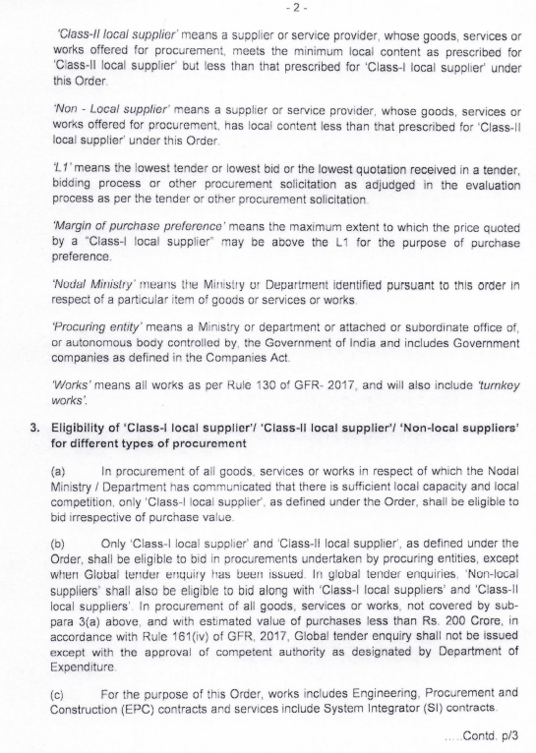

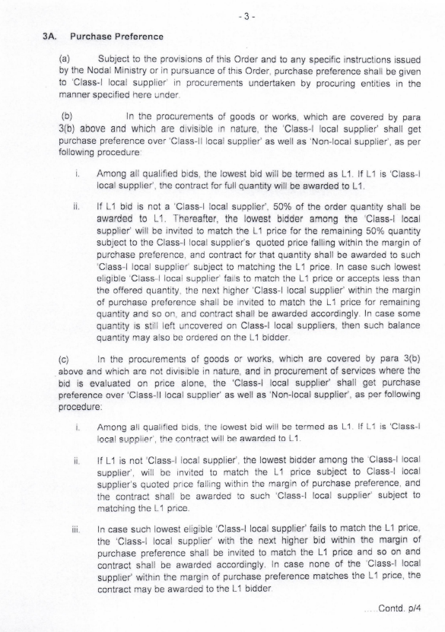
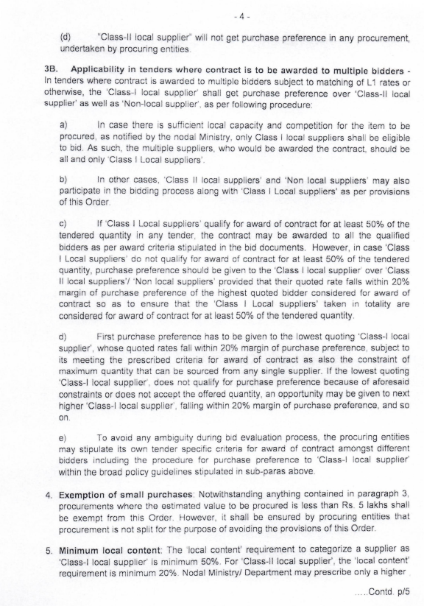
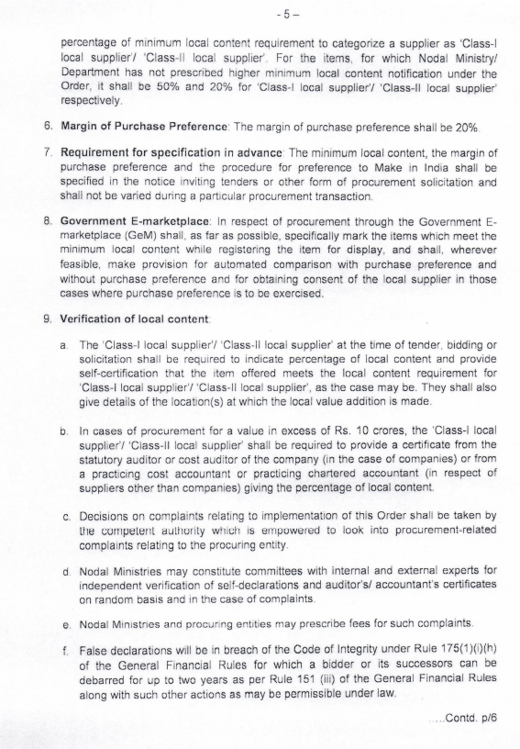

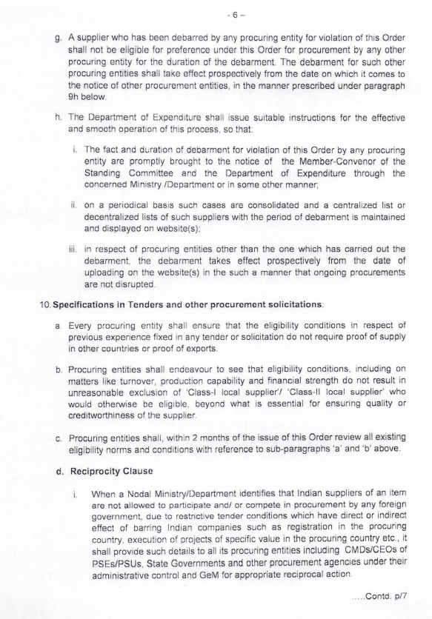
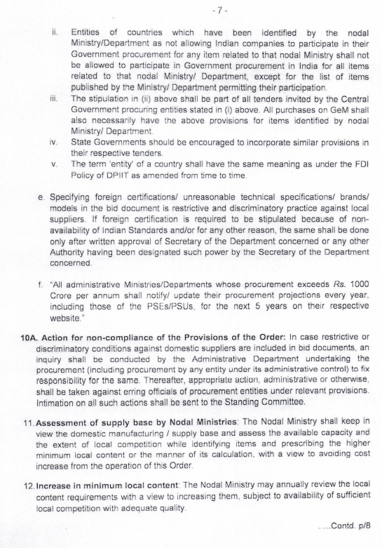

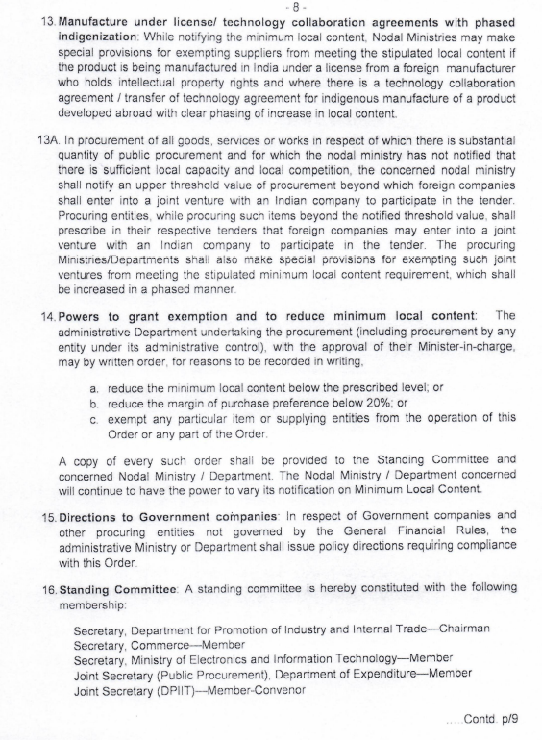

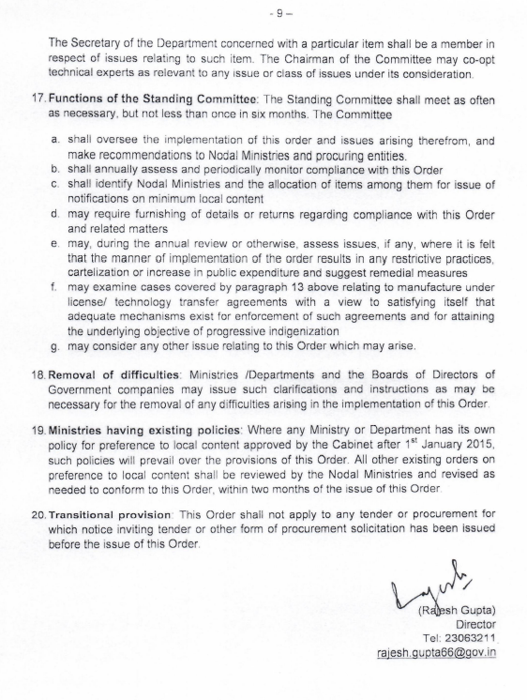

Annexure –IX
UNDERTAKING FOR COMPLIANCE OF ONE BID PER BIDDER
I/We, ----------------------------------------------------, Proprietor / Partner / Legal Attorney / Authorized Representative of -----------------------------------------------------(Name of bidder), submitting the Bid for the work of “--------------------------------------------------------------" vide Bid Notice No. < Tender Reference No. >, Dated------------, BID ID No. --------------------- solemnly declare that:
1. I / We do not have relationship with other bidder participating in this tender, directly or through common third parties that put us in a position to have access to information about or influence on the bid of another Bidder, and
2. I / We or any of our affiliate have not participated as a consultant in the preparation of the design or technical specification of the contract that is the subject of the bid.
3.* I / We declare that the following company(s) is/are our Subsidiary / Sister Concern / common business / Management in same / similar line of Business:
(a) ..... <Name , Address, contact details>.....
(b) ..... <Name , Address, contact details>......
(c) ..... <Name , Address, contact details>.....
[* Please strike out if not applicable.]
Signature with Seal

Note:
1. In case of a holding company having more than one Subsidiary / Sister Concern having common business ownership / management only one of them can bid. Bidders must proactively declare such sister / common business / management in same / similar line of Business.
2. In case of Proprietorship firm or Limited Company, this document is to be signed by Proprietor or authorized person by Limited Company respectively.
3. In case of Partnership firm/Joint Venture (JV)/Consortium, this document is to be signed by all the partners of the partnership firm/Joint Venture (JV)/Consortium.

ANNEXURE - X

PROFORMA OF LETTER OF ACCEPTANCE
(In the letter head paper of employer)

To
---------------------------------
-----------------------------

Sub: Letter of Acceptance (LOA) for the work of …………

Ref: 1. Tender Notice No.:…………………………….

Dear Sirs,

This is to inform that your Bid dated _____________ for execution of the
______________________
( name of the contract and identification number, as given in the Instructions to bidders ) for the contract Price of Rupees _______________( ______________ ) (amount in words and figures ), as corrected and modified in accordance with the Instructions to Bidders is hereby accepted.

The time of completion for the work shall be as prescribed in the NIT.

You are further advised to furnish Performance Security deposit in the form as detailed in Clause No 37 of NIT for an amount of Rs. ……………… within 21 days of issue of this letter of acceptance and sign the contract failing which actions as stated in NIT/Tender Document will be taken.

You are advised to contact General Manager (Geomatics), CMPDIL for detailed work order and execution of agreement.

You are also advised to return a copy of the letter of acceptance duly signed and sealed as a token of your acceptance within a week.

Yours faithfully,

Signature
Name and Title of Signatory

Annexure - XI

Format of Affidavit to deploy matching equipment
(To be filled by the Bidders)
Non-Judicial Stamp Paper of appropriate value

AFFIDAVIT

I/We, ..................................................................................., Proprietor/Partner/Legal Attorney/director/ Accredited Representative of M/s. ..................................................., solemnly declare that:

- We are submitting Bid for the work …………………………………….. against Bid Notice
No…………………………. dated…………………………….

- We hereby confirm that we shall deploy matching equipment, PPK enabled UAV/Drone/ UAVs, Sensors and accessories etc. of required capacity/type as per NIT.

Signature of the Bidder.
Dated……………………….

(In case of joint venture, the LEGA shall be signed by all the members of JV)

Seal of Notary

ANNEXURE - XII

(Not Applicable for this Tender)
FORMAT OF MEMORANDUM OF UNDERSTANDING WITH ASSOCIATE(S)
(Format for the MoU between the Bidder i.e. Lead Member & its Associate(s) and to be submitted by Bidders)
(To be executed on Non-Judicial Stamp Paper of appropriate value)
Memorandum of Understanding
Sub: Provision of services for acquiring data from UAV based sensors for various application in outsorcing mode as detailed in the NIT services in the ___________________ Project(s), ____ Coalfield of ____ District in the state of ____________ .
Ref: Detail E-Tender Notice No. ……….……………………………
We, M/s ….…………………………………………………. (Name & Address of the Bidder i.e. Lead Member) and (1) M/s ……………… (2) M/s…………………& (3) M/s……………….* (Names and addresses of the Associate/ Consortium partners) have formed a Consortium for services for acquiring data from UAV based sensors for various application as detailed in the NITin the ____ project, ____ Coalfield of ____ District in the state of ____ under option-___ and hereby undertake:
1.0 To conduct services for acquisition of data from UAV based sensors for various application as detailed in the NIT in _____ project(s), _____ Coalfield of ____ District in the state of ____ under option _____ as per the period of association specified at para 5.0 of this MoU. (1) M/s ……………. (2) M/s……………. & (3) M/s……………. * (name of Associate/ Consortium partners) have the liberty to dissociate themselves after a time period as mentioned at para 4.0 of this MoU. The periods of association/ dissociation are in accordance with Cl. No. 8.4 of Detailed E-Tender Notice.
2.0 That M/s …………………………. (Bidder/ Associate or Consortium partners) * have the experience of undertaking field work for services for acquiring data from UAV based sensors for various application as detailed in the NITas per Clause No 9.1 (A) and (B) of Detail E-Tender Notice whose details are given hereafter.
Name of Bidder/ Associate *(Consortium) partners: ………………………………….

Sl. No. | Area of Experience | Number of related projects handled independently or as associate member and the years of experience in the indicated field | Details of the last project completed successfully (As on last day of month previous to the one in which Bid is invited) | Remarks
1
2
3

(The Bidder as well as each Associate/ Consortium partner with experience of ‘services for acquiring data from UAV based sensors for various application as detailed in the NIT’)
3.0 That M/s ……………………………… shall be the Lead Member for this Associate/ Consortium.
4.0 That M/s ……………..……….………. (Name of the Bidder i.e. Lead Member) has associated with (1) M/s ………..………….(2) M/s…….………….& (3) M/s………….……. *(name of the Associate or Consortium partners) for the subject work as per the role, tenure & % stake in association as given hereafter:
Sl. No. | Name of Bidder (LM) & Associate/ Consortium partners | Role of Bidder/ Associate/ Consortium partners (set up/ operation/ Financial Qualification(FQ)/ None) | Tenure of Association**
 | M/s……….. (Bidder/ LM)  M/s……….. (Associate 1)  M/s……….. (Associate 2)  M/s……….. (Associate 3) | Set up/ Operation* & FQ  Setup/Operation/ None*  Setup/Operation/ None*  Setup/Operation/ None* | Entire Contract Period  …………………  …………………  …………………

5.0 That M/s …………………. (Bidder i.e. Lead Member) have formed consortium with (1) M/s ……………. ………… (2) M/s……………. & (3) M/s………………………* (name of Associate/ Consortium partners) having collective experience towards services for acquiring data from UAV based sensors for various application as detailed in the NIT as per para 2.0 of this MOU. We hereby undertake that this MoU as per the provision of the Bid Document shall remain valid for the term of association as specified at para 4.0 of this MoU.
6.0 That this MoU shall be valid till this subject work is completed.
7.0 That the above MoU shall be governed by substantive and procedural laws in India.
For and on behalf of : ……………………………………………….
(The Lead Member of Associate/ Consortium)
Signature : ……………………………………………….
(The Authorized Signatory)
Name of the Signatory : ……………………………………………....
Designation : ……………………………………………….
Company’s Stamp/ Seal :
For and on behalf of : (1) …………………... (2)….……………….. (3) ….………………..*
(The Associate)
Signature : (1) ……………….….. (2) ………….……….. (3) ……….…………..*
(The Authorized Signatory)
Name of the Signatory : (1) …………..……….. (2) ….………………. (3) ….………………..*
Designation : (1) …………..……….. (2) …….…………….. (3) …………………..*
Company’s Stamp/ Seal :
Witness (1): Witness (2):
Signature: ………………………….. Signature: …………………………
Name: ……………………………… Name: ……………………………..
Official address: ………………….. Official address: ………………….
Date:
Place:

ANNEXURE - XIII

CONSENT TO ARBITRATION CLAUSE 13OF GTCand 52 of NIT
(Applicable in case of Partnership firm)
We,………………………………………………………………………………………………………………..(Name of Partners of Partnership Firm), partners of …………………………………………………………………..(Name of Partnership Firm) hereby consent to abide by the provisions of Clause 13 of GeneralTerms and Conditions pertaining to arbitration.

(Name, Signature and Seal of Partners of Partnership Firm)

PLATE – 1

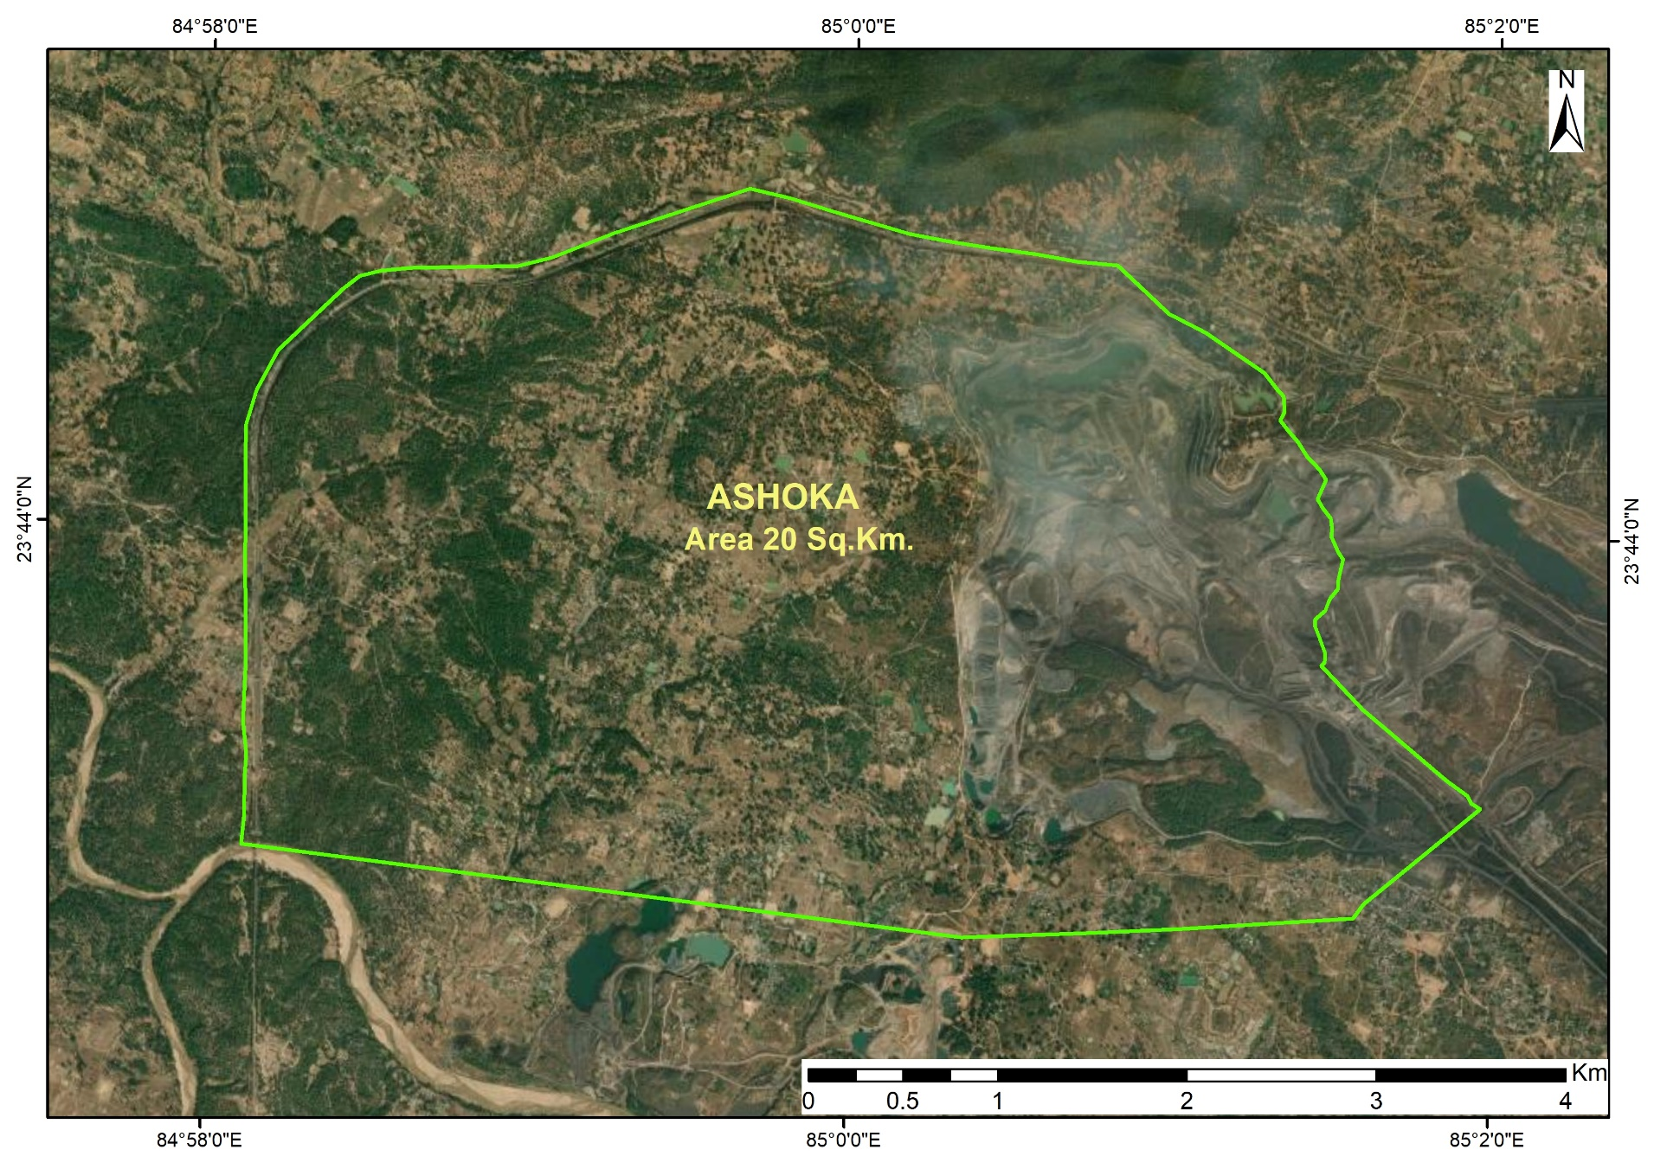

PLATE- 2

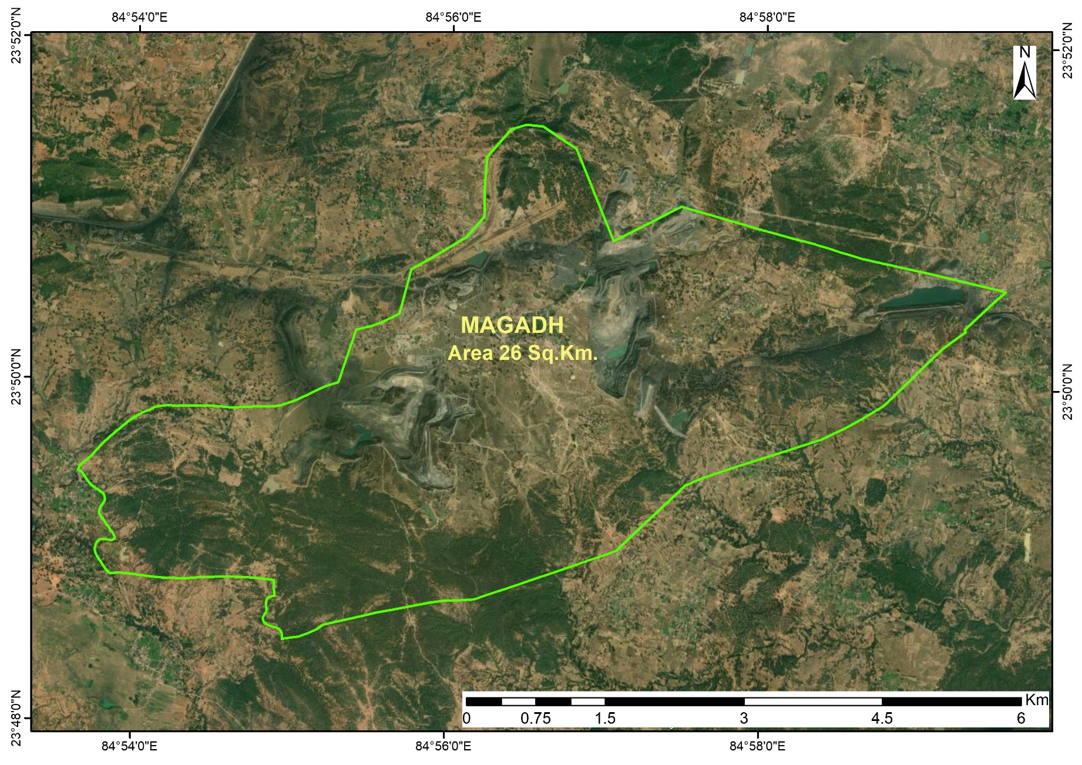

PLATE- 3

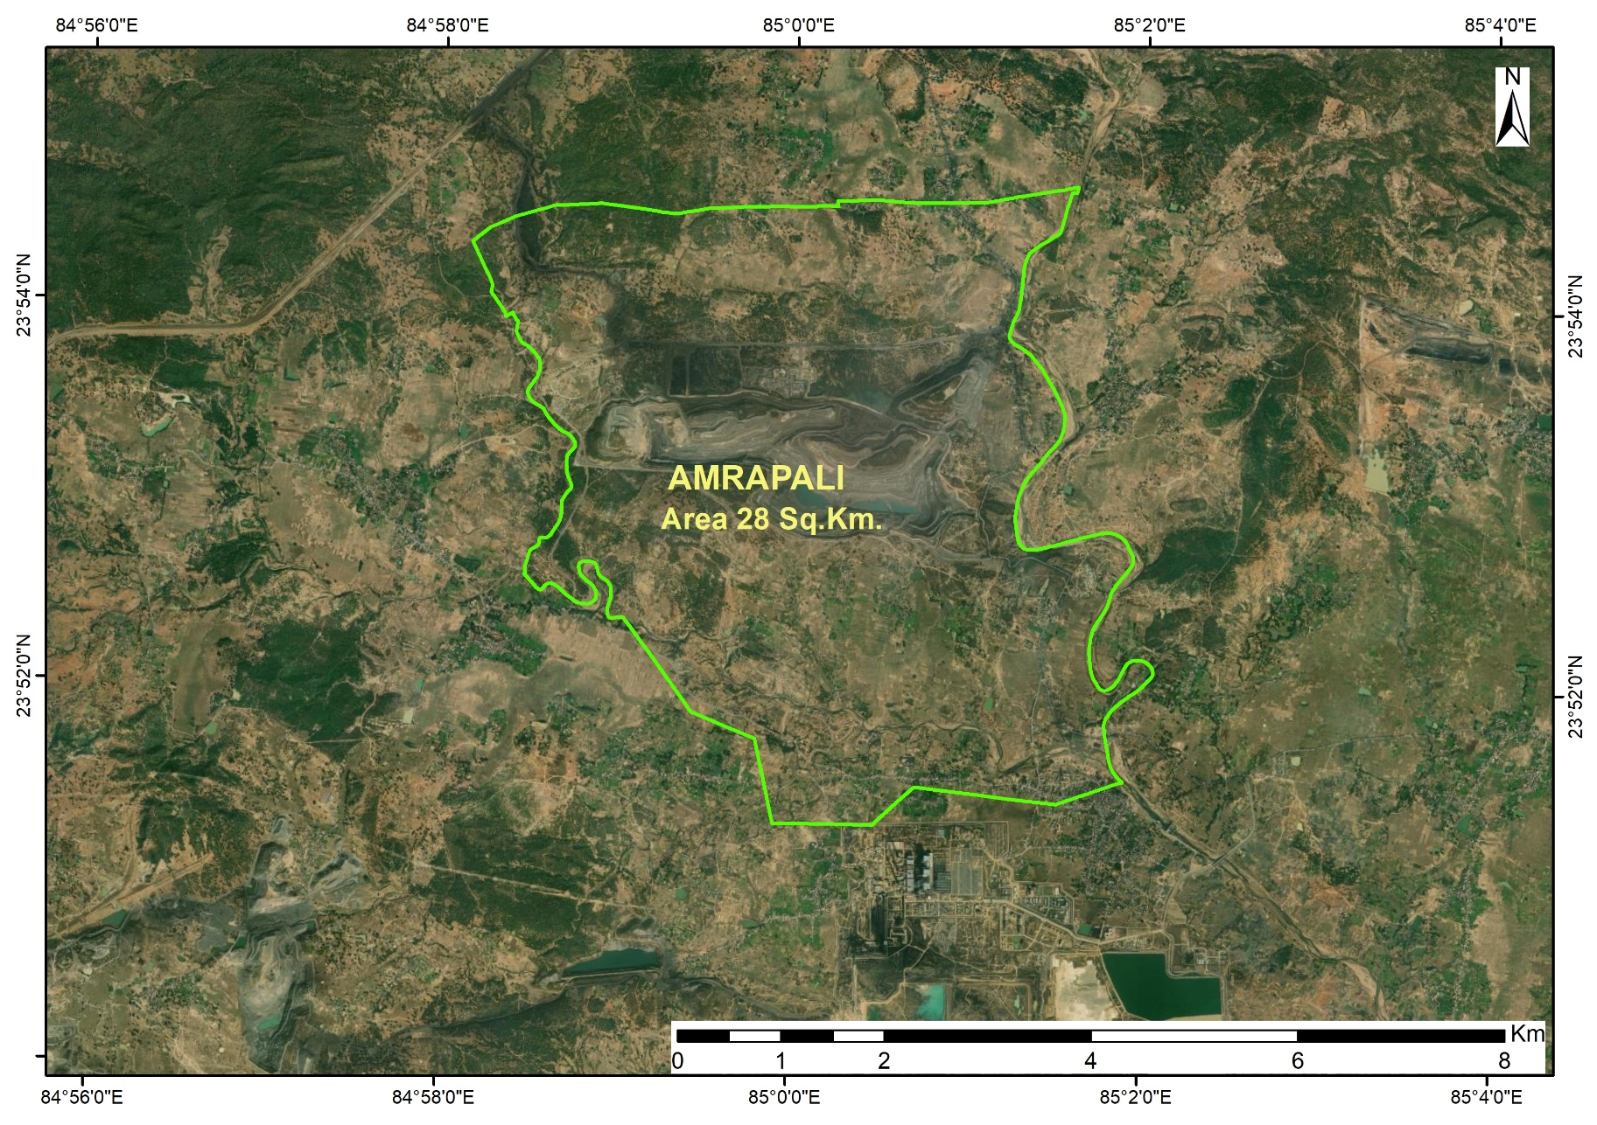

PLATE- 4

