


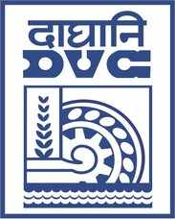

E-Tender Notice
Damodar Valley Corporation invites online bids in Open Tender from the eligible bidders for:
REFERENCE NO. | Description of item | Tender Downloading Period and Time
DVC NIT NO:- 2600002706 DATED 05/08/2026. ***************************  CPP Tender ID:- 2026_DVC_286626_1 | Establishment of Centralized Transmission Asset Management Service for Remote Operation of DVC Substations. | From:  05.08.2026 at 18.00 Hrs. (IST)  TO  09.09.2026 at 12.00 Hrs. (IST)

For further details and to participate in tender, please log on:
https://etenders.gov.in/eprocure/app

Note: For any Technical Queries call:- 0120-4001 002, 0120-4001 005,0120-4493395
.
E-Mail Support: Technical - support-eproc(at)nic(dot)in

